Bowen Therapy

About
Tom Bowen from Mount Dandenong, Melbourne is the founder of this technique in the 1950’s. The main concept behind his practice and teachings is that the body is able to heal itself. Now his technique is practiced all over the world, Europe, Asia, Americas. Some hospitals have Bowen Therapy for rehabilitation alongside Physio and Occupational Therapy as the Calvary hospital , Kogarah as well as in Hong Kong and Germany.

The technique is not massage, acupressure or chiropractic. There is no manipulation involved and no force used. Thumbs and fingers are used in gentle movements over muscles and tissues with waiting periods between sets.

This makes Bowen technique unique, offering long-lasting relief from pain and discomfort in 2 to 3 treatments. It helps to speed up recovery time but does not replace medical treatment. It reduces rehabilitation time after illness, surgery or injury regardless of how old they may be.

Muscle pain relief.
Most moves are done either at the origin or belly of the muscle where the nerve receptors are found. These receptors inform the central nervous system by energy impulses to release tension initiating the body’s self-healing mechanism. The moves create energy surges and vibration that help regain blood and lymph circulation to the area relieving spasms.

Fascia
To understand how Bowen works, we must understand a bit about fascia.

Our fascia is a connective tissue (mostly collagen) that runs beneath the skin and wraps around muscles, organs and joints from the tip of our head to the tip of our toes. All muscles, organs, tendons, ligaments, even nerves are wrapped by it.

Fascia has many functions: to protect us, nourish us and keep our bodies in taut shape. A healthy fascia lubricates the muscles and allows them to slide against each other when we move making the movement smooth. It creates a sheath around each muscle and protects it from over stretching and connects the organs to the ribs, and to muscles and bones. It is all inter-connected, so when there is a pull from one end, a large area is affected. Similar to when one pulls at a garment from the collar, the whole garment moves. It helps to nourish all parts of the body and holds us together and makes us mobile and flexible. Our coordination, postural alignment and flexibility depend on a healthy fascia. It is alive, contract and move independent of the muscle.

With an injury fascial fibers thicken to protect the muscle, they can become stuck, dry and lose the flexibility. There is no flow of fluid in the area which results in the accumulation of toxins. The fascia cells will secrete inflammatory mediators that start an inflammation process resulting in pain, swelling and redness. It has a large network of nerves connection that there is no part of the body that it is without nourishment, fluid or nerves.

Bowen therapy moves and releases the fascia in all levels (superficial and deep fascia). It allows the flow of fluid to the injured area and provides space for the muscle to move to its original position. Electrical impulses are sent to the nervous system to make it aware of the pressure release, increased circulation and unblocked pathways so it can start the healing process. The body will re-balance correcting any postural problems.

Improve circulation and lymphatic drainage.
Bowen moves help to increase lymphatic circulation and drainage to eliminate toxins and improve the body’s immunity and healing powers.

Referred healing
Moves on the spine, along erector spinae which forms two columns along each side of the spinal column, produce referred reactions to other areas of the body such as the organs. People may find an improvement with their digestion. This is because it works on visceral (deep) fascia.

Balancing the body’s energy
Bowen moves stimulates circulation of energy and balances energetic blocks. A lot of the moves run along the energy meridians that are used in acupuncture to balance the body’s energy. It balances and unblocks the body’s energy center or chakras.

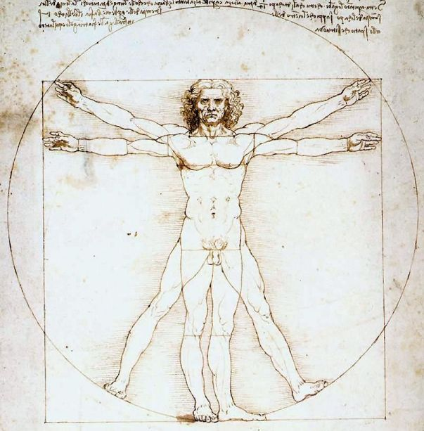
Leonardo Da Vinci - “The Proportions of the Human Figure”

What can it treat?
- Acute and chronic pain with musculo-skeletal or neurological origins
- fibromyalgia,
- back pain
- lumbago,
- sciatica,
- chronic fatigue syndrome,
- neck pain,
- arm pain and carpal tunnel syndrome
- TMJ syndrome,
- shoulder pain (frozen shoulder),
- leg and foot pain (plantar fascitis),
- emotional depression and stress,
- asthma,
- sporting and other trauma injuries.
- Ear problems / vertigo / Menier’s disease

Information cited from:
- Kwong, EH, Findley TW 2014, Fascia—Current knowledge and future directions in physiatry: Narrative review. Journal of Rehabilitation Research & Development. Pp 875-884 http://eds.a.ebscohost.com
- Text book: Serge Paoletti , 2014, The fasciae – Anatomy dysfunction and treatment.
- Text book: Leon Chaltow, 2015, Fascial Diysfunction – manual therapy approaches.
- http://www.bowen.asn.au/bowen-therapy

