A few days after the Virgin's last apparition in Beauraing, she appeared in the nearby town of Banneux. Between 15 January and 2 March 1933, 12-year-old Mariette Beco saw a lady in a white gown and blue sash who claimed to be the Virgin of the Poor, and stated: "Believe in me and I will believe in you."
The Virgin asked Mariette to put her hands in a small spring, ordaining it for healing for all nations. A chapel is built where the Virgin requested it. The Marian apparition of Banneux carries two titles: Our Lady of the Poor and Queen of Nations.
Mariette was made fun of, even by her own grandmother and aunt. Others tauntingly called her 'Bernadette', after the French girl who had visions of Mary in Lourdes. Mariette married and led a quiet life. In 2008, three years before her death, she said: "I was just delivered the message. The messenger is of no importance."
Arsène Heitz, designer of the 12-starred flag, credited a passage in chapter 12 of the Book of Revelation as a source for the image. It refers to a woman "clothed with the sun, with the moon under her feet and on her head a crown of twelve stars."

And that is why the number of stars on the flag does not refer to the number of member states (28 now, 27 after Brexit), but is in fact an emblem of Catholic devotion to Mary.
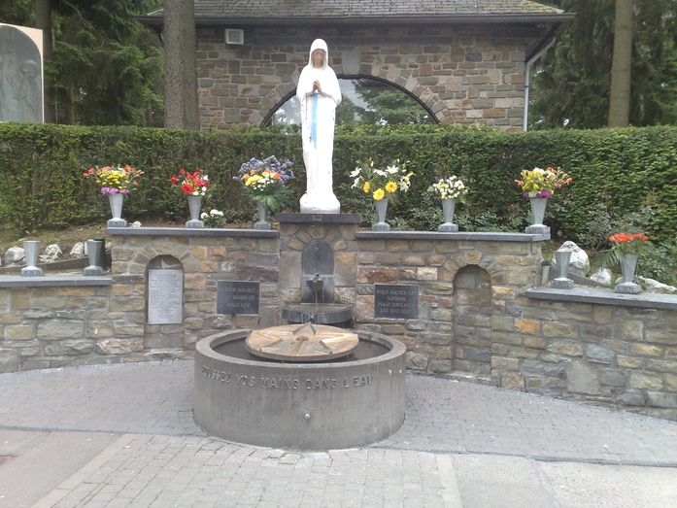

The miraculous spring of Our Lady of Banneux.
Image: Johfrael, CC BY-SA 3.0

European flags fluttering in front of the Berlaymont
building in Brussels.Image: Thijs ter Haar, CC BY 2.0

