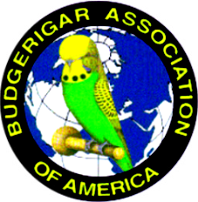
DFW Annual Budgie Show 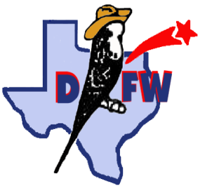

August 20th & 21st, 2022
Ables Springs Volunteer Fire Department
30000 FM 429 N
Terrell, TX 75161

Hosted by: Dallas - Fort Worth Exhibition Budgie Club
Affiliated with: Budgerigar Association of America
All Divisions – Rare, Junior, Novice, Intermediate, Champion
BAA Panel Judges: MaryAnn Silva and Rodney Silva
Entry - $3/bird, $30 max (per day) or $5/bird, $50 max for both days

Schedule of Events

FRIDAY 3:00-6:00 PM Show hall open for Setup and Check-in
6:30 PM Dinner to be announced

SATURDAY 7:00 AM Show Hall Opens
9:00 AM Bird check in and entry complete. Staging of entries
10:00 AM Judging Begins
12:00 PM Lunch – Club will provide main meal. Please bring drinks,desserts and sides.
~ 6:00 PM Dinner provided by the club.

Sunday 7:00 AM Show Hall Opens
9:00 AM Judging Begins
Noon - 1:00 PM Lunch, Raffle – All donations are appreciated
6:00 PM Show Hall Closes – Awards, wrap up, and clean up. All help is appreciated

-Sales Division, Raffle Extraordinaire and a Budgie Auction-
*Budgie Auction may take place on Saturday or Sunday after lunch, depending on the members request*

Local hotels in Terrell, TX:
Further information contact : Joshua Anthony
- 381-9051 joshda12101984@gmail.com

Show Secretary contact: Julie Willis
(469)524-9700 juliebelle57@gmail.com
*Preregister: Email. Electronic entry form to Julie Willis*
Lowest-highest ($65 -$110 per night)
Days Inn : (972) 551-1170
Quality Inn: (972) 210-2344
Surestay : (972) 563-1511
Red Roof Inn: (972) 551-1090
Baymont Inn: (972) 563-1521
Tru By Hilton: (469) 837-7200
Holiday Inn : (972) 563-7888

