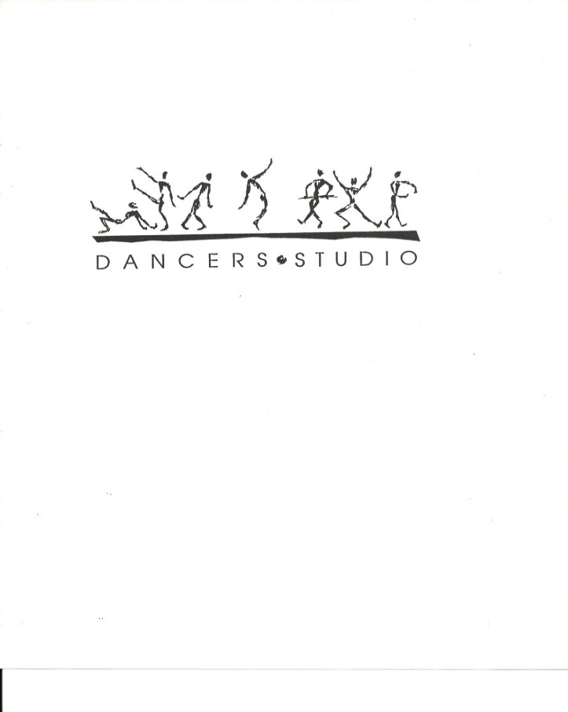

**Join us this summer for many fun filled weeks!**

**Summer Camp Schedule 2023**

|  |  |  |  |  |
| --- | --- | --- | --- | --- |
| **Class** | **Date** | **Age** | **Description/Theme** | **Cost** |
| **Disney Dance Camp** | July 3 to 7  9:00 to 12:00 | 3 to 4 years | **Disney Dance Camp!**  Our popular Disney themed camp is back! Enjoy a fun filled morning of dance in Disney style! Dancers will be studying Jazz, Tap and Ballet along with many themed Disney craft activities. | $150.00  Plus HST |
| **Camp Superhero** | July 3 to 7  12:30 to 3:30 | 3 to 4 | **Camp Superhero!**  Become a superhero in an exciting afternoon of dance, crafts, games and more! Dancers will be studying Jazz, Tap and ballet all while exploring their superpowers in the fun themed camp. | $150.00  Plus HST |
| **Mini Movie Madness!** | July 10 to 14  9:00 to 3:30 | 5 to 8 years | **Mini Movie Madness!**  Get your popcorn! Dancers will be studying Jazz, Tap, Ballet and Musical Theatre along with many popular movie themed craft activities. | $225.00  Plus HST |
| **Movie Madness!** | July 17 to 21  9:00 to 3:30 | 9 to 12 years | **Movie Madness!**  It’s Showtime! A movie themed camp for our older dancers will include studying Jazz, Tap, Ballet, Lyrical, Hip Hop, Musical Theatre and Choreography, along with many movies themed craft activities | $225.00  Plus HST |
| **Triple Threat!** | July 24 to 28  9:00 to 3:30 | 8 to 12 years | **Triple Threat!**  Do you love to sing, dance and act!?  Our Triple Threat camp is for you! A fun filled week of singing, dancing, and acting along with many themed craft activities. | $225.00  Plus HST |
| **Camp Wizard!** | July 31 to August 4  9:00 – 3:30 | 5 to 8 years | **Camp Wizard!**  Back by popular demand, our magic camp caters to the imaginations of budding young wizards. It will feature dancing in styles such as Jazz, Tap, Ballet and Musical Theatre with many themed games and crafts. | $225.00  Plus HST |
| **Images Dance Company Camp!** | Aug. 8 to 11  9:00 – 3:30 | Open to all Images Dance Company  dancers | **Company Camp!**  Dancers will learn, the history of dance, how the body works for a dancer, nutrition, conditioning, technique, along with many styles of dance and crafts  **\*Note, 4-day program** | $180.00  Plus HST |

For more information or to register, please visit our website [www.dancersstudiomidland.com](http://www.dancersstudiomidland.com) or [dancersstudiomidland@gmail.com](mailto:dancersstudiomidland@gmail.com)