ACROSS: 1, Awaken. 4, Quench. 8, Hit me. 9, Sadness. 10, Semitic. 11, Ridge. 12, Testimony. 17, Psalm. 19, Indulge. 21, Deserve. 22, Ariel. 23, Rose as. 24, Beggar. DOWN: 1, Aghast. 2, Attempt. 3, Eject. 5, Undergo. 6, No end. 7, Hasten. 9, Sacrifice. 13, Samaria. 14, Yelling. 15, Spider. 16, Dealer. 18, Asses. 20, Drake.
__________________________________________________________________

Lent Services – Wednesday Evening
Stockport Town Centre Churches
Wednesday Evening Worship during Lent

20th February at St Peter’s, Petersgate
27th February at St George’s, Buxton Road
6th March at St Joseph’s, Tatton Street
13th March at Tiviot Dale Methodist, Tiviot Dale
20th March at Our Lady’s, Shaw Heath

Worship begins at 7.00pm

Readers contributions to the magazine are always welcome. Hard copy (hand written if easier) to the Rectory address or by email: to : st.marysstockport@gmail.com
Editorial discretion with regard to content and space available will apply.
St Mary’s in the Marketplace
St Mary’s Rectory, 24 Gorsey Mount Street,
Stockport, SK1 4DU.
0161 429 6564 www.stmarysinthemarketplace.com
St Mary’s in the Marketplace
“SECURING THE FUTURE FOR THE NEXT 100 YEARS” 50p

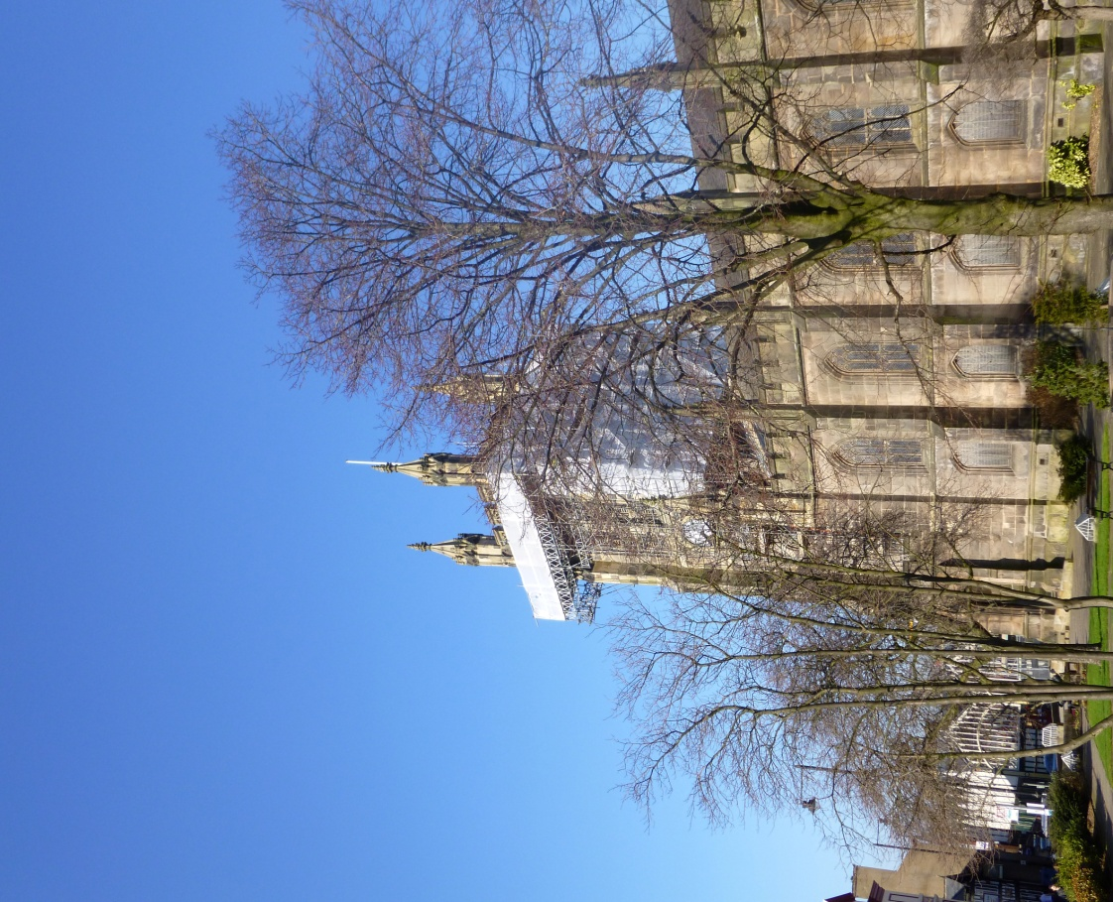

31st March EASTER
– the most joyful day of the year
Easter is the most joyful day of the year for Christians. Christ has died for our sins. We are forgiven. Christ has risen! We are redeemed! We can look forward to an eternity in his joy! Hallelujah! The Good News of Jesus Christ as a message is so simple that you can explain it to someone in a few minutes. It is so profound that for the rest of their lives they will be still be ‘growing’ in their Christian walk with God.
Why does the date more around so much? Because the date of Passover moves around, and according to the biblical account, Easter is tied to the Passover. Passover celebrates the Israelites’ exodus from Egypt and it lasts for seven days, from the middle of the Hebrew month of Nisan, which equates to late March or early April. Sir Isaac Newton was one of the first to use the Hebrew lunar calendar to come up with firm dates for Good Friday: Friday 7 April 30 AD or Friday 3 April, 33 AD, with Easter Day falling two days later. Modern scholars continue to think these the most likely. Most people will tell you that Easter falls on the first Sunday after the first full moon after the Spring Equinox, which is broadly true. But the precise calculations are complicated and involve something called an ‘ecclesiastical full moon’, which is not the same as the moon in the sky. The earliest possible date for Easter in the West is 22 March, which last fell in 1818 and won’t fall again until 2285. The latest is 25 April, which last happened in 1943 and is next due in 2038.
Why the name, ‘Easter’? In almost every European language, the festival’s name comes from ‘Pesach’, the Hebrew word for Passover. The Germanic word ‘Easter’, however, seems to come from Eostre, a Saxon fertility goddess mentioned by the Venerable Bede. He thought that the Saxons worshipped her in ‘Eostur month’, but may have confused her with the classical dawn goddesses like Eos and Aurora, whose names mean ‘shining in the east’. So Easter might have meant simply ‘beginning month’ – a good time for starting up again after a long winter. .
9

Diary dates – charity fund raisers with food in mind!

Super Soup Lunch
Tuesday, 14th May
St Mary’s in the Marketplace

In aid of: Christian Aid Week, 12-18 May 2013
Today around 870 million people are desperate for food. One in eight people will go to bed hungry tonight. This is a scandal. But IF we bite back at hunger this Christian Aid Week we can help communities find ways to not only survive but to thrive, with enough food to eat not just today but tomorrow. We will be serving soup and a roll – all profits to be donated to Christian Aid. .
.

The Big Lunch - Sunday, 2nd June 2013
St Mary’s in the Marketplace
Advanced notice is given for the 2013 “big lunch” – details to follow.

World Porridge Day –
Thursday, 10th October 2013
St Mary’s in the Marketplace
A long way off – but a date for your diary. Breakfast will be served consisting mainly of porridge obviously. All profits to Mary’s Meals a global movement setting up school feeding programmes in some of the worlds poorest communities.
14

From the Rector’s Desk
Dear Reader .
.

1

St Andrews News

Chris Hudson
Chris has decided that the time has come to hang up her mob and bucket at St Andrews. A very big “thank you” for the years spent looking after our community church/hall. We wish her health and happiness for the future.
The ladies from the “Mums & Dads at Home” group have kindly volunteered to clean at St Andrews each Wednesday morning before/after their group session. Thanks Kelly and friends for your assistance.

New Users
Joining us on a trial basis between January – March we are delighted to welcome new users: Family Language (Tuesday), Twins (Thursday), Henry (Thursday), Little Superstars (Friday/Saturday) and Zumba (Friday).

It has also been a pleasure to assist the ladies from the gym across the road (who are experiencing a few accommodation difficulties at the present time) who have held meetings at St Mary’s but presently using St Andrews. The Nave Café is temporarily set-up there to offer them refreshments before, during and after their meetings!

Usage is growing, which is delightful, we even have a waiting list for Sunday or Wednesday mornings!

22
Where were you? /
. .
The 3rd February was of course our first Sunday away from St Mary’s with the opportunity to visit other churches, to network and meet new people. The Secretary Bird had in mind an easy morning, St Albans maybe or Norbury St Thomas, but no that wasn’t to be. Taking a message off the office answering machine Saturday afternoon it became apparent that our Architect wished access to St Mary’s to take a photographer in to record the work on the Tower. Well fine, I could meet them first then drift off in time to get to St Matthews or St Georges (where I knew Isobel would be). But, no – James and Jack were late! What none of us had known of course was that Lambert Walker had a team working in church and on the archway outside – so there was actually no need for me to be there (keys in hand) at all! .
It seemed very strange, I parked the car at the usual time, in my usual parking space, but none of you were there. There was no Frank ringing the bell, no Isobel playing the organ, no sides-persons handing out hymn books - instead a guy sanding the floor (with mask and ear protectors), another painting behind the screens – a radio playing in the background - not the normal tranquillity you expect to find at St Mary’s on a Sunday morning. The guys arrived – I’d decided to wait for them whilst the Lambert Walker team went for breakfast - access to the tower sorted for when they returned - so off I went! .
I was out of time for attending a service anywhere “on time” – but time enough to drive round and find a parking space outside St Georges. I sort of arrived for coffee, which wasn’t quite the idea really, but it was a networking opportunity of sorts! Having found Isobel (via mobile phone from one side of the church to the other) we decided that lunch at the “Puss in Boots” was in order (well we had sort of decided that the day before) and it was a very nice meal and a change from our normal attendance at The Old Rectory. We went from there to St Marks, for a pew viewing – cold and damp and… where was my scarf?
3

Biscuit tins and cookery books Rotary Club of Stockport
Once again the Rotary Club of Stockport are collecting air-tight biscuit and chocolate tins for use by students as Parrs Wood High School & Sixth Form. We would also appreciate any good quality cookery books you may have spare. Please bring them to church as and when you can. Thank You

We still need to raise funds for the interior refurbishment

In case there was any doubt, we still need to raise funds for the continuing re-ordering of St Mary’s. The project team are carefully watching the budget to ensure that we can pay all the bills as they come in, but we are struggling to complete all the work that we have permission to do and at the present time. It is important that we authorise as much of the work as we can whilst Lambert Walker are on site and whilst we have faculty approval.
There are also associated costs that are not yet budgeted for, additional equipment for the kitchen, furniture for the café area, being just a couple of examples.
Lots still to do – please support us as best you can and spread the word – we still need your help.
20 Thank You

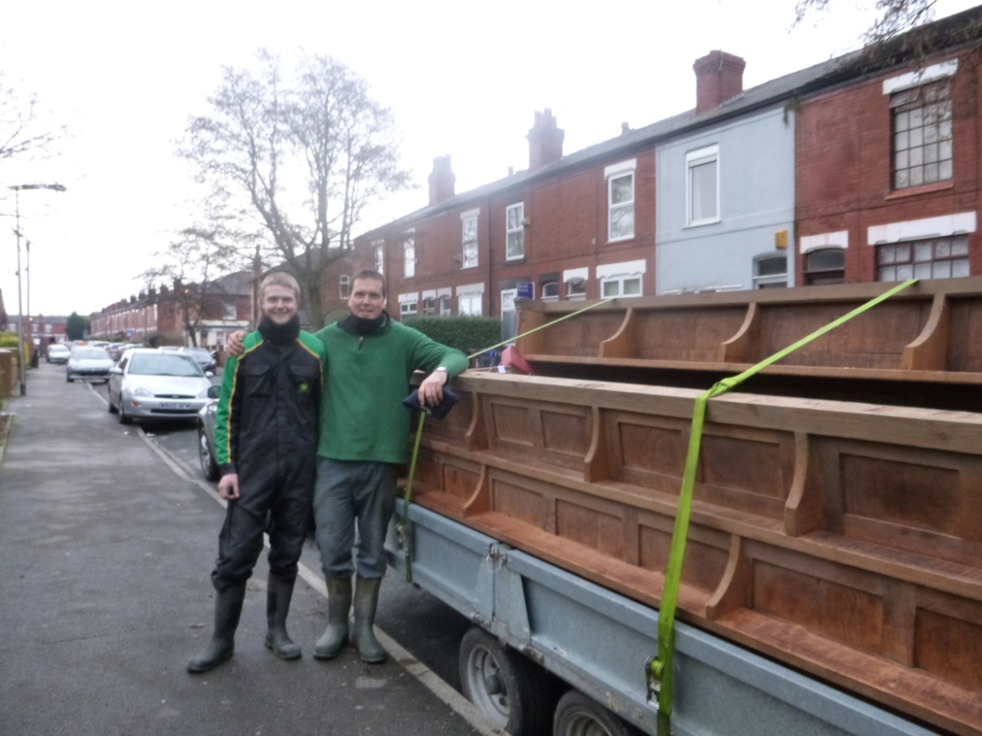

It’s always the same don’t you think – like waiting for the bus – you wait ages then two appear. It has been much the same with the pews – after the private sales were dealt with we received two offers to take all that were left! I am delighted to say that everything has been sold – anyone wanting one now will need to talk to the new owner (I have his phone number) – although you might just be able to bid for one on e-bay! For us it is “cash in hand”, the best deal we could find, and the ability to hand the keys back to St Marks before being evicted! What a relief… going, going and gone!

19
Pews viewed (and I am not entirely sure they are actually buying one yet), we returned to the “Puss in Boots” and behold my scarf was on the floor, where it had fallen during our meal. I was so pleased I hadn’t lost it.
By now we were late for our next adventure of the day. Arriving to find the door locked we rang a couple of door bells – so clearly causing some disruption to proceedings as we gained entry and shuffled in, taking possession of the last couple of seats at the back of the room. They were singing their second hymn at the time but books were found for us and we quickly joined in (pretending to have been there all the time). My eye landed on a model of a lighthouse sat on a table near the front of the room. It was lit and there were clearly other objects beside it. By now I had reached the stage of disbelief (and the giggles) at the way the day had turned out – and the fact that Isobel’s day had turned from being straightforward as well – and the odd route she had taken us on the back streets of - I have no idea – just followed her car in the hope that no traffic lights turned red! I suddenly realised my mobile phone was switched on – dare I switch it off during the next hymn? The idea was that said Architect and his mate would phone if they needed the church keys to lock up, although they should have finished before the contractors went home (but how was I to know). My mobile is the contact number for people wanting to talk pews – it could go off at any second. As if getting in there wasn’t bad enough without risking the phone going off! To switch off or not to switch off – that was the question!

Why were we in this position in the first place? Earlier in the week I had printed the wrong version of a form when meeting Margaret for her signature as our Electoral Roll Officer. It seemed therefore a good idea for us to find her on Sunday afternoon (whilst out and about) the correct form in hand. We knew where she would be – but the idea was to arrive at a reasonable time. The pew viewers were messing around for an age, what was lost needed to be found. But we were there and more than happy to join the congregation, so phone was duly switched off during the next hymn, and although I don’t like being late anywhere - let along making a 4dramati welcome.
dramatic entrance – it was alright really, we were made very welcome and I really enjoyed the afternoon. All was revealed about the lighthouse listening to a dear lady speaking about Grace Darling, a lighthouse-keepers daughter famed for her rescue of survivors following the sinking of the Forfarshire on the 7th September 1838. I’m not quite sure of the significance of this talk on the 3rd February 2013 but still.

I’ll share the story with you - Grace, looking from an upstairs window of the Longstone Lighthouse on the Farne Islands, spotted the wreak and survivors on Big Harcar, a nearby rocky island. The Forfarshire had founded on the rocks and broken in half, one of the halves having sunk during the night. She and her father (William) took a rowing boat (a Northumberlad coble) across to the survivors determined that it was too rough for the lifeboat to put out to sea. Taking the long route they kept to the lee side of the islands, a distance of nearly a mile. Grace kept the coble stead whilst her father helped four men and a lone surviving women (Mrs Dawson) into the boat. Although she survived the sinking, Mrs Dawson had lost her two young children during the night. William and three of the rescued men then rowed the boat back to the lighthouse. Grace then remained at the lighthouse while William and three of the rescued crew members rowed back and recovered the remaining survivors. Meanwhile the lifeboat had set out from Seahouses but arrived at Big Harcar rock after Grace and her father had completed the rescue: all they found were the dead bodies of Mrs Dawson's children and of a vicar. It was too dangerous to return to North Sunderland so they rowed to the lighthouse to take shelter. Grace's brother, William Brooks Darling, was one of the seven fishermen in the lifeboat. The weather deteriorated to the extent that everyone was obliged to remain at the lighthouse for three days before returning to shore. Grace Darling died of tuberculosis in 1842, aged 26. The model lighthouse made by the speakers father many years ago, along with other rocks and pebbles were brought to illustrate her talk.

A most interesting time spent in this new purpose-built facility and a tour afterwards of the Stockport Sunday School – thank you Margaret (Forster) and the guiding hand that got us there in the first place. The day ended where it began, back at St Mary’s to ensure all was well – that all the lights were off and our church safety tucked up for the night. That there were no Architects “locked in” or “stuck up” the tower. A day with a difference – but then most are – that’s the fun part of being the Secretary Bird!
5

Thanks St Peters, Petersgate
Our thanks to the wardens of St Peters, for the loan of the Church for our Tuesday services. To the volunteers for providing refreshments, to the Rev David Brewster, and Rita Waters for covering services whilst Roger was on holiday.

Don’t forget
the new Electoral Roll is being prepared (last date for entry before publication 24th March 2013)

Everyone who wishes to be on the new roll must apply in writing using the appropriate form – these will be available in Church, from the Electoral Roll Officer (Margaret Forster) or at the Rectory Office, St Mary’s Rectory, 24 Gorsey Mount Street, Stockport, SK1 4DU. Telephone: (0161 429 6564). Email: st.marysstockport@gmail.com. Everyone on the existing roll has been sent a form and covering letter in the post.

Notice of Annual Parochial Church Meeting
The APCM will be held in St Mary’s in the Marketplace on the 14th April 2013 at 12.00 noon following morning service and Meeting of Parishioners.

Are you interested in standing for election as a member of the Parochial Church Council? Would you be interested in being a Sides-person? Let us know. There is no election for Deanery Synod representatives in 2013.
18

School visit

Returning to visit St Mary’s are children from Castle Hall High School who will be rolling up on the 1st and 19th March to spend time looking round and being entertained by Roger. Difficult to know who has the most fun – our Rector or the children! .

Castle Hill High School is a day, co-educational special school for children with complex learning difficulties and related special needs. It is always a delight to welcome them to St Mary’s.

21

Yours very sincerely

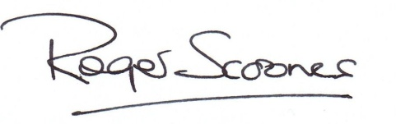

2

Crossword

Across
1 Arouse (Song of Songs 2:7) (6)
4 Extinguish (Isaiah 1:31) (6)
8 ‘“They — — ,” you will say, “but I’m not hurt!”’ (Proverbs 23:35) (3,2)
9 Unhappiness (Nehemiah 2:2) (7)
10 Jewish (7)
11 Dirge (anag.) (5)
12 ‘A truthful witness gives honest — , but a false witness tells lies’ (Proverbs 12:17) (9)
17 Paul quoted from the second one in his address in the synagogue at Pisidian Antioch (Acts 13:33) (5)
11
19 ‘Do not use your freedom to — the sinful nature’ (Galatians 5:13) (7)
21 ‘As you can see, he has done nothing to — death’ (Luke 23:15) (7)
22 Name applied by Isaiah to Jerusalem (Isaiah 29:1) (5)
23 ‘All the people — — one man, saying, “None of us will go home”’ (Judges 20:8) (4,2)
24 Lazarus, who was carried by angels to Abraham’s side when he died, was one (Luke 16:20) (6)
Down
1 Appalled (Job 26:11) (6)
2 ‘In an — to escape from the ship, the sailors let the lifeboat down into the sea’ (Acts 27:30) (7)
3 Expel (Acts 18:16) (5)
5 ‘But I have a baptism to — , and how distressed I am until it is completed!’ (Luke 12:50) (7)
6 ‘Of the increase of his government and peace there will be — — ’ (Isaiah 9:7) (2,3)
7 Hurry (Psalm 119:60) (6)
9 ‘For I desire mercy, not — , and acknowledgement of God rather than burnt offerings’ (Hosea 6:6) (9)
13 One of its towns was Sychar, where Jesus met a woman at Jacob’s well (John 4:5) (7)
14 Shouting (Acts 7:57) (7)
15 Arachnid (Isaiah 59:5) (6)
16 One of Paul’s first converts in Philippi was Lydia, a — in purple cloth (Acts 16:14) (6)
18 Donkeys (5)
20 Raked (anag.) (5)

12

Building news (2)
If you managed to get your hands on a copy of “News from St Marys” – the last edition – you will have noticed the photo of the new flag pole whilst it was sat in the nave of the church. Before it could be hoisted up the tower and put into position and whole weight-bearing structure it was to sit in had to be checked and double checked and no way in the world would it have been put in place without the permission of our structural engineer, Fred Tandy. It was a delight then to see it in place on the tower roof just waiting for the day that we can once again fly our flag – and it won’t be long.

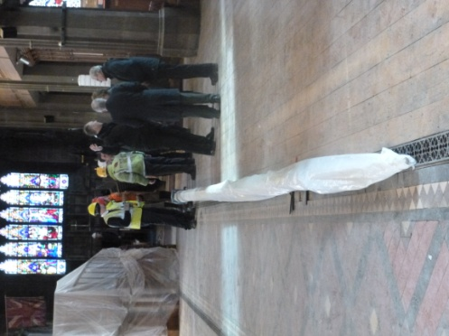

17

World Day of Prayer

Friday, 1st March
Stockport East United Reform Church Buxton Road
2pm
I was a stranger and you welcomed me
service prepared by the Christian women of France
THE WORLD DAY OF PRAYER WORSHIP SERVICE HAS A SPECIAL ANNUAL THEME WHICH IS DEVELOPED BY WOMEN OF A DIFFERENT COUNTRY EACH YEAR. A NATIONAL COMMITTEE THEN PREPARES AN ORDER OF SERVICE ON THAT THEME.

24th March
Palm Sunday: Jesus at the gates of Jerusalem
Holy Week begins with Palm Sunday, when the Church remembers how Jesus arrived at the gates of Jerusalem just a few days before the Passover was due to be held. He was the Messiah come to his own people in their capital city, and yet he came in humility, riding on a young donkey, not in triumph, riding on a war-horse.
As Jesus entered the city, the crowds gave him a rapturous welcome, throwing palm fronds into his path. They knew his reputation as a healer, and welcomed him. But sadly the welcome was short-lived and shallow, for Jerusalem would soon reject her Messiah, and put him to death. On this day churches worldwide will distribute little crosses made from palm fronds in memory of Jesus’ arrival in Jerusalem.
6
Why Easter Eggs?
On one hand, they are an ancient symbol of birth in most european cultures. On the other hand, hens start laying regularly again each Spring. Since eggs were forbidden during Lent, it’s easy to see how decorating and eating them became a practical way to celebrate Easter.
Here is one for the children/grandchildren to colour in

15

29th March Good Friday
– the day the Son of Gfod died for you
Good Friday is the day on which Jesus died on the cross. He was crucified at 9am in the morning, and died six hours later, at 3pm. It is the most solemn day in the Christian year, and is widely marked by the removal of all decorations from churches. In Lutheran churches, the day was marked by the reading of the passion narrative in a gospel, a practice which lies behind the ‘passions’ composed by Johann Sebastian Bach (1685 – 1750). Both the St Matthew Passion and the St John Passion have their origins in this observance of Good Friday.
The custom of observing a period of three hours’ devotion from 12 midday to 3 pm on Good Friday goes back to the 18th century. The ‘Three Hours of the Cross’ often take the form of an extended meditation on the ‘Seven Last Words from the Cross’, with periods of silence, prayer, or hymn-singing.

30th March
John Climacus (d. 649)
Is there something down at, say, B&Q, which reminds your friends of you? John Climacus had a thing about ladders. He was a monk in Palestine who was only seen out at the weekends (at church, not B&Q); during the week he prayed and wrote in solitude. He wrote The Ladder to Paradise, a treatise of spiritual encouragement to other monks. This gave him his name ‘Climacus’ (= ladder), and also led to him being chosen as abbot of Sinai when he was 70. John Climacus had a helpful picture of the spiritual life: he saw it as a ladder up which the believer slowly climbed to heaven, with God’s help.
8

28th March Maundy Thursday
– time to wash feet
Maundy Thursday is famous for two things. The first is one of the final acts that Jesus did before his death: the washing of his own disciples’ feet. (see John 13) Jesus washed his disciples’ feet for a purpose: “A new command I give you: Love one another. As I have loved you, so you must love one another.” His disciples were to love through service, not domination, of one another.
In Latin, the opening phrase of this sentence is ‘mandatum novum do vobis’ The word ‘mundy’ is thus a corruption of the Latin ‘mandatum’ (or command). The ceremony of the ‘washing of the feet’ of members of the congregation came to be an important part of the liturgy (regular worship) of the medieval church, symbolising the humility of the clergy, in obedience to the example of Christ.
But Thursday was also important because it was on that night that Jesus first introduced the Lord’s Supper, or what we nowadays call Holy Communion. Jesus and his close friends had met in a secret upper room to share the Passover meal together - for the last time. And there Jesus transformed the Passover into the Lord’s Supper, saying, ‘this is my body’ and ‘this is my blood’ as he, the Lamb of God, prepared to die for the sins of the whole world. John’s gospel makes it clear that the Last Supper took place the evening BEFORE the regular Passover meal, and that later Jesus died at the same time that the Passover lambs were killed.

7

It’s a messy job but someone has to do it!

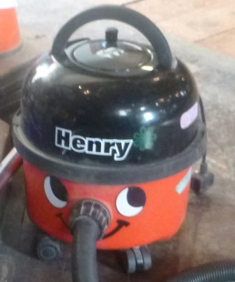
If you had been in St Mary’s whilst the floors were being sanded you would never have thought that we would get the dust shifted in a million years, but it has to be said that our contractors (Lambert Walker) have done a pretty good job of clearing up the mess with a rather large industrial cleaner and a little bit of help from Henry I and Henry II (our own two trusty cleaners). That little vac is still smiling !

16

Volunteers Needed
We will soon be starting our recruitment campaign for additional volunteers – from cleaning the brasses, the church, the toilets…. to welcoming visitors and acting as “host” at events. From acting as verger (including setting-up and setting-down furniture and staging etc) to working in the Nave Café.
To make life easier for all of us we will provide a “job description” and all the training that is necessary – including “handling and lifting”, “health and safety awareness” and of course” Level 2 Food Hygiene” for those who will be preparing and serving non pre-packed refreshments. Applications forms will be made available shortly to help us know who is interested in doing what! We will also be looking at working with partner organisations to undertake voluntary roles within St Mary’s. Our first formal links being with the Stockport Heritage Trust, working together to encourage visitors to St Mary’s - offering talks and presentations, exhibitions and special events, and for the SHT to manage and operate the Church shop on behalf of both the Trust and the Church.
We will also be looking at working with other charitable institutions for example, Pure Innovations (PURE Community Projects) – and within the business sector, for example Cheshire Flowers, Cheshire Weddings and others.

POLICY FOR SAFEGUARDING VULNERABLE GROUPS

(PROTECTION OF CHILDREN, YOUNG PEOPLE AND VULNERABLE ADULTS)
The PCC has approved the appointment (or re-appointment) of a Safeguarding Officer (and Deputy) who will be responsible for ensuring that all necessary requirements for working with vulnerable groups is complied with. This will include, as appropriate, necessary Volunteer checks.
13

Tuesday Services at
St Mary’s during Lent

The Message of the Cross – Christian truth in a changing world. Join the Tuesday congregation at St Mary’s for our Lent Tuesday services at 12.15pm.

Holy Communion at
St Mary’s 7pm

Easter Sunday at St Mary’s

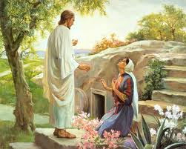
Holy Communion 10.30 AM

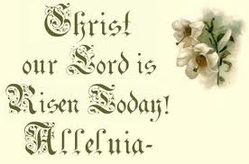

10

