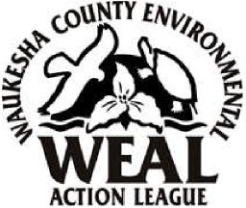
Dear Friend of Waukesha County’s Environment,
We'd like to ask that you consider becoming a member of WEAL this year. To be honest we need you! Whether it’s volunteering your time, talent, or dollars, it’s all 100% dedicated to Waukesha County through local environmental initiatives.
This year, WEAL is working on a large number of important issues. We’ve been writing letters to legislators in support of recent billboard legislation. We’ve been watching local highway expansion projects, working to encourage the city of Waukesha to decrease radium in its drinking water and helping educate Waukesha County residents on our disappearing deep water aquifer. We’ve been watching land use issues throughout the county and continue to monitor and comment on our Waukesha landfills. Whether it’s the Pabst Farms development or genetically engineered food, the depletion of Waukesha’s aquifer or land use planning, you can bet that WEAL will be paying attention and taking action where necessary.
You can always get the latest environmental news by visiting WEAL’s web site at www.weal.org. And remember, your $17 membership includes WEAL’s newsletter mailed directly to your home. WEAL meets IRS criteria as a tax deductible organization.
Please complete the membership portion of this letter below and mail. Won’t you join WEAL this year? We need your support now more than ever!
Sincerely,
Angela Reifenburg
Membership Chair WEAL
PLEASE PRINT FORM
Cut Here and Mail Bottom Portion
JOIN NOW Your Membership is $17.00. Make checks out to WEAL. (Student memberships are $5.00)
Mail to: WEAL, PO Box 1532, Brookfield WI 53008-1532
Your e-mail address will assure that you receive WEALNet Action Alert updates.
Name: E-Mail Address:
Address: Phone:
City: State: Zip:

