ACROSS: 1, Wife. 3, To battle. 8, Obal. 9, Disciple. 11, Bitterness. 14, Niacin. 15, Attain. 17, Passionate. 20, Tertiary. 21, Meet. 22, Weakness. 23, Deer.

DOWN: 1, Woodbine. 2, Feast day. 4, Orient. 5, Accusation. 6, Type. 7, Eyes. 10, Dedication. 12, Gadarene. 13, Ancestor. 16, Esdras. 18, Stew. 19, Area.

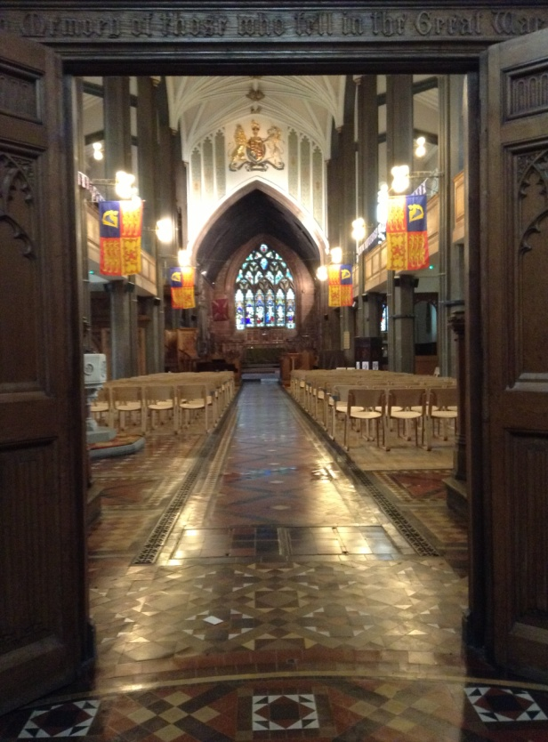

Readers contributions to the magazine are always welcome. Hard copy (hand written if easier) to the Rectory address or by email: to : [**st.marysstockport@gmail.com**](mailto:st.marysstockport@gmail.com)

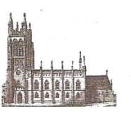Editorial discretion with regard to content and space available will apply.

**St Mary’s in the Marketplace**  
St Mary’s Rectory, 24 Gorsey Mount Street,  
Stockport, SK1 4DU.   
0161 429 6564 [www.stmarysinthemarketplace.com](http://www.stmarysinthemarketplace.com)



St Mary’s in the Marketplace   
“SECURING THE FUTURE FOR THE NEXT 100 YEARS” 50p

**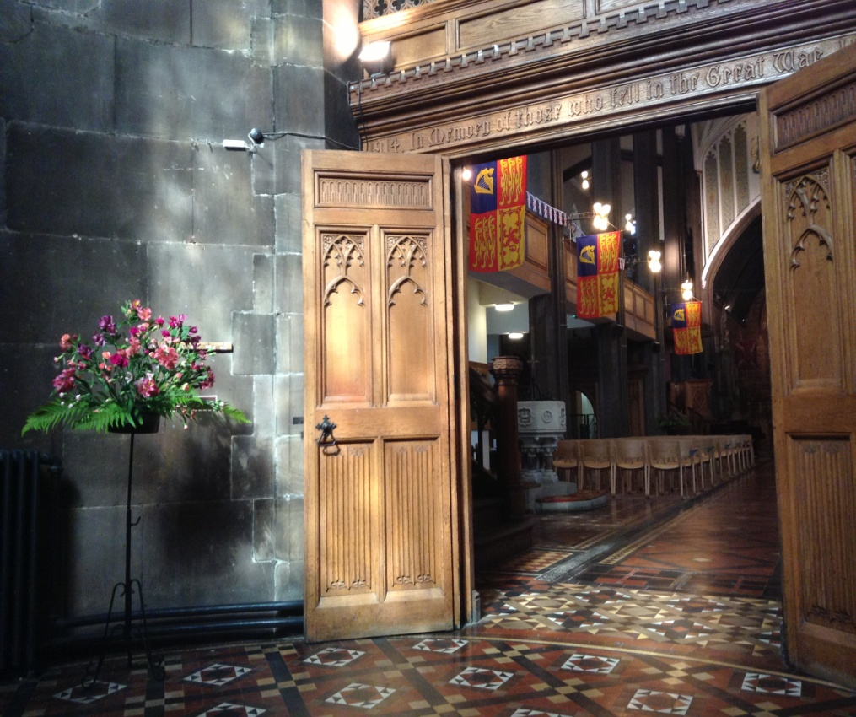**

Parish Magazine

July 2013

What a difference a year makes…..

****From the Rector’s Desk

Dear Reader .  
 .   
As I was strolling through the streets of London on a recent visit I looked up at a great public building – the London School of Hygiene and Tropical Medicine – part of London University, admiring its architecture and its association with the great names of science inscribed around its walls, Jenner, Lister, Pasteur and others. Then, an inscription caught my attention, nearer to street-level. “7th July 1926 This stone was laid by the Minister of Health the Right Honourable Neville Chamberlain”! That was in the last Century – historic personages, history in the making.

On 5th July 1813, 113 years earlier, “the great and the good” of Stockport will have gathered in the churchyard of St Mary’s for the laying of the foundation stone of the New Church, on the site of the ancient parish church, much of which has been demolished in the preceding three years. (I am grateful to Peter Arrowsmith for this information, given in his excellent book “From Castle to Covered Market – a History of Stockport Market Place” published in 2010 and available in the Tourist Information Centre shop).

For some strange reason the actual foundation stone that was ‘laid’ that day does not appear to be inscribed anywhere around the church, although I was lead to believe that the trowel used for the ceremony still exists somewhere in safe-keeping in Stockport!

The vision for a great new church to be built in that era, at very considerable cost, even in those days, was carried through to a successful completion in 1817, when the church was consecrated by the Bishop of Chester in August of that year. So this month sees a very significant anniversary – the 200th, in the life of our fine historic parish church, its re-building, and its completion in 4 years time when one would hope that there will be many celebrations once again.

**Cash Flow**

There is something exciting about going out and ordering extra items of furniture, kitchen equipment, pew cushions and nice things like that. Most these items have been paid for from donations to the interior fund generally or specifically and from private donations being payable directly to suppliers. A big thank you to everyone who has contributed. A big thank you to everyone who has given to the overall interior project.

Less attractive however is the prospect of paying the gas bill, the water rates, the electricians invoices, for the testing of fire extinguishers, and all the other things we need to pay for.

**The Treasurer is suffering from a serious cash-flow problem now finding it harder and harder to find the money to pay the bills and cover the Direct Debits and Standing Orders. Our income is “down” and has been for several months now and our expenditure is “up” as more little jobs need doing.**

C:\Users\sue\Downloads\jul13_crossword_grid.tif

Across

1 Proverbs describes her as being ‘of noble character’ (Proverbs 31:10) (4)

3 ‘Shall we go up again — — against the Benjamites, our brothers?’ (Judges 20:23) (2,6)

8 A descendant of Shem (Genesis 10:28) (4)

9 ‘Anyone who does not carry his cross and follow me cannot be my — ’ (Luke 14:27) (8)

11 Resentment(Ephesians 4:31)(10)

14 In Cain(anag.)(6)

15 ‘Such knowledge is too wonderful for me, too lofty for me to—’ (Psalm 139:6) (6)

17 Intense (1 Thessalonians 4:5)(10)

20 Third Order of the Roman Catholic Church(8)

21 ‘At midnight the cry rang out, “Here’s the bridegroom!Come out to — him”’ (Matthew 25:6) (4)

22 ‘My grace is sufficient for you, for my power is made perfect in — ’ (2 Corinthians 12:9) (8)

23 ‘As the — pants for streams of water,so my soul pants for you, O God’ (Psalm 42:1) (4)

Down

1 Nickname of popular First World War chaplain, the Revd G.A. Studdert Kennedy, — Willie (8)

2 Occasion of religious joy (Lamentations 2:22) (5,3)

4 ‘We three kings of — are’ (6)

5 Allegation or charge (Jude 9) (10)

6 Kind (1 Chronicles 12:33) (4)

7 ‘Open your — and look at the fields!’ (John 4:35) (4)

10 Also known as the Feast of Lights (John10:22)(10)

12 Area that saw the healing of two demon - possessed men and a herd of pigs stampeding to their deaths (Matthew 8:28) (8)

13 Forebear(James2:21)(8)

16 Name given to the first two books of the Apocrypha(6)

18 Esau sold his birthright for this (Genesis25:34)(4)

19 Rear(anag.)(4)

**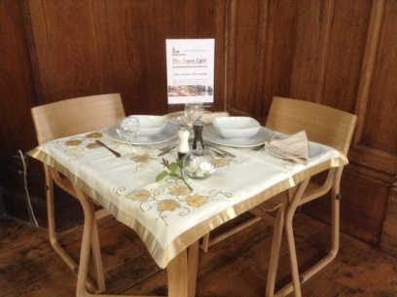The Nave Café**

Is now open…

The new arrangements for the running of the Nave Café are well underway with all the crockery and cutlery already delivered and stashed away – including those for banqueting as well as for the everyday running of the café.

We have a professional quality microwave, professional toaster and Paini grill. We have day dots, temperature probes, coloured chopping boards and all sorts of other “goodies”. We have several thousands of pounds worth of “kit” now, so no excuses for not getting on with the job in hand. Our semi-professional kitchen is ready to “GO”. Give or take … There are still items of general equipment to purchase, storage racking and of course the round tables we will need as well as all the table linen. We still require an electronic till, a professional standard coffee machine and at some point a professional quality deep fat fryer.

The snag was anticipated to be the actually running of the café / kitchen – but with a little bit (well quite a lot really) of help we have cracked that as well – at least for Tuesday, Thursday and Friday. For during the week (when we are open) the kitchen will be run by Pure Innovations Ltd – all on a voluntary basis – helping us to help them! That is surely what partnership working is all about.

For weekend opening we are on our own – so volunteers prepared to join the new Saturday “café” rota are most welcome – preferably also being prepared to undertake the Level 2 Food Hygiene training – but not strictly necessary if not actually preparing food.

Look out for our starter menu – and meeting the Nave Café team.

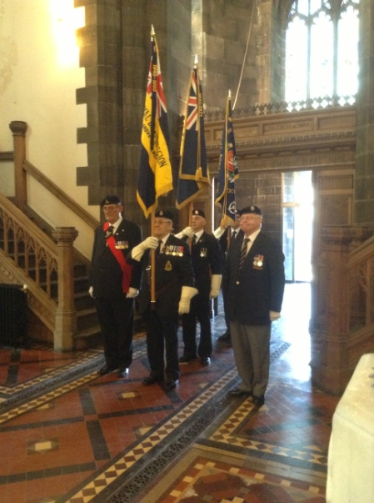

The Civic Service this year was in celebration of a new Mayoral Year, the 60th Anniversary of the Coronation of HM Queen Elizabeth II and the near completion of interior works to St Mary’s.

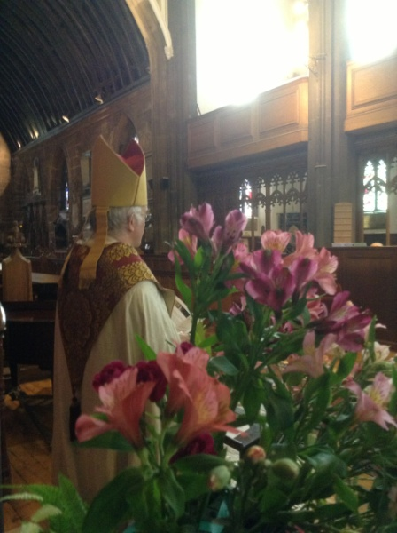The service was led by the Rector, with standards being received during the singing of the first hymn. Readings from Deuteronomy and Philippians were read by the Eamonn Boylan (Chief Executive of Stockport Council) and Cllr Chris Murphy (Mayor). The sermon was given by the Bishop of Chester. Assisting with the prayers was Rita Waters, Reader from St Matthews, Edgeley and our guest organist was Reg Holmes.

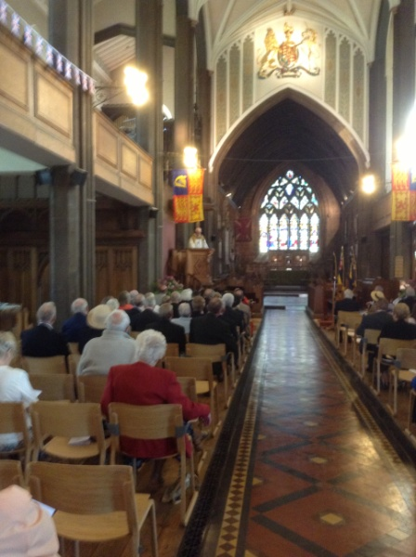

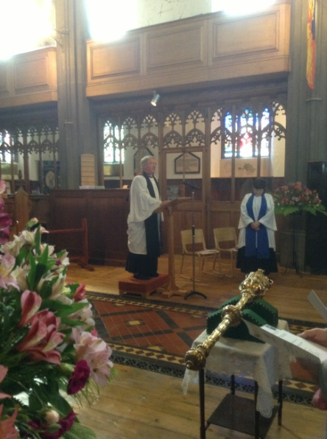We had chairs (delivered only days earlier), a lovely morning and slipping into the Tower before twelve noon, our steeple-keeper and members of the Chester Diocesan Guild of Church Bellringers (the President of which is our own Rector).

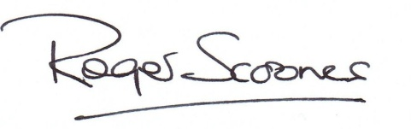Civic Sunday – 9th June

A beautiful sunny Stockport morning and our first official service since the near completion of the interior of the Church and the opportunity to hear the bells ringing once more.

It was a pleasure to be able to welcome The Worshipful and Mayor and Mayoress of Stockport, Cllr Chris Murphy and Dot Murphy, Bishop Peter and many others to this very special service.

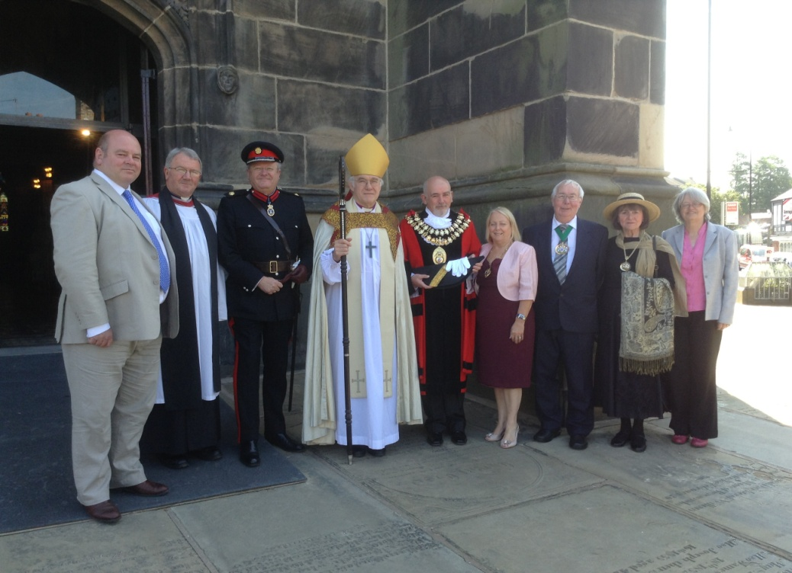

Shown above – Eamonn Boylan - Chief Executive Stockport Council; Roger Scoones, Rector, St Mary’s, Paul Griffiths, High Sheriff of Greater Manchester; Bishop Peter, Bishop of Chester; Cllr Chris Murphy, Mayor of Stockport; Dot Murphy, Mayoress, Cllr Mike Wilson, Deputy Mayor; Jacqueline Hawkins, Deputy Mayoress & Cllr Sue Derbyshire, Leader of the Council.

**Celebrating the 60th Anniversary of the Coronation of Queen Elizabeth II**

**The Big Lunch – held on Sunday, 2nd June** was an enjoyable occasion and an opportunity to spend some time together after the morning service. Raising the sum of £248.20 from the sale of tickets, income from the “bring and buy” and donations, the lunch made a profit of £176.42, which has been used to purchase a small freezer for the Nave Café.

**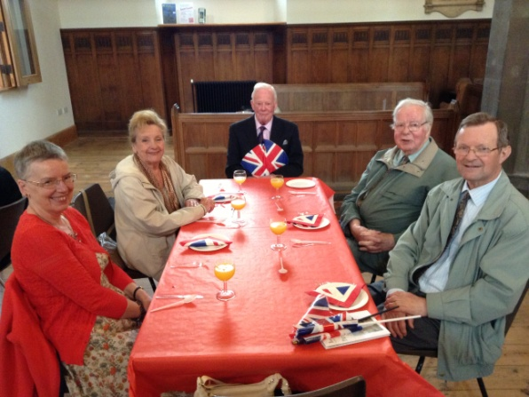**

**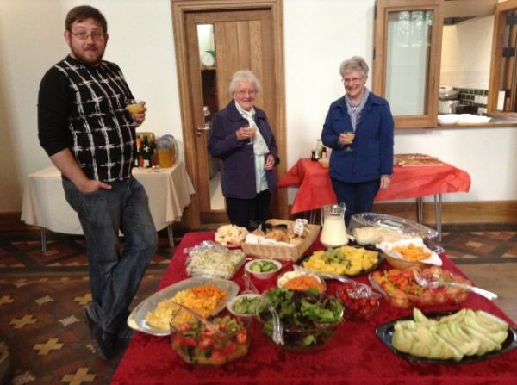**

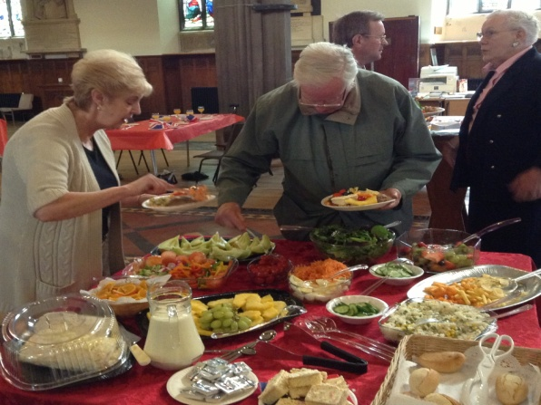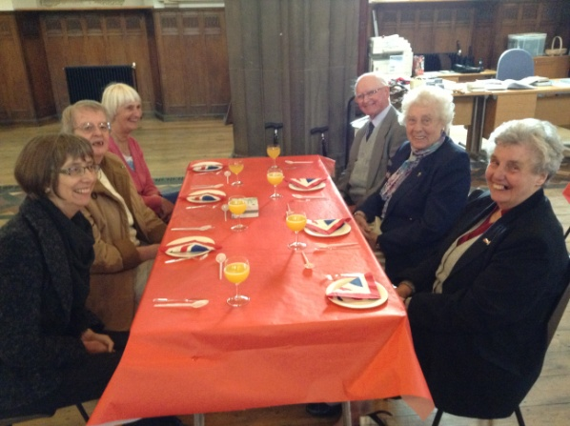

More photographs on the web-site at: www.stmarysinthemarketplace.com

**Welcome back to Stockport…**

**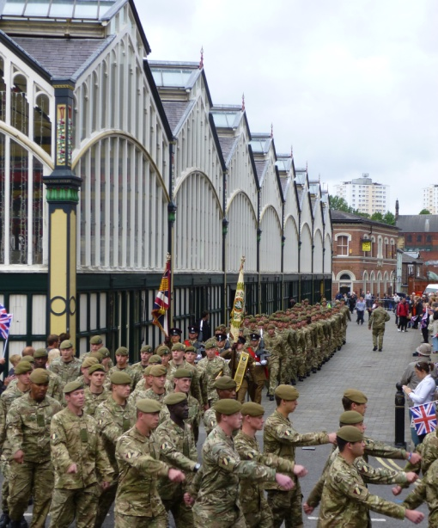** St Mary’s opened to welcome visitors coming into Stockport’s Marketplace on Thursday, 13th June when the 1st Battalion of the Mercian Regiment (Cheshire) returned to Stockport for a Homecoming March. Assembling outside the market hall, activities including the presentation of medals (to those soldiers from Stockport who have completed their first tour of duty in Afghanistan) by the Mayor. It is always nice to see the Marketplace alive with people and on this special occasion many were waving flags to show their support and appreciation.

It was a splendid sight to watch members of the Regiment (approximately 200 personnel, including a number from Stockport) march past St Mary’s.

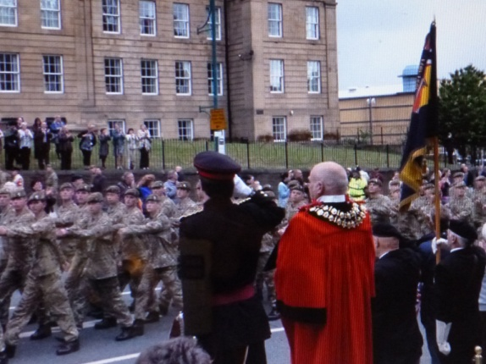 The parade route covered Millgate, Corporation Street, Warren Street, Bridge Street, Great Underbank, Chestergate, Mersey Street, St Petersgate and Wellington Road (A6) past the Town Hall where the Regiment took the salute from the Mayor. The parade ended at Stockport Armoury on Greek Street.

Three years ago, in November 2010, after a previous tour in Afghanistan, the Regiment was presented with the Freedom of the Borough on a similar Homecoming March. The Mercians were formed out of the Cheshires and two other regiments in 2007.

Indeed, in contrast to the sobering and sombre observancies of the centenery anniversaries of the First World War over the next four years, our own anniversaries will be quite a jolly contrast, in this century!

In the meantime, as is evident in the July edition of the magazine, and from the experience of all who are now coming to visit St Mary’s in these early days of this new era of life and miistry, there is surely much cause for rejoycing, as we give thanks to God for his wonderful provision for the life and ministry of this much loved and admired Parish Church into the 21st Century! Deo Gloria!



**The Nave Café**

**Café: Opening Hours:**

**Tuesday, Thursday, Friday & Saturday**

**09:00am – 03:00pm**

Our menu will be changed from time to time as our new team settle into life at St Mary’s. Our first regular menu is now available and you are advised to look out for our “specials” – for example, Saturday “ploughmans lunch” and “early afternoon cream tea”.

**Pew Cushions**

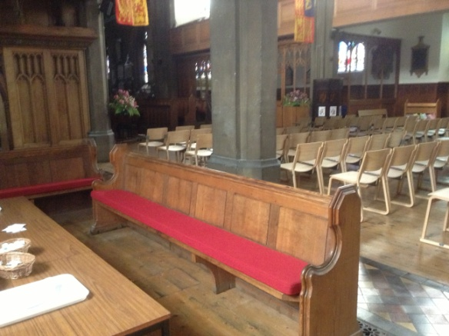If you have been in Church lately you cannot fail to have noticed that the remaining pews all have new cushions - made to measure and a perfect fit. In a warm wine colour they are designed to look (and feel) “warm” and to match the floor tiling. There are individual cushions in the ”sedilia” in case you have not noticed them.

The cushions have been suppled by Alpha Furniture Ltd of Beaconsfield. The new kneelers for the communion rail (6” in height) will be arriving shortly with the exisiting blue ones moving into the Memorial Chapel.

**Speaking of which ….. The Memorial Chapel**

Work on the Memorial Chapel isn’t quite finished, but the glazing is in, the new doors fitted and the area now multi-functional. We were more than happy in have with us recently the Diocesian Advisory Committee (DAC) who used St Mary’s as a venue for their June meeting.

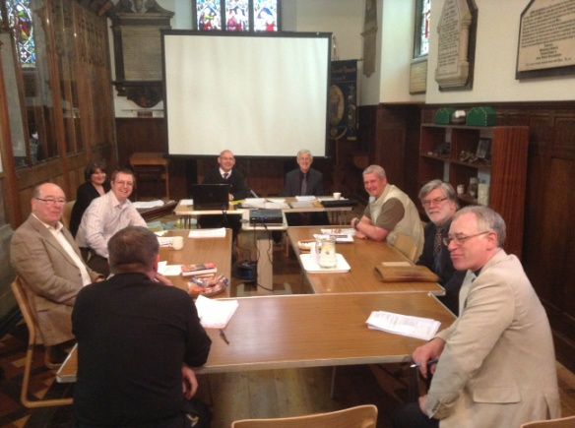

As a separate room the Chapel can be used for a variety of purposes, and has separate heating from the rest of the Church for those chilly evenings. The Parochial Church Council will be a regular user as future meetings will now be held at Church.

**At least it was a fine day…**

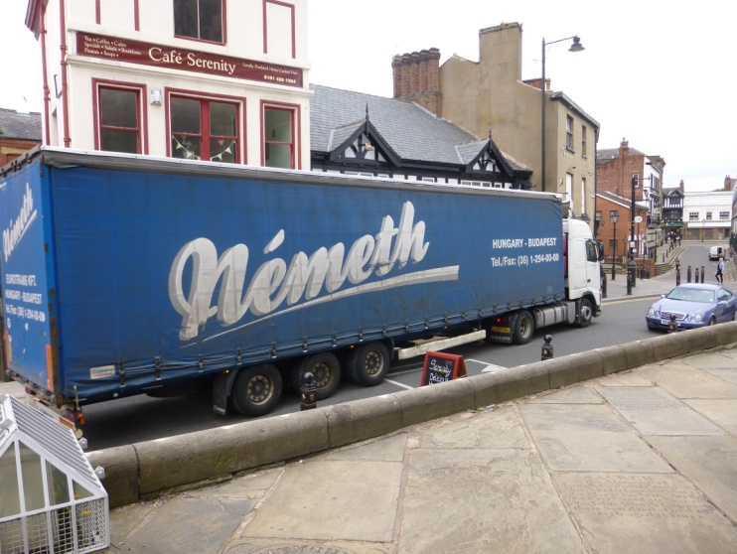It was an early start at St Mary’s to take delivery of the new furniture.

There has been days of negiotation with the suppliers, with Highways and other Agencies over the challenge of parking a 40ft articulated lorry on Churchgate to unload a lot of boxes.

Armed with a frying pan, bacon and barm cakes – the day began….

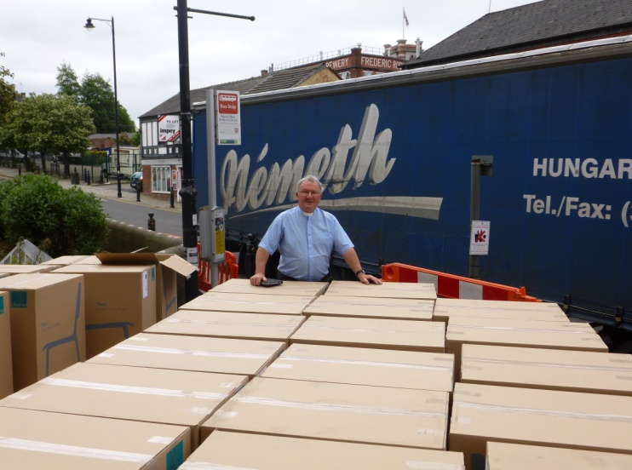Andy arrived from Solutions SK as did two fitters from Howe/Chorus. Then appearing in Church a Hungarian gentleman, waiving papers, but who spoke no English. The paperwork wasn’t in English either, but it was as it turned out the delivery note for our goods.

**We hope you like our new furniture.**

Now in Church we have 180 stacking chairs with a further 20 with arms. Six (three-seater) benches and four square tables. Not much change out of £40K (and that is well discounted from the normal purchase price). We have taken the recommendation of our Architect - John Prichard of Lloyd Evans Prichard and have changed the Faculty Application twice during the process of making the right choice.

Chorus Furniture is a relatively new company who launched their first produce range, the “Theo” in 2011. Designer Simon Pengelly has been awarded a Design Guild Mark 2012 for his Theo range. Design Guild Marks are awarded each year by the Worshipful Company of Furniture Makers for excellence in the design of furniture in volume production. Imagine what a delight, for us, to welcome Simon Pengelly and a team from Chorus Furniture (including the Managing Director) to St Mary’s to see our furniture in use and for them to take a set of professional photographs.

Originally our thoughts were with one of the Howe stackable chairs – and many of you will remember trying them out – and later with the Alpha ” Winchester”. Similar to the Howe “40/4” with a metal frame. Weight became an issue (especially considering the delecate tiled floor) and enter stage the new Theo. It won hands down on lightness, stackability, durability and of course style. And in the end…. on price for the bulk of the chairs we have bought.

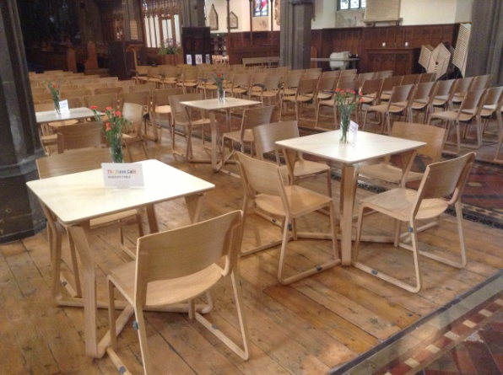

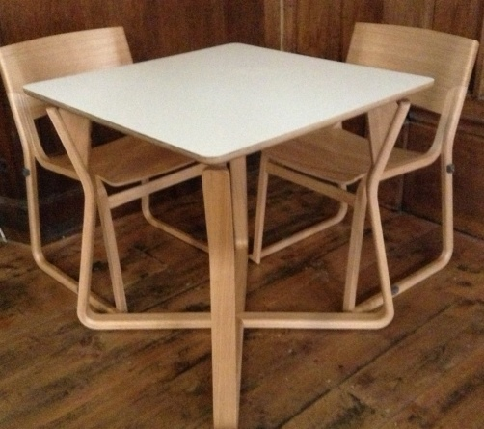

Are you a member of St Mary’s – can you spare us a little time to welcome visitors and keep the doors open once more?

We have been closed for awhile now – longer than originally expected – and further works will take place shortly to build the new chair store in the south aisle, but we must get back to “business as usual”

The roll of “Welcomer” (front of house) is no longer to serve cups of tea and crumpets - as in days of old – or to sit at the welcome desk waiting for someone to approach. It is to leave the kitchen and café to the catering team and to take a more pro-active part in meetings and greeting.

To walk up to visitors and ask them how they are – can you be of any assistance – would they like you to walk them round and give them a sort tour of the Church.

Maybe the visitor just wants to light a candle, visit the café area, or just to spend some quiet time alone. Maybe they just want some information as to what is happening – we need to promote what we are all about. Some may be happy, some sad, some seeking guidance, an appointment with Roger, a chat with Rita or just for **you** to spend some time with them.

**Can you make a commitment and join our “in-house” team – we very much hope so.**