Nutrition Plus, Inc.

121 Mays Rd., Winfield, KS. 67156
www.nutritionplusinc.com

Executive Director: Emily Roark (620) 221-2777 roark2@cox.net
Administrative Supervisor: Patti Brenn (620) 218-1811 pattibrenn@cox.net
Topeka Area Coordinator: Susan Morrell
(785) 230-7441 smorrell12@gmail.com
Menu Advisor: Jacque Zimmerman (620) 660-0236 jacque.nutritionplus@gmail.com

July is:

3rd – National Eat Your Beans Day
4th – National Caesar Salad Day
5th – National Graham Cracker Day
6th – National Fried Chicken Day
7th – National Macaroni Day
8th – National Freezer Pop Day
11th – National Blueberry Muffin Day
13th – National Beans N’ Franks Day
20th – National Hot Dog Day
22nd – National Mango Day
25th – National Wine and Cheese Day
(I highly recommend you celebrate this!
29th – National Lasagna Day
31st – National Avocado Day

Important Dates:

July 5th – Claims Due
July 29th – Checks/Direct Deposits go out
Last trainings of the year will be in August so keep your eyes out for emails with dates and locations.

Product Formulation Statement News!

We now have documentation for many more convenience items you serve! Rather than make all new packets for you, we will just be making a list with pictures and serving sizes for you to keep on hand in your daycare. The official documents will be in the Nutrition Plus office. I will create the list with pictures, double check the serving sizes, and get them to you asap. For now, here’s a sneak peak of the complete list you now have available!

July 2022

Bacon: Jennie-O Turkey Bacon 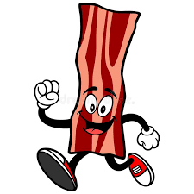
Beef: Fast Fixin Country Fried Steaks, Tyson Country Fried Steaks, State Fair Beef Mini Corn Dogs, Tyson Beef Mini Corndogs, AdvancePierre
Fully Cooked Flamebroiled Beef Patties, AdvancePierre Breaded Beef Fingers.
Bosco Sticks by Tyson ( 4" Breadstick Stuffed with Mozzarella Cheese), Farm Rich Breaded Mozzarella Sticks. 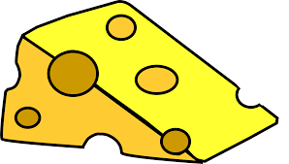
Chicken: Nuggets by Fast Fixin, Foster Farms, Hyvee, Kirkwood, Members Mark & Tyson. Chicken Fries by Kirkwood and Tyson. Chicken Patties by Fast Fixin, Foster Farms, Hyvee & Tyson. Chicken Strips by Fast Fixin, Foster Farms & Tyson. Popcorn Chicken by Tyson.
Corndogs: Foster Farms, State Fair & Tyson.
Deli Meat: Hillshire Farm Smoked Ham, Black Forest Ham, Honey Ham Oven Roasted Turkey Breast, Mesquite Smoked Turkey Breast, Combo of Turkey and Smoked Ham & Roast Beef. 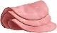
Fish: Fillets by Fisher Boy and Van de Kamps. Fish sticks by Gortons and Trident. 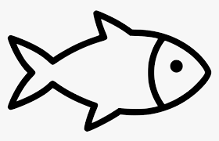
French Toast Sticks: Farm Rich.
Meatballs: Farm Rich, Hyvee, Rosina & Tyson.
Pancakes on a stick: Jimmy Dean. 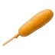
Pepperoni: Armour, Hillshire Farm, Hormel, Hyvee & Sugardale.

Hotdogs are creditable, as long as they do not contain byproducts, cereals, or binders/extenders (It says this on the front of the packages). Brands that have hotdogs that qualify, are Oscar Mayer Uncured Wieners, Ball Park, Nathan’s & Hebrew National.
We are extremely happy to be able to provide you with this documentation on all the new products so you can serve these items without additional meat alternatives!

Toilet Paper Roll Bees!

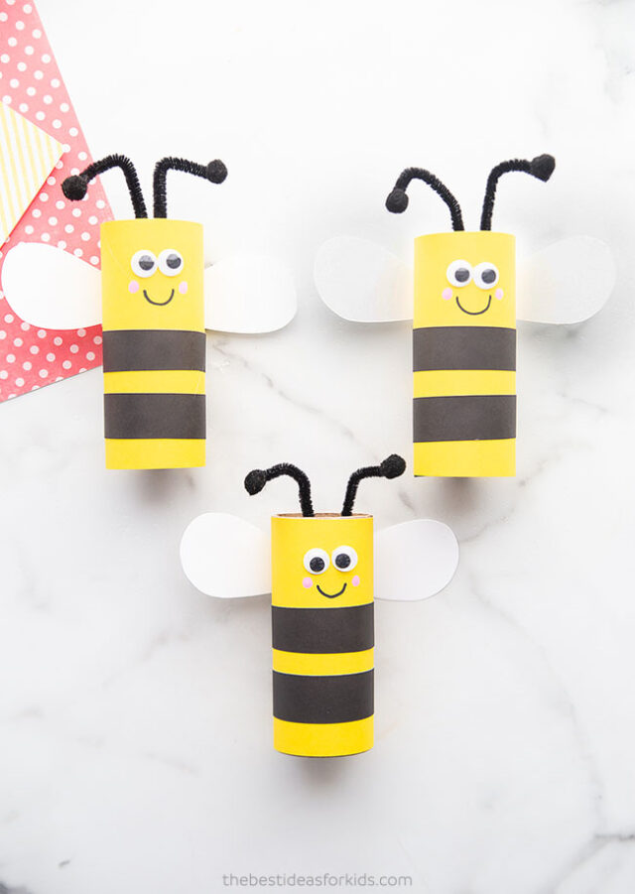

You will need:
Toilet paper rolls or paper towel rolls cut in half
Pink paint or marker
Black marker
Cardstock – white, black and yellow
Small googly eyes
Black pipe cleaner
Small black pom poms
Glue – Hot glue always works best but please supervise during use.

Instructions:
- Cut a rectangular piece of yellow cardstock to fit around the paper roll. Overlap the edges of the paper slightly and glue or tape along the seam.
- Cut 2 narrow strips of black cardstock. Glue around the paper roll to make stripes, leaving a space on top for the bee’s face.
- Add 2 googly eyes to the front of the paper roll.
- Draw the mouth on with a black sharpie or marker.
- Dip the end of a paint brush in pink paint and add 2 dots of paint on either side of the mouth to make cheeks. Marker will work in a pinch.
- Bend a black pipe cleaner into a “V” shape.
- Glue 2 pom poms onto each end. Glue the pipe cleaner to the inside top of the paper roll.
- Cut out two wings from white cardstock. Glue or tape to the back of the paper.
Homemade Mango Freezer Pops
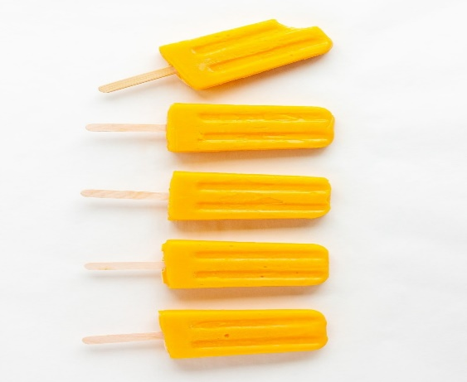

You will need:

4.5 cups mango chunks, fresh or frozen (thaw first if using frozen)
1/2 cup water
1 tbsp fresh lime juice
1/3 cup honey (or to taste)
(This batch will make 6 - ¾ cup popsicles. Double to make 12.)

Instructions:

Blend: Place all the ingredients into a blender and blend until smooth.
Fill popsicle molds: Pour mixture into popsicle molds.
Freeze: Freeze for at least 4 hours (preferably overnight) and enjoy!

Mango Smoothie
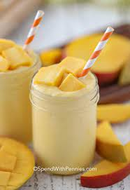

You will need:

2.5 cups peeled diced mango
2 cups sliced bananas
2 cup plain nonfat yogurt, or vanilla yogurt
2 cup crushed ice
Milk, or water, optional

Instructions:

Place the diced mango, yogurt, and ice in a blender. Blend or process until smooth. If the smoothie is too thick, add a little milk or water and blend again. Serve immediately. Enjoy!

