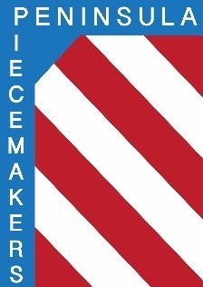
Peninsula Piecemakers Quilt Guild
P.O. Box 1295
Newport News, VA 23601

Board of Directors Meeting October 17, 2022

Attendance:
Board
President: Rhonda Gianturco (abs) Vice President: Karen Carr
Executive Treasurer: Natalie Hutchinson(abs) Executive Secretary: Lois Bates
Day Coordinator: Mark Fowler Day Treasurer: Lori Murdock (abs)
Day Secretary: Linda Tozier Night Coordinator: Calie Mowery
Night Treasurer: Debbie Martin (abs) Night Secretary: Susan Waddles

1. Vice President Karen Carr called the meeting to order at 5:04 p.m.

2. Mark made a motion to approve the minutes of the September 19, 2022 meeting. Calie seconded. Approved.

3. Treasurer’s report: not available

4. Old business:
a. Retreat: Nineteen people have paid their deposits which means we will not have to pay extra for the sewing room. There are a few more members thinking about going.

b. Symposium: Everyone agreed the day went very well. All seemed to be happy with their classes and the food was good. Thank you to the committee for their hard work.

c. Fall Festival was cancelled due to weather. Susan is writing a document for the future chairperson with all necessary information. She has returned all the quilts to their owners.

d. Programs: Karen is having a meeting on Tuesday, October 18 for anyone willing to plan programs for the coming year.

e. Zoom: More people are returning in person so it is not necessary. There were only a handful of people on zoom for the October meetings.

5. New business:
We discussed the December meetings. Karen will check with Denise to see if we are allowed to have food for the party. Karen is planning a few games.

6. Meeting was adjourned at 5:35 p.m.

Respectfully submitted,
Lois A. Bates
Executive Secretary

