Trinity Times
Volume 11, Issue 2
March & April 2023

Let’s Talk

Over my years in ministry, I have found that the greatest misunderstandings I have had with others have been through the use of e-mails and texts. Because of that, I have little use for either.

Number one, I have found them unreliable. Sometimes, they don’t get to me at all. Sometimes, they have been re-directed to my spam and deleted, and sometimes, I get them but don’t quite get the message. There are many times I have received them and got the wrong message or misunderstood the message. All of these things have also occurred with e-mails and texts which I have sent. So please don’t always expect me to always reply to an e-mail or texts. Some days I receive over 800 and if I tried to reply to every request or message, I would not have time to visit or write my weekly sermon. If you want to know if I got the message, call me or come by.

I truly believe that the best way to communicate with others is to be able to look them straight in the eyes and talk with them. After reading Matthew 18, I believe this is what Jesus thought too.
1

Don’t get me wrong. For a pastor to stay informed,

Do not get me wrong. In today’s world for a Pastor to stay informed, they have to read their e-mail and texts. But if something is really important, then it should be important enough to tell someone in person, or at the very least talk to them by telephone where oral and or visual communication can take place.

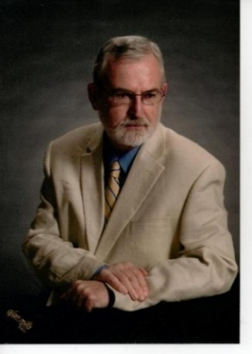
I have decided that in most cases, it is best not to answer questions or problems that might be misunderstood by e-mail or texts. I prefer to look my friends or foes in the eyes and talk face to face. It is my experience that when I do that, I keep more friends and lose more enemies, and I ask that in most cases you call or come to see me if you can. If you need me, let’s talk.

In Christ,
Pastor doug

Trinity United Methodist Church
1160 Trinity Church Road
Newberry, SC 29108
803-276-1245 Office
803-542-0082 Pastor Cell
dobenton@umcsc.net
trinityumcnewberry@gmail.com
www.trinityumcnewberry.net
PLEASE VISIT OUR WEBSITE
AS OFTEN AS YOU CAN!

Church Secretary: Peggy Bogart
Head Usher: Harry Longshore
Choir Director:
Organist: Eddie Welborn
Alternate Organist: Phyllis Sanders
Video Technicians: Josh Pitts, Foster Senn, Bryan Waldrop
Newsletter Editor: Harriet Stevenson

We are a caring church and want to share your concerns. Let us know if you or someone you know would like to share a prayer request with us. We will be happy to pray for you. To add or remove names, contact Peggy Bogart, Church Secretary, or Harriet Stevenson.
Nursing Home:
Continued Prayers: Shirley Berry, Boyd Hendrix, Jeannette Poag, Lavone Coates, Pastor Doug and Carrie, Frieda Kesler, Alice Longshore, Sonny Longshore, Harry Longshore, Bryan Waldrop, Jed Brehmer
Family and Friends of Trinity: Woody Kreuzinger (Carrie’s father), Faith Benton (Pastor’s niece), Sandra Bodie, Charlotte Berry, Buddy Waldrop, Family of Trudy Force Brown

NEEDED: LEADERS AND TEACHERS FOR VACATION BIBLE SCHOOL and CHILDREN’S CHURCH! Let Clarissa Hendrix know if you are interested.

1- David Morris
1 – Ralph D. Waldrop III 14- Kathryn Armstrong
3 – Grady Senn 15 – Jane Pollard
4 – Corban Cutshall 15 - Joan Morris
5 - Ken Morris 15 – Gavin Wilson
6 – Cheryl Longshore 15 – Wyatt Wilson
8 – Bobby Pollard 16 – Kevin Bundrick
8 – Joyce Suber 25 – Harriet Stevenson
10 – Barbara Rogers 26 – Wilson Senn
10 – Wayne Black 39 – Jamie Capps
12 – Roger Longshore
13 – June Pitts

14- Bill Lominack
2 - Steve Morris 15- Bridget Bouknight
5 – Mia Kate Brehmer 15 – Maverick Temples
7- Foster Senn 17 – Suzana Pruitt
8 – Ann Senn 19- Lauryn Wilson
8 - Terry Woodward 22- Melissa Spicer
10- Henry Senn 28- Nancy Pitts
11- Sylvia Holmes
11- Diane Waldrop
13- Charlie Rogers

2

For March and April

March 5 – Watkins Martin
March 12 – Clarissa Hendrix
March 19 - Linda Lominack
March 26- John Pollard

April 2 - Lorrie Capps
April 9 – Phyllis Sanders
April 16 – Gary Holmes
April 23 - Debbie Lipscomb

Greeters be in Narthex by 10:40 a.m.

March 5 – Crystal Waldrop
March 12 – Dixie Waldrop
March 19 – Lynn Mohler
March 26 – Kelly Morris

April 2 – Sharon Baughman
April 9 – Harriet Stevenson
April 16 – Josh Pitts
April 23 – Sylvia Holmes

Acolyte Schedule
March 5 – C.J.Griffen
March 12 – Kelly Morris
March 19 – Noah Mohler
March 26 – Kruz Bouknight

April 2– Wyatt Pitts
April 9 – Kelly Morris
April 16 – Sylvia Holmes
April 23 – Kruz Bouknight
ACOLYTES: Be robed and in narthex by 10:50 a.m.

Contact Kelly Morris (803) 924-5715 if you are unable to serve or if you need to switch with someone, so we can make changes in the bulletin. Readers, you will receive a
Bulletin in the mail with scripture included for your assigned Sunday.
3
TRINITY WOMEN’S CLUB - The TWC sponsored their annual Soup Sunday on January 26. Thanks to all those who contributed financially as well as those women who made soup, sandwiches, corn muffins and pound cake! Wow, we have some awesome cooks at Trinity!

We collected over $350 and made a donation to GAAP (God’s Abundance for All People) Food Bank at O’Neal Street UMC Church and a donation to the Pomaria Food Bank. Sharon Baughman volunteers at GAAP. They are in need of more volunteers. If you are interested, talk to Sharon or Pastor Darlene at O’Neal St. Thank you, Sharon, for serving others in this way.

Our next meeting is Monday, March 6, at 5:00 p .m. in the Fellowship Hall.

SILVER AND GOLD – The Silver and Gold travelled to Clinton for their annual lunch at Dempsey’s Pizza. We all enjoyed the PIZZA!

Thanks to Jane Pollard for being in charge of the Bake Sale in conjunction with the sale of the Boston Butts. It was a huge success. Thanks to all who donated items to the Bake Sale, especially those outside of Silver and Gold, who weren’t expected to bake anything. Y’all are awesome! We collected over $600 which will be used for a community outreach project.

We will meet again on March 8 for a covered dish lunch in the Fellowship Hall. Meeting time: 11:30 a.m. We will discuss what projects we will undertake with the money we raised from the Bake Sale. We will also play Bingo with our new Bingo Game Set donated by Wilson Senn. Thank you so much, Wilson.

The April meeting of Silver and Gold will be announced after the March meeting.

Trinity Men’s Club – The Trinity Men’s Club will meet on Wednesday, March 8.

Thanks to the Men’s Club for all who helped make the sale of Boston Butts such a great success! The men stayed up all night cooking and we want them to know we appreciate all they do for our church. Without the fundraisers that the Men’s Club perform each year, Trinity would not be able to do as much financially. The boston butts were delicious by the way!!! April meeting will be April 5 at 7:30 p.m.

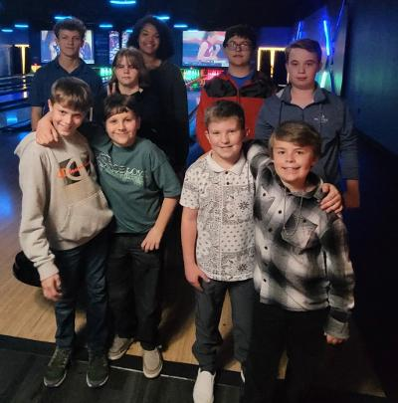
METHODIST YOUTH FELLOWSHIP (MYF) –
Erin Pitts, Leader
The MYF went to Stars and Strikes for bowling and arcade games (see photo) on Sunday afternoon, Feb. 26. They will be delivering the donations and canned goods from the Souper Bowl of Caring as well as volunteering at Pomaria Food Bank on March 11 from 11:00 a. m. to 2:00 p.m. On March 12, after the church service, the MYF will hold a BBQ Plate fundraiser in the Fellowship Hall for donations only. Their regular meeting at church will be March 26th at 5:00 p.m. In April, they will attend a movie at the 25 Drive-In Movie theater in Greenwood. Time TBA later. The regular meeting will be on April 30 from 5:00 – 6:30 p.m.
Members of the 2023 MYF are: Kella Battiste, President; Hunter Black, Josh Black, Kruz Bouknight, Noah Mohler, Jessi Pitts, Sami Pitts, Wyatt Pitts, and Maverick Temples.

Calendar for and 2022

March 6 Trinity Women’s Club @ 5 :00 p.m.
March 8 Men’s Club Meeting & Dinner @ 7:30 p.m.
March 8 Silver and Gold – 11:30 a.m. Fellowship Hall – Covered Dish
March 12 Daylight Saving Time Starts at 2:00 a.m.
March 13 Administrative Council Meeting @ 6:30 p.m. - CANCELLED
March 15 Deadline to apply for Frank Sr. and Audrey Senn Academic Scholarship
March 17 St. Patrick’s Day
March 20 First Day of Spring
April 2 Palm Sunday Service @ 11:00 a.m.
April 3 Trinity Women’s Club @ 5:00 p.m.
April 5 Men’s Club @ 7:30 p.m.
April 6 Maundy Thursday Service @ Trinity at 6:00 p.m.
April 7 Good Friday Service @ New Chapel at 6:00 p.m.
April 9 Easter Sunday – Information on service at Trinity TBA
April 10 Administrative Council Meeting @ 6:30 p.m.
April 22 Church Spring Clean Up Date – 9:00 a.m. – 1:00 p.m.

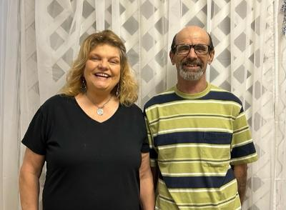
Welcome New Members
Lorrie and Jamie Capps.
Lorrie and Jamie come to us from Grace LutheranChurch. Their
grandson, Maverick Temples, will be joining Trinity later. Lorrie and Jamie have a passion for working with youth and they look forward to being a part of our Trinity church family. Please welcome them when you see them at church 4

. When Is Holy Week?
Here are the dates for Holy Week for 2023:
Sunday, April 2 - Saturday, April 8.
Easter is on Sunday, April 9.
Important Dates of Lent | Significance | 2022 Dates
Palm Sunday | Celebrates Jesus's triumphant entry into Jerusalem | April 2, 2032 -11:00 a.m. Service at Trinity
Holy Week | The week leading up to Easter | April 2 – April 18, 2023  NOTE: Holy Week does not include Easter
Maundy Thursday | Commemorates the foot washing and Last Supper of Jesus Christ with the Apostles | April 6, 2023- Service at Trinity at 6:00 p.m.
Good Friday | Commemorates the crucifixion of Jesus and his death at Calvary | April 7, 2023 – Service at New Chapel at 6:00 p.m.
Holy Saturday | Commemorates Jesus' body resting in the tomb | April 8, 2023
Easter Sunday | Celebrates the resurrection of Jesus from the dead and his victory over sin and death. Easter Sunday is  not a part of Holy Week. | April 9, 2023- Sunrise Service (7:00 a.m.) followed by Breakfast and Regular worship service at (11:00 a.m.) at Trinity.

5
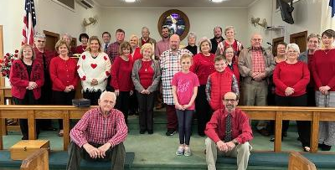
Wear Red Sunday and Recognition of American Hearth Month - Feb. 19, 2023 – This photo and an article will appear in the April 2023 issue of the United Methodist Advocate newspaper. Thanks to all who supported this important outreach ministry.

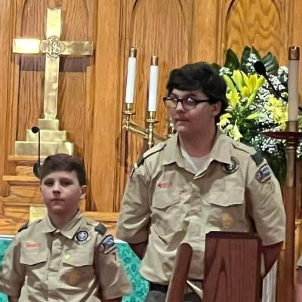

Josh and Hunter Black

On April 22, starting at 9:00 a.m., we will hold our annual Spring Clean Up Day at Trinity. We hope those who are able will show up with a positive attitude and a desire to work to make Trinity a more welcoming church. Things we will be working on include cleaning up rooms after installation of blinds, work on History Room, work on Adult Sunday School Room, beautification around church, etc. There will be a sign-up sheet in the Narthex in early April. We would like for all organizations of the church to be involved, including youth.

6

DISCERNMENT PROCESS
LEADING TO DISAFFILIATION

As you know, The United Methodist Church is going through a very difficult time right now. At a congregational meeting held on January 8, 2023, in the Fellowship Hall of Trinity, Pastor Benton, discussed and handed out information on disaffiliation. Later in February, Trinity had two church meetings immediately after church service. One was to explain the topic of disaffiliation and the discernment process and the other was to vote on entering into the discernment process. Pastor Benton, Craig Waldrop and Michael Bouknight were facilitators at the first meeting and Craig and Michael facilitated the second meeting. At the second meeting, we voted unanimously to enter the discernment process. We are now waiting for more information from the pastor or the Greenwood District.

You may find the following blog posts written by Rev. Josh McClendon to be helpful in understanding where we are and how we got here. If you have other questions, call Pastor Benton.

McClendon ‘Breakdown’ series to help clarify UMC conflict.

In an effort to share his perspective on the current conflicts in The United Methodist Church, one South Carolina UMC pastor has written a series of blog posts titled “Breakdown “and to date consist of eight reflections. The Rev. Josh McClendon, pastor of Pisgah UMC, Florence, said he wrote the posts to be a resource for people. “In the face of our denominational woes, the most common refrain that I hear from Methodists everywhere is that they feel uninformed,” he said.

The series can be found at https://joshtmcc.wordpress.com/

***************************************************************************************

* Holly Myers was selected as the Teacher of the Year at Dutch Fork High School.
* Kathryn and Charleigh Armstrong will be performing in the Newberry County School District’s play, The Lion King, with students from schools all over the district. There will be four performances at The Ritz in mid-March.
* Noah Mohler made the Varsity Golf Team at Newberry Highschool as a freshman and is playing as No. 1 on the team.
* Kella Battiste is playing on the Ninety Six Travel Volleyball Team and recently scored the winning point for her team.
* Maverick Temples was selected to play on the Reuben Dodge Ball All-Star team which will be playing against other elementary schools at Newberry College on M arch 18 from 10 a.m. to 2:00 p.m.
* Josh and Hunter Black received their Merit Badges during the Court of Honor at St. John’s Lutheran Church in Pomaria recently.

7

Trinity United Methodist Church
1160 Trinity Church Road
Newberry, SC 29108

