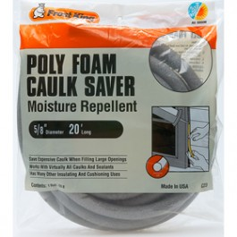
Doberman Puppy Ear Supply List
- Frost King 5/8” Foam Backer Rod - can be purchased at Lowes or Home Depot in the window/ door insulation isle for approx $3.99 a package.

- (1) roll of duct tape any color.
- 1 inch rolls of Johnson and Johnson POROUS Zonas tape – can be found at your local pharmacy for approx $1.99 per roll or through Amazon.com. Order at least 24 rolls. You’ll need them!
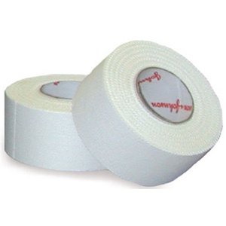
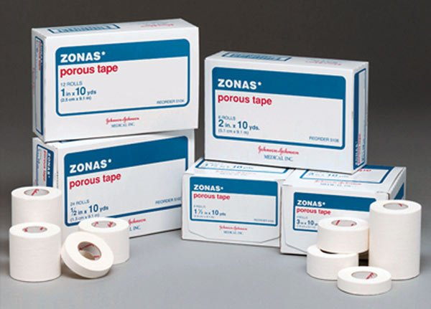

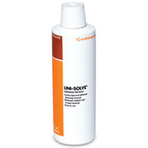
- Recommended (1) bottle of Uni-Solve Adhesive Remover 8 oz bottle – can also be purchased at your local pharmacy (some may have to order) for approx $14.99 a bottle. I have some available most times for sale for $15.00

***Please remember not to tape the puppy’s ears too tight and to go with the direction of the natural fold on the inner part of the ear.
If you need help with the ears, please contact me. I am happy to go over it with you as many times as needed. I also have instructions on my website to help. www.jamboloudobermans.com

