MARCH/APRIL 2022

Happy Spring! Wishing everyone a new season
of hope & happiness. It’s thrilling to see buds on trees and flowers
poking their heads from garden soils, not to mention birds & animals
bringing new life into the world! All of this is good! Hope you have a joyous season!

SAVE THE DATE
Come join your Alumni
for a casual gathering of the

GHHS Class of 1967
at our
55 Year Class Reunion

August 20, 2022

Mark your calendar now!
Look for your detailed invitation
in June

reunion contact
mrshola@sbcglobal.net

Just in case it was “lost” in your email box, this “save the date” announcement card for our 55th casual class reunion was sent April 5, 2022 to those alumni who have shared their email addresses with us. A detailed invitation will also be sent to you by email sometime in June. Those folks for whom we have no email addresses have been sent save-the-date postcards and will be sent invites via the U.S. postal service.

SPOILER ALERT: For those beginning to have difficulty driving in the dark, this reunion will be held earlier than in the past so that those who want to leave while it is still light, may do so.

As the announcement card says: Mark your calendar now!



Our Traveling Alumni - April finds some of our alumni traveling. Those that have been are:
Amy Roman Kostka, with husband, Bill, and other family members boarded the Odyssey of the Seas cruise ship at the port of Fort Lauderdale, FL in early April and sailed to the Caribbean visiting Oranjestad, Aruba, and Willemstad, Curacao;

Rhea Jones Ashmore headed for Spain beginning April 4, 2022; some of the cities she explored while there were Granada, Sevilla, and Salamanca;

To help celebrate the Easter holiday, Tawny Owens Rollheiser was on her way to Phoenix, Arizona, April 15th to visit her son’s family which includes two grandchildren;

And, Peggy Terry Berteau with hubby, Bob, decided to board the Celebrity Apex cruise ship for a long awaited trip of leisure.

Kudos are extended to – Tawny Owens Rollheiser & family as they announced March 19, 2022, that her son, Jeff Newell, has been made head pro at Desert Forest Golf Club in Carefree, AZ. Since he received his PGA card, he has worked as an assistant & head pro at various courses over the last 25 years. Phoenix is home to Jeff and his wife, Jodi, and children, Taylor & new son, Maddox.

Also in March, Barbara Filipski Bunsey received her spring edition of “Trend & Tradition” magazine published by Colonial Williamsburg. Upon viewing it, she was pleasantly surprised to see that one of her designs was included in it! The issue featured “Art from the Heart”, and Barb’s design was one inspired by something she saw when visiting Williamsburg several years ago.

Cindy Ruggerio Rifici and family upon the March 29, 2022, induction of her brother, Tony Ruggiero, into the Lawrence Livermore National Laboratory (LLNL) Entrepreneurs’ Hall of Fame. He was part of the third class of inductees, who have been honored for developing technologies during or after their Lab careers that created major economic impacts or spawned new companies. While Tony passed away in March 2018, he joined LLNL in 1990 and his 18-year career was highlighted by significant research & development advances in ultrahigh bandwidth laser optical free-space communications, as well as in photonics, laser technologies & optoelectronics which led him to start a successful venture known as Sierra Photonics. It became so successful in producing technologies that it caught the eye of Google. Tony guided the company through a smooth acquisition by Google X LLC.

To Peggy Terry Berteau, and husband, Bob, as they celebrated their 52nd wedding anniversary on April 11, 2022, and,

A belated birthday wish to former faculty member, Dennis Blue, who celebrated his 82nd birthday on February 27, 2022! Mr. Blue has recently been recovering from a virus pertaining to vertigo, so we also hope that he is now feeling 100%!!

Congratulations to all!

Thinking of – Susan Said who had been hospitalized for a week and then in rehab for 3 more due to heart failure issues. While she is now at home, she fatigues easily and becomes weak.

Audrey Sopko & Dusty Bowling whose daughter, Keleigh, continues to recover from her long stay at Cleveland Clinic Hospital, and,

Mary Chadwick who was told in March that her metastatic breast cancer has returned. Mary was having a PET scan and an MRI several weeks ago to determine course of action.

We are thinking of all of you!

Condolences to – Nico Bujak & family upon the mid-March passing of Nico’s mother, Maria, age 97. Mrs. Bujak was mother to six children, grandmother of 15, great-grandmother to many and great-great-grandmother to several. Mrs. Bujak was born in Salamanca Guanajuato, Mexico, and was one of 14 siblings. Nico said that his Mom did not judge anyone, accepted all & made everyone feel the joy of family and being loved. Her wit & humor brought a smile to all who knew her.

“Death leaves a heartache no one can heal. Love leaves a memory no one can steal”

Newsy Reflections & Tidbits: The “Lady Bulldogs” celebrated St. Patrick’s Day with lunch at 1pm at Danny Boy’s in Broadview Heights on March 12th. One stipulation was to remember to wear green!! Those who participated were: Leslie Mroz Readinger, Sharon Travagliante Weitzman, Helen Steblinski Cejer, Rosie Martinovich Spatney, Gayle Glowick Konet, Kathy Schneider Nowack, Linda Sindelar Steffen, Audrey Sopko, Jan Wroblewski Hola, Linda Wike Calkins, Nancy Levis Knowlton, and Peggy Terry Berteau.

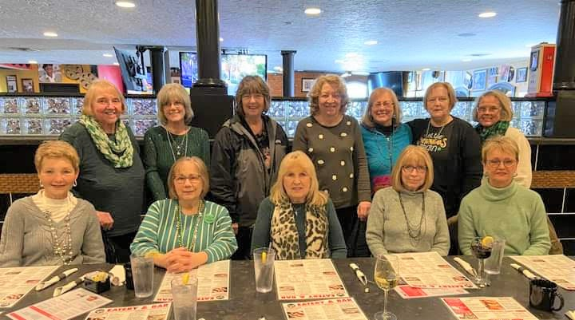

♥ ♥ ♥ ♥ ♥ ♥ ♥ ♥ ♥ ♥

And Ken Zielaskiewicz offered the following tidbit that should put on smile on your face:

God Created Seniors....................before we were seniors in 1967………
On the 8th day - God created Seniors. Most seniors never get enough exercise. In His wisdom God decreed that seniors become forgetful so they would have to search for their glasses, keys, and other things, thus doing more walking. And God looked down and saw that it was good.
Then God saw there was another need. In His wisdom He made seniors lose coordination so they would drop things, requiring them to bend, reach, and stretch. And God looked down and saw that it was good.
Then God considered the function of bladders and decided seniors would have additional calls of nature,
requiring more trips to the bathroom, thus providing more exercise. God looked down and saw that it was good.
So, if you find, as you age, you are getting up and down more, remember it's God's will. It’s all in your best interest even though you mutter under your breath.
Nine Important Facts to Remember as We Grow Older:
#9 Death is the number 1 killer in the world.
#8 Life is sexually transmitted.
#7 Good health is merely the slowest possible rate at which one can die.
#6 Men have two motivations: hunger and hanky-panky, and they can't tell them apart. If you see a gleam in his eyes, make him a sandwich.
#5 Give a person a fish and you feed them for a day. Teach a person to use the Internet and they won't bother you for weeks, months, maybe years.
#4 Health nuts are going to feel stupid someday, lying in the hospital, dying of nothing.
#3 All of us could take a lesson from the weather. It pays no attention to criticism.
#2 In the 60's, people took LSD to make the world weird. Now the world is weird, and people take Prozac to make it normal.
#1 Life is like a jar of jalapeno peppers. What you do today may be a burning issue tomorrow.

Until the next issue, Go Bulldogs!!!
Your loyal editor,
Gail Russler Meyer

