
Concord Mt. Diablo Trail Ride Association
“Celebrating Over 50 Years On The Mountain”

Application For Membership(please print or type in your responses)

Last name, first and middle names: |  | Last name, first and middle names:

Street Address:

City: |  | Zip: |  | Contact Phone:

Mailing Address (if different):

Email Addresses:

Children (under age 26): |  | - Name: |  |  |  |  |  | Birth Year:
- Name: |  |  | Birth Year: |  |  | - Name: |  |  | Birth Year:

Do you own a horse(s)? No Yes If YES, how many? _____

Riding preferences: Western English Trail Other ______________

We are happy that you have chosen to apply to become a member in our equine and recreation club. This application process requires that you (A) attend a Board of Directors meeting to introduce yourself and ask any questions you may have, (B) attend a general membership potluck social meeting to meet other CMDTRA members and (C) assist the club staff at a potluck (or volunteer at another club event). The Board of Directors can then complete the review of your application and approve your membership.

Process: Please fill out this application and submit it with a check for $285.00 which includes the Membership Application Fee ($150.00), two months Membership Dues (2 x $50 = $100) and a key fob purchase ($35) to gain access, via our security gate, to participate in all our amazing benefits. Once your membership is approved you will receive a CMDTRA Membership Card with safety information. (If for any reason the process is not completed the above listed fees will be refunded.)

Other Benefits of Membership Include:

- Monthly membership meetings
- Barbecue social events
- Large clubhouse, and spectacular view
- Swimming Pool and picnic grounds
- Hiking and Camping (with some restrictions)
- Reduced rate on rental of facilities
- Boarding facilities & horse trailer parking
- Wash racks and grain/tack rooms
- Two large riding arenas (jumps available)
- Round pens and dressage arena
- Pony club affiliated (any ages)
- CSHA Member

(application continued on next page)

Responsibilities of Membership: CMDTRA is a “not-for-profit” organization, owned and managed by members, therefore, volunteer support is essential to the maintenance and improvements of our club. Members are required to contribute at least 8 hours/year, or they may instead choose to pay $100 towards hiring a replacement for the tasks. We have varied and fun activities for you to contribute your talents: horse events, work parties, maintenance of grounds or special projects, all of which offer you the opportunity to meet new friends and enjoy our beautiful club property.

I (we) hereby apply for membership in the Concord Mt. Diablo Trail Ride Association, and if accepted as a member, agree to abide by all the rules set forth in the bylaws.

Signature: |  | Date:
Signature: |  | Date:

Mail your application to: CMDTRA, Attn: Membership, P.O. Box 419, Clayton, CA 94517 Or Email to membership@cmdtra.org (and present your payment at the required Board Meeting)

For Office use only
Dates attended required meetings: | Board Meeting: |  | General Meeting: |  | Volunteer Date(s):

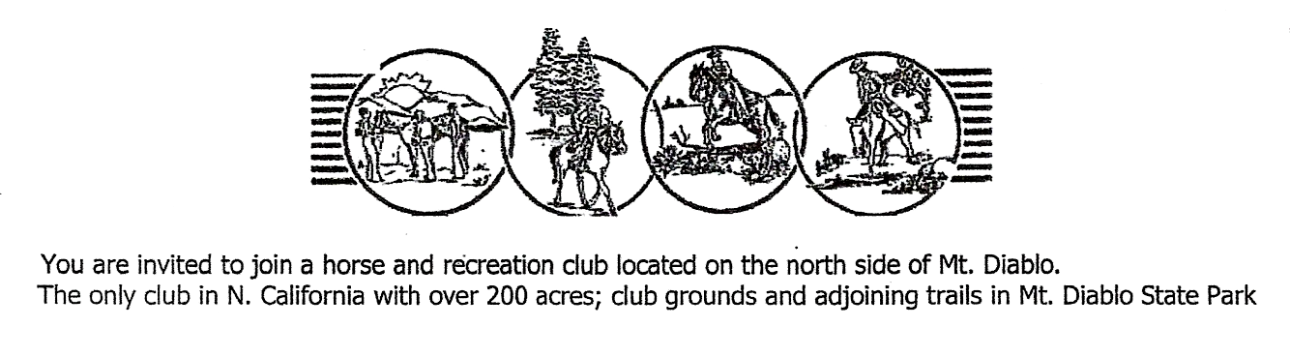

Website: CMDTRA.org Do check out the “calendar” tab for upcoming events!

