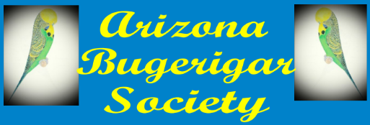

Chandler 2 day Show
April 21 & 22, 2018
Judging Begins at 9:00 A.M.
Boys and Girls Club of Chandler
300 E. Chandler Blvd.
Chandler, Arizona
Judges:
Saturday; Bob Wilson, Missouri
Sunday; Larry Moore, North Carolina
Show Secretary: George Hollingsworth
Excel and email entries will be accepted until 9:00 P.M. on Wednesday, April 18th. If entry is received by the no later than the Wednesday deadline entry fee will be $2.00 per bird, with a cap of $30. Entries received after the deadline will be $3.00 per bird with a $45.00 cap. Email entries to George at outbackbirds@cox.net
All entry fees MUST be paid before judging begins.
The AZBS follows the BAA Schedule of classes

