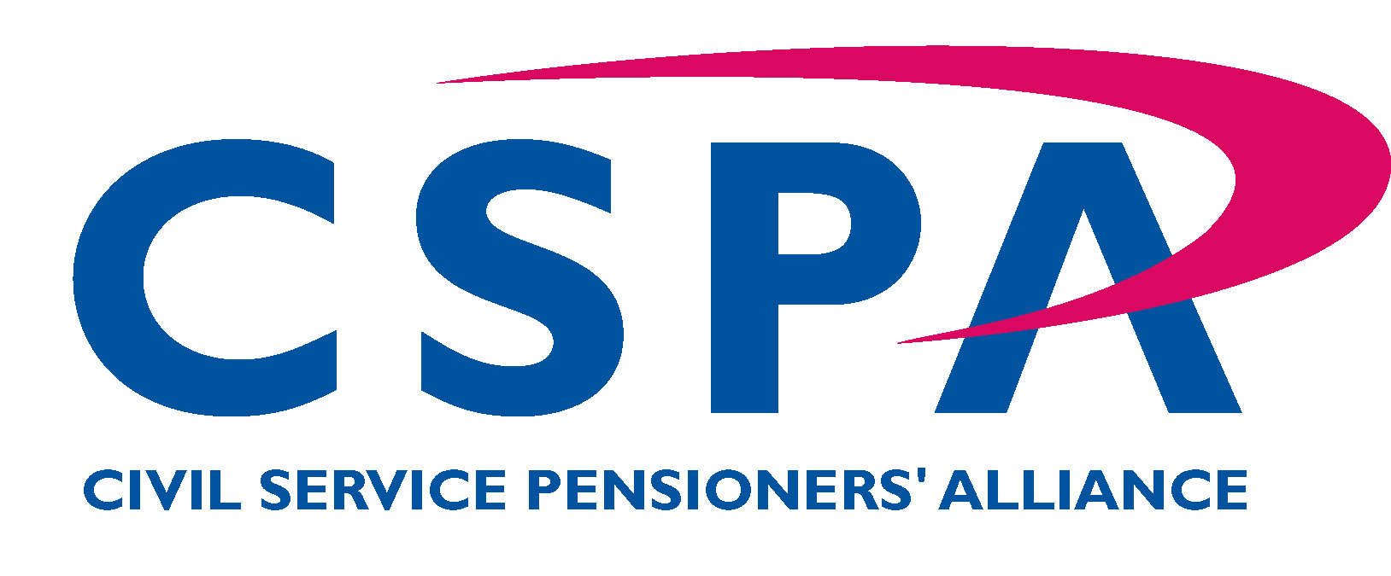

Northern Ireland Branch

APPLICATION FOR CSPA ASSOCIATE MEMBERSHIP

Please complete in BLOCK LETTERS and return to:
Freepost BE 719, (No stamp is required)
Civil Service Pensioners’ Alliance- Northern Ireland Branch,
54 Wellington Park
Belfast
BT9 6DP

Applicant’s Details
Title: | Forename: |  | Other initials: |  | Surname: |  | Nat Ins No:
Date of  Birth: / / |  | Date of  Retirement: / / |  |  |  | Employing Authority:
Address: ______________________________________________________________

___________________________________________________ Postcode: _________

Email Address: |  |  |  | Telephone Number:
Members are encouraged to make payments by standing order/direct bank transfer/internet banking to the Branch’s account using the following details:

AIB/First Trust Bank, 11-15 Donegal Sq North, Belfast BT1 5GB
Account: Civil Service Pensioners Alliance (NI Branch)
Sort Code: 938623
Acccount no: 01595030

Please quote your SURNAME AND POSTCODE as reference.
If alternate payment methods are required please contact our membership secretary Roisin Lilley.

I wish to join the Civil Service Pensioners’ Alliance as an Associate Member and I have set up an annual standing order/bank transfer of £18:00 to the Civil Service Pensioners’ Alliance
I understand that Associate Membership gives me full membership rights with the exception that I cannot vote in a General Meeting or Annual General Meeting and that I cannot be a Member of the Executive Committee.

I agree to the use of my personal contact details to enable CSPA to make marketing calls, send texts or emails about membership benefits to be notified to me.
Tick here
(Please tick box to indicate agreement)

Signature: |  | Date:

I also enclose a donation of £ to assist in the work of the Alliance
(This is entirely voluntary)

