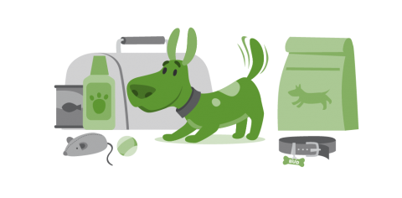June is National Pet Preparedness Month!
Include your pets in your family emergency plan. Does your pet have ID? Put your name and contact information on your pet’s ID tag in case you’re separated in an emergency. A picture is worth a thousand words. Take a current photo of you and your pet in case you get separated during a disaster! If you become separated from your pet during an emergency, a picture of you and your pet together will help you document ownership and allow others to assist you in identifying your pet.
Pets need an emergency supply kit too. Keep your pets' vet’s name and vaccination records handy in case of emergency. Other items to include are:
- Food. Keep several days’ supply of food in an airtight, waterproof container.
- Water. Store a water bowl and several days’ supply of water.
- Medicine. Keep an extra supply of the medicine your pet takes on a regular basis in a waterproof container.
- Collar with ID tag and a harness or leash. Include a backup leash, collar and ID tag. Have copies of your pet’s registration information and other relevant documents in a waterproof container and available electronically.
- Traveling bag, crate or sturdy carrier, ideally one for each pet.
- Grooming items. Pet shampoo, conditioner and other items, in case your pet needs some cleaning up.
- Sanitation needs. Include pet litter and litter box (if appropriate), newspapers, paper towels, plastic trash bags and household chlorine bleach to provide for your pet’s sanitation needs.
- Familiar items. Put favorite toys, treats or bedding in your kit. Familiar items can help reduce stress for your pet.

