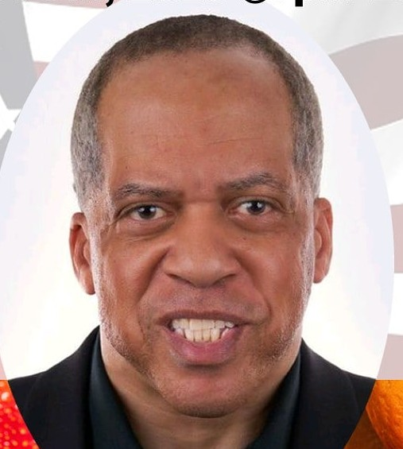

Troy Richardson
Inspirational Speaker
U.S. Air Force Veteran
Activist, Mentor, Entrepreneur.
25 years as a Government Contractor in various leadership roles responsible for generating $300M in contract revenue. Expert in sales, marketing Business Development and building long-lasting relationships.
CEO - RCG LLC
VETERAN OWNED Health and Wellness company.
www.rcghome.net
Executive Director:
BHNI - BLACK AND HISPANIC NUTRITION INITIATIVE. Empowering and educating communities with the team of pastors health coaches and financial coaches.
www.bhni.org
Founder of INOJ Skin Care
Inspiring the name of Jesus. All natural vegan based line of products
www.inoj.org
Creator of everyday is veterans Day campaign.
https://www.change.org/StopVeteransSuicide

RCG Media Film/TV Producer

Global Health Advocate
Board Member:
www.fozainc.org
www.tinytownca.org
www.goalfe.com

Rates: $30 - $120 per hour for consulting.

Speaking: $250 30 min/$450 1 hour

Contact:
troy@rcghome.net
Cell: 202-517-4922

Payment: Cashapp, Zelle, Paypal

