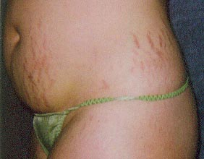
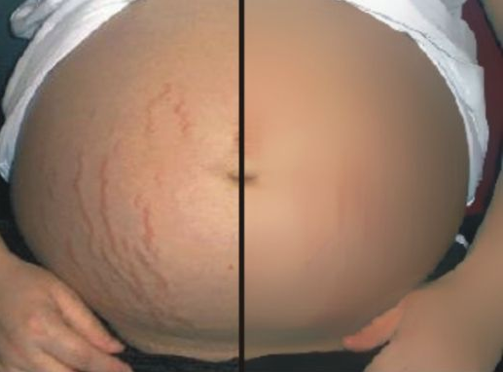

Stretch Marks

What are Stretch Marks?
- Stretch marks are wavy stripes appearing on the abdomen, buttocks, breasts, and thighs.
- They start out reddish in colour and gradually turn white
- They are caused by rapid weight gain, such as that typically associated with preganancy, and appear when the skin becomes overstretched and the fibres in the deep layers tear.
- Once they appear, they can remain as permanent, but they do become mush less noticeable with time. However, there are all sorts of things one can do to support the repair of the torn fibres.
- Obviously, ideally what we want to do is STOP the tearing in the fibres in the first place.

How to Reduce the Risk of Developing Stretch Marks:
Since some girls develop stretch marks during pregnancy and others don’t, there are obviously some reasons why some girls did not experience “tearing of the deep layer fibres of the skin”. So how do we reduce the risk of developing them:
- Optimal hydration (drink adequate water – no less than ½ oz of water per pound of body weight DAILY)
- Optimal essential fatty acids in your diet – such as ground flaxseed and supplementation with Omega 3 & Omega 6 fatty acids (Shaklee OmegaGuard & Shaklee GLA)
- Optimize protein intake (your skin is 95% protein), with a guaranteed supply of the nine essential amino acids DAILY. (Shaklee Soy Protein or Shaklee Cinch Shakes)
- Optimize Vitamin C – along with protein, Vitamin C is responsible for the production of collagen and also the elasticity of the skin so that it can stretch without tearing (Shaklee Vitamin C Sustained Release)
- Optimize Zinc intake – when we are pregnant we are “building” a baby, and our need for zinc doubles with the massive amount of cellular development that is happening.
- Topically … apply skin lotions that contain rich emollients and supplements … many girls will rotate by using one in the morning and one at night
  - Shaklee Spa Cream … Ultra Moisturizing Shea Butter Cream with Vital Repair+(patented vitamins for your skin formula: Vitamin E, Vitamin C, Vitamin A, Panthenol, Grape Seed Extract, Superoxide Dismutase (SOD), Beta Glucan)
  - Shaklee Mentholate Skin Cream … an herbal cream that contains several nourishing and healing herbs, some of which are: sage, coltsfoot, restharrow, horse chestnut, horsetail, yarrow, rosemary, dandelion, matricaria, and witch hazel

What to do if you have already developed Stretch Marks:
Basically, you follow the same program, addressing the issue internally and externally CONSISTENTLY. It takes time, so don’t expect miracles … four months is a good evaluation period.

Some girls have found benefits from laser treatments, but this can be expensive. It is better to invest your money in the internal and external suggestions above.

