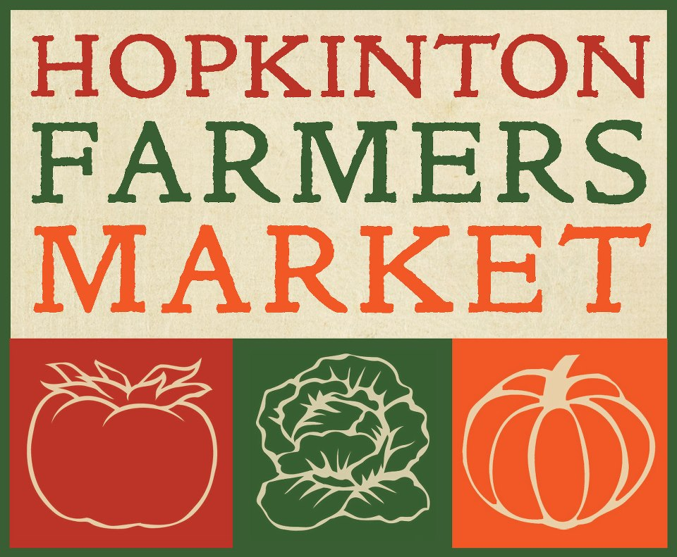
Hopkinton Farmers Market Association Announces Scholarships for 2023

Objective:
The objective of this scholarship is to support education in the fields of agriculture, healthy food systems, environmental studies, civics and social justice.

Who is eligible?
- Hopkinton High School Seniors pursuing a degree in one of the above fields.

What you must do to apply?
The applicant must write an essay of at least 500 words and no more than 600 words answering ONE of these questions:

- How do you plan to stop the earth from warming?

- How do you plan to overhaul the current food system?

- How do you plan on revitalizing agriculture?

- How will you commit to make a change to improve our world’s environment?

- What would you do to insure the organization that you work for is equitable and inclusive?

Applications are due by April 10, 2023 at midnight and must be emailed to hopkintonharvest@gmail.com

Please complete the following and attach with your essay when submitted:

Name: ____________________________________________________________________________________

Address:__________________________________________________________________________________

Email:_________________________________________ Phone: __________________________________

Field of Study: ___________________________________________________________________________

College/University: _______________________________________________________________________

