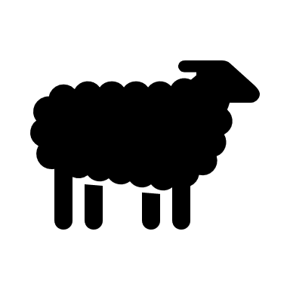

Leicester Longwool Sheep

DIY Leicester Longwool Farmhouse Decor

A simple do it yourself needle felt starter kit for anyone new to wool felting. One of my most popular kits!. A simple do it yourself needle felt starter kit for anyone new to wool felting.

Craft your own fun and fuzzy sheep décor with this diy needle felting kit! No previous wool felting, sewing, knitting, or crocheting experience/skills are necessary to create this sweet little sheep, making this needle felt kit ideal for crafting beginners. This delightful diy craft kit allows you to make one cute ‘n’ curly black sheep. Your finished sheep will measure approximately 4×4 inches, depending on how firmly it is felted, and the project will take around three hours to complete if you are a felting newbie.

The wool for this adorable needle felted sheep is collected from the specialty breed sheep raised on our farm in Pennsylvania, so you can be assured of the quality and integrity of our wool felt kits! All our needle felting kits are packaged in a smoke-free home in resealable plastic bags making them the perfect gift for any crafter or fiber enthusiast! Why not create your own flock of these endearing sheep to add a touch of country charm to your home? You can craft your sheep however you like and watch it take shape as you can see from the pictures I have included here.

**Our beginner sheep craft kit comes with –**

black/grey wool

white wool

black/grey curly wool

black wool for the mouth

glass eyes

two felting needles

felting cushion

detailed instructions with photographs of each step by Fiber Artist Amy Farrell

DOES NOT include needle and thread to sew on the eyes

Leicester Longwool Kit $25.98 + 7.47 Shipping