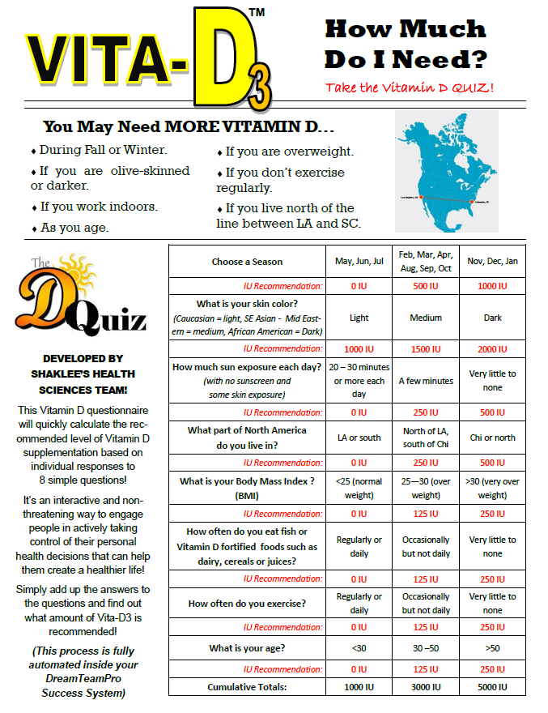
Chicago or
North
For information, contact:
Martha Willmore - 905-871-4281 hoop@inter-pc.com
www.imwillmore.myshaklee.com

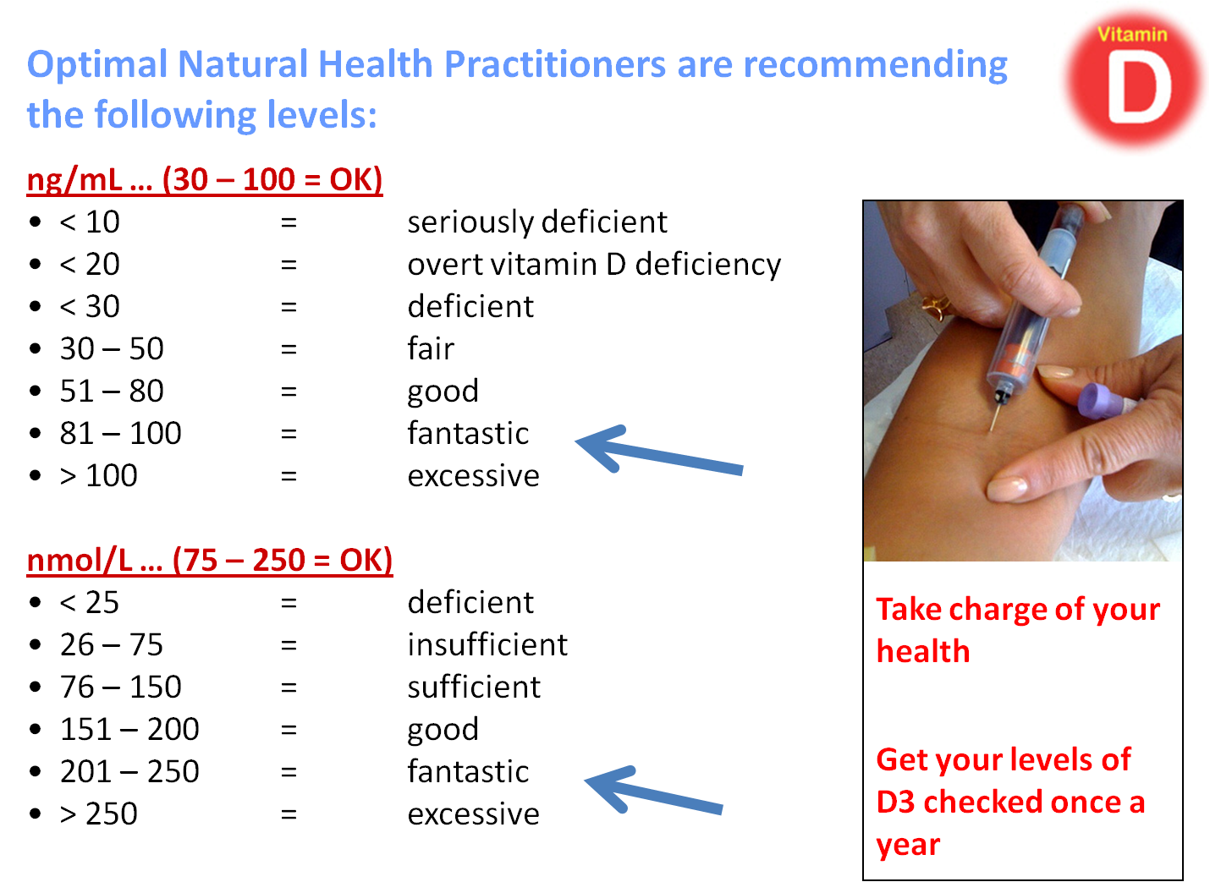
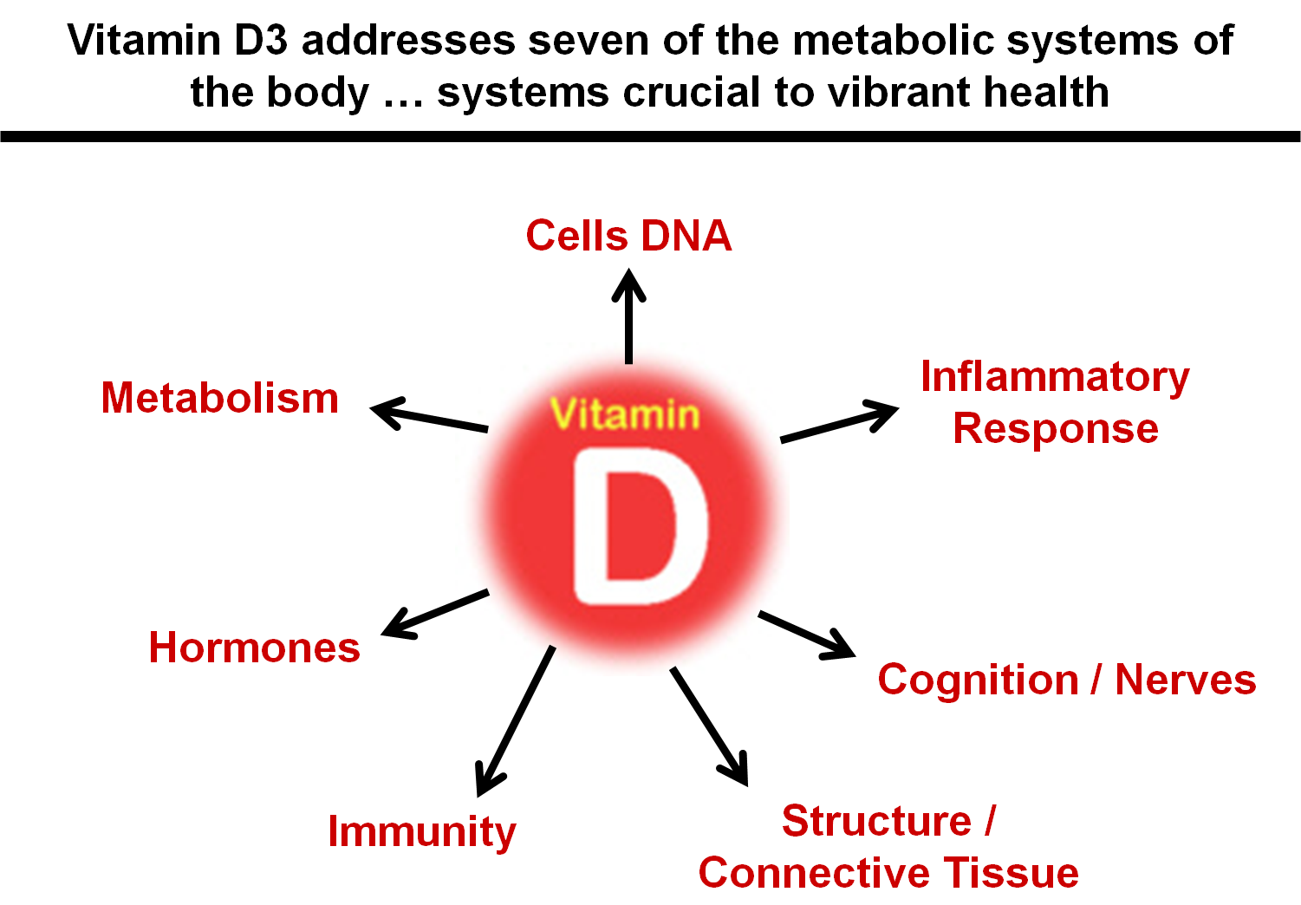


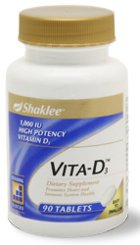

For more information contact:

Martha Willmore
905-871-4281
Toll-free: 1-877-262-3729
hoop@inter-pc.com
www.imwillmore.myshaklee.com


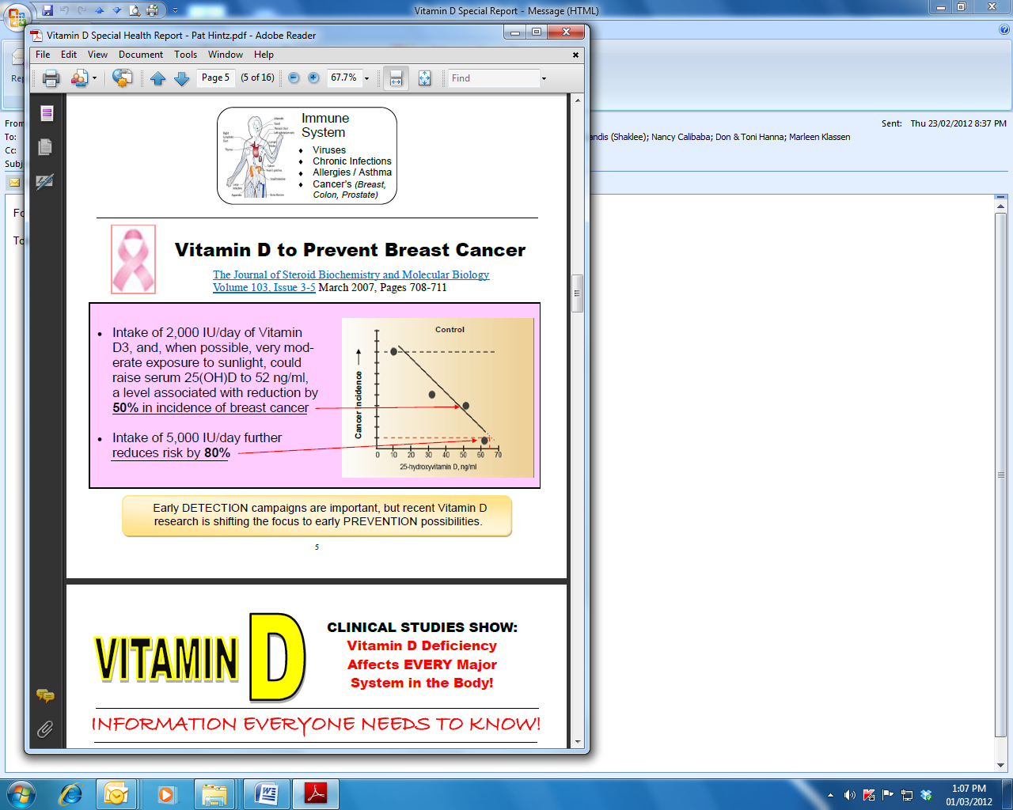


For information, contact: Martha Willmore ... 905-871-4281 ... hoop@inter-pc.com ... www.imwillmore.myshaklee.com

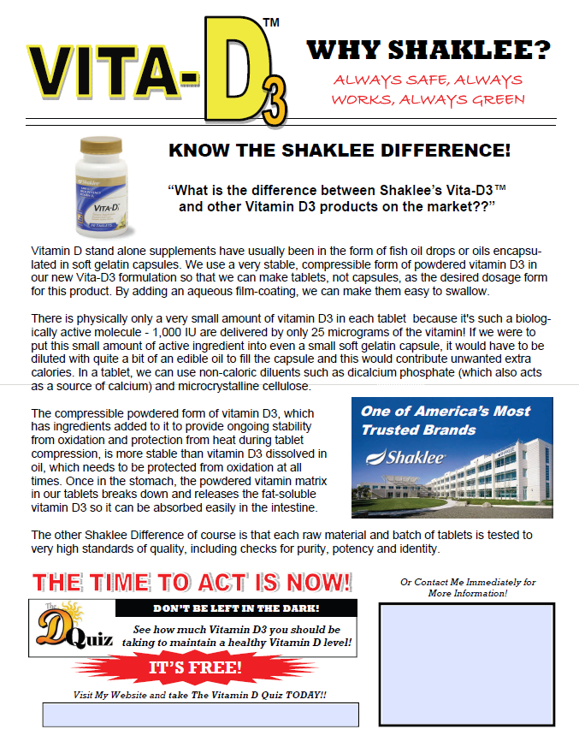
Martha Willmore
905-871-4281
Toll-free: 1-877-262-3729
hoop@inter-pc.com
www.imwillmore.myshaklee.com
http://imwillmore.myshaklee.com/us/en/pop_VitaminD_Quiz.s.html

