Inaccuracies in the DESE Information Packet For Legislators
on Common Core Standards

DESE Statement: “The standards establish consistent learning goals for all students, regardless of where they live so that children will stay on track in school when moving from one state to another.”

- The transient student population is not a large problem that requires a whole new system for standards development. The actual percentage of students who move each year is between only 0.3-2%.
- In addition, CC standards provide only a year end proficiency goal. If individual districts may determine their own curriculum, order and pacing, as the CC proponents claim, there is no inherent guarantee in the standards that a student moving mid-year will have received instruction in the exact portion of the standard as any another district.
- Section 160.2000 of the Missouri Revised Statutes, Interstate Compact on Educational Opportunity for Military Children, already addresses barriers to educational success imposed on children of military families because of frequent moves and deployment of their parents. Common Core offers nothing new.

DESE Statement: “The standards are relevant to the real world, focusing on knowledge and skills students will need to succeed in life after high school, in both post-secondary education and a globally competitive workforce.”

- There are no pilot data to support this statement. This is merely a statement of intent, not a guaranteed, or even likely, result.
- Members of the both the ELA and Math Validation Committees refused to sign off on the standards because this statement could not be substantiated with research or data.

DESE Statement: “A diverse team of teachers, parents, administrators, researchers and content experts developed the CC to be academically rigorous, attainable for students and practical for teachers and districts.”
- CC was developed primarily by people affiliated with DC nonprofit Achieve, Inc., financed by large grants from the Bill and Melinda Gates Foundation.
- The standards development committee contained no high school English or mathematics teachers or English professors. It was made up primarily of test preparers, test providers and administrators. The two people credited with writing the grade-level English language arts standards (David Coleman and Susan Pimentel) have never taught in K-12 and have never published anything in K-12 curriculum and instruction. They have no credibility to the field.
- The two people credited with writing the grade-level mathematics standards (Jason Zimba and William McCallum) have never taught in K-12, have never published anything on K-12 curriculum and instruction, and have no experience writing K-12 mathematics standards. No one in the field of education had ever heard of either of them.
- Missouri’s Show Me Standards requirements for proficiency in fourth grade were already the second-most rigorous requirements in the country.²
- Barbara Reys, who was a key opposition witness and who testified that CC standards were more rigorous than Missouri’s Show Me Math Standards, was the co-chair of a standards development committee which authored Missouri K-12 Mathematics Learning Goals. Reys is a mathematics educator, not a mathematician. A 2008 letter signed by more than two dozen Missouri University math professors was the result of their frustration with DESE’s math goals development process and the failure of Ms. Reys to incorporate their input. The goals she developed resulted in at least 1,000 students per semester entering Missouri University requiring remedial coursework in math. The letter cited constructivist math processes in the lower grades that is still rampant in the CC math standards. It would be a travesty for Missouri to continue to listen to mathematic standards advice from Ms. Reys.

²Phillips, Gary W. (2010). “International benchmarking: State education performance standards.” American Institutes for Research. View online here: http://www.air.org/files/AIR_Int_ Benchmarking_State_Ed__Perf_Standards.pdfSee sample worksheet. In most cases they have moved standards down a grade

DESE Statement: “The common core state standards will ensure that students graduate high school prepared to succeed in credit-bearing college courses without the need for remediation.”
- CC is more likely to increase college remediation. CC chose to lower the standards and eliminate Algebra 2 content like geometric and arithmetic sequences, or combinations and permutations, from its own version of Algebra 2. Among students who just take Algebra 2, only 7% are ready and 22% are conditionally ready for college.
- Remediation rates may drop only because colleges will be expected to alter their entrance requirements to eliminate the need for remediation, i.e. lower their requirements. DESE and the MDHE have worked together only to “ensure k-12 standards and entry level college standards are in alignment.” If everyone is taught the same standards but some colleges have higher admission requirements, who is more likely to have to change: the colleges who are out of alignment or the entire k-12 standards and assessment system?
- A report on the SMARTER Balanced Consortia website confirms that the plan is for colleges to reduce their requirements to accommodate students “educated” under CC. According to this report, “colleges and universities should seriously consider creating consistent placement standards for similar entry-level courses, aligned with the Common Core State Standards and assessments. . . . Will students who successfully complete a college-ready curriculum transition seamlessly into first-year college courses? Do those courses assume mathematics or English-language arts knowledge and skills that are not part of the standards? . . . The standards thus opens (sic) up . . . exciting opportunities for postsecondary faculty members . . . to reassess their own curricula for . . . general education in light of these new common state benchmarks.”3

³ Jacqueline E. King and Allison Jones, “The Common Core State Standards: Closing the School-College Gap,” Assessment Solutions Group, March/April 2012, available at http://www.smarterbalanced.org/wordpress/wp-content/uploads/2012/04/Closing-the-School-College-Gap-AGB-Trusteeship.pdf.

DESE Statement: “CCSS will boost Missouri’s long-term economic competitiveness because students will graduate high school with real world skills they need to be successful in college and the workforce. Nearly 75% of students graduated from MO’s high schools in 2010. Lost lifetime earnings for those who did not graduate total $2.3B. “
- There is no graduation crisis. MO’s graduation rate is higher than the national average of 72% according to EdWeek. That number has been steadily climbing and is the highest it's been since the mid 1980s.
- There is nothing in these unpiloted, untested standards that guarantees graduation. That is still up to the student and individual school.
- A higher percentage of all racial and ethnic groups are graduating now than a decade ago.

http://www.usnews.com/education/blogs/high-school-notes/2011/06/13/national-high-school-graduation-rates-improve

DESE Statement: “The CC standards were created through a state-led initiative” – See chart.

- The CC standards were developed by an organization called Achieve Inc. and the National Governors Association, both of which were generously funded by the Gates Foundation. There was minimal public engagement in the development of the Common Core. Their creation was neither grassroots nor did it emanate from the states.⁴
- Many state officials signed on to the CCSSI before the final standards were even written. The former Commissioner of Education in Texas, Robert Scott, has publically stated he was pressured by CC proponents to sign the Common Core Standards MOU before they were available for inspection. There is evidence that governors in other states compelled their education leaders to rubber stamp the CCSSI. As the legislatures of each state were largely cut out of the process, their constituencies could not have been involved - the “parent support” claimed by CCSSI advocates is illusory. Few parents even know about the CCSSI or that their schools are now being restructured to meet its demands.⁵
- PTA support for the CC standards was paid for with a $1 million grant from the Gates Foundation which also helped fund the development of the standards.

DESE Statement: “The Federal Government is not funding or implementing the standards.”

- The federal government gave federal stimulus money to Achieve and the NGA to write the standards.
- The federal government pushed the states into adopting the standards through the Race To The Top Grant application and the No Child Left Behind Waiver.
- The Fordham Institute provided testimony stating “They [CC opponents] are right that President Obama politicized the standard by using federal Race to the Top dollars to coerce their adoption in the states. It doesn’t help that the president took credit for the common standards every time he had a chance on the campaign trial, and did it again in his recent state of the union address.”

⁴ http://dianeravitch.net/2013/02/26/why-i-cannot-support-the-common-core-standards/
⁵ Mark Garrison SB210 Testimony 3/6/13

DESE Statement: “The standards draw from the best existing standards in the country and are benchmarked to top performing nations around the world ensuring that students are well prepared to compete not only with their peers at home but also with students around the world, maintaining America’s competitive edge.”

- Even CCSSI has backed off its original claim, that the standards are internationally benchmarked. The CCSI website now says the standards are “informed” by international standards. Dr. Sandra Stotsky testified that members of the CC Validation Committee tried for months – and failed- to get the drafters to identify the countries supposedly used for international benchmarking.
- The Fordham Institute, which submitted testimony in opposition to the bills, has reported¹ that District of Columbia ELA standards were higher than the CC standards, yet no one would say that DC schools are superior or that their students’ academic performance is superior as a result.⁶
- International benchmarking is not a reason to adopt the CCSS. Until the CCSS tests are developed, we will not know to what level the new standards have been benchmarked. Our own Show Me Standards already are internationally benchmarked.²

⁶ Byrd Charmichael, Sheila, Gabrielle Martino, Kathleen Porter-Magee, and W. Stephen Wilson. (2010). “The state of state standards—and the Common Core—in 2010.”Thomas B. Fordham Institute.
DESE Statement: “With Consistent Standards, states have the option to pool their collective expertise and resources in order to reduce costs for each individual state and bring the most well-informed creative thinking to various efforts around the standards.”

Missouri not only already had the ability to do this, but has been recognized as a national leader in professional development and teacher collaboration. DESE had been granted authority and financial resources by the Missouri Legislature via the Outstanding Schools Act⁷ to:
- create professional development programs so teachers could develop/implement high quality curriculum to help all students reach the Show-Me standards
- develop /implement comprehensive assessment systems based on Show-Me standards
- make whatever policy changes were necessary for students/educators to meet standards and other assessments

In addition, the legislature provided funding for collaborative discussions/programming for teachers from around the state.

Missouri test scores using a nationally normed test such as the NAEP indicated a steady increase of test scores each year.

⁷ https://powerfulprofessionallearning.wikispaces.com/file/view/2010Phase3TechnicalReport.pdf see pages 55-79

DESE Statement: “CC will allow states to… Develop and implement high quality curriculum that best enable teachers to help all students reach the standards.”

- Teachers readily admit that they are bombarded daily with offers for resources, lesson plans and curriculum. The only thing having a common set of national standards will do is make all those resources the same, not richer or more rigorous.

DESE Statement: “Will local teachers decide what and how to teach with CCSSS?”

The CC standards absolutely direct how to teach in some cases. For example:
- CC replaces the traditional foundations of Euclidean geometry with an experimental approach. This approach has never been successfully used in any sizable system; in fact, it failed even in the school for gifted and talented students in Moscow, where it was originally invented. Yet teachers are instructed not just to teach geometry but to teach it using this experimental method.
- CC requires teachers to use a certain percentage of non-fictional texts in order to teach ELA skills. This is an arbitrary decision with no data to support it. In fact, even though all the historical and empirical data establish the superiority of literary study to “information text” study, teachers are instructed to follow the CC mandates.

DESE Statement: “CC Standards are only English Language Arts and mathematics.”

- We know other standards are already in the works. Science standards coming from Achieve Inc. are in the review process. Additionally, social studies and even arts standards are being developed, and a set of national health/sex education already exists (and is being used in, for example, Chicago kindergarten). Once a framework for creating and adopting a set of common standards is established, many special interests will attempt to use it to push their standards. And the federal government will “persuade” states to adopt those new standards just as it did with CC – through the power of the purse
- The CC ELA standards in fact already dictate some instruction in other subjects. The ELA standards include “Literacy in History/Social Studies, Science, and Technical Subjects.” Through the device of improving “literacy,” the ELA standards inject content from other subject areas.
- There is nothing in the NCLB waiver that precludes other subjects from being implemented.

DESE Statement: “The CC has now established the same rigorous expectations for a majority of students; however, each state remains fully in control of its own standards and all related decisions”
- From Achieve Inc.⁸ who wrote the standards “Therefore, states who adopt the (CCSS) are expected to adopt them in their entirety. While states will not be considered to have adopted the common core if any individual standard is left out, states are allowed to augment the standards with an additional 15% of content that a state feels is imperative.“

⁸ http://web.archive.org/web/20101205092524/http://achieve.org/files/15PercentGuideline.pdf

DESE Statement: “(T)eachers have been a critical voice in the development of the standards to ensure that they are practical in the classroom. The NEA, AFT, National Council of Teachers of Mathematics (NCTM) and National Council of Teachers of English (NCTE), among other organizations, have been instrumental in bringing together teachers to provide specific, constructive feedback on the standards.”

- When the opposition claims that MO teachers, professors and parents were involved in the standards development it means a small number of teachers were given the opportunity to review a confidential draft . They did not have a seat at the drafting table and nor did Achieve Inc. have any obligation to either accept or even explain why they did or did not make changes based on comments.

DESE Statement: “Allow states to develop and provide better assessments that accurately measure whether students have learned what was taught.”

- While the standards themselves do not dictate that states use a particular assessment, Missouri has signed a contract with the Smarter Balanced Assessment Consortia (SBAC) to develop assessments aligned with CC. We therefore are not currently developing our own assessments. We have only one vote in twenty six on those approving those tests in which items are prepared by Pearson, a significant funder of the standards’ development.
- Also, performance items must be reviewed subjectively by individuals which allows for bias (corruption and manipulation) in the evaluation of performance data. Missouri will have little if any influence in controlling for this error source once the SBAC assessments become the state’s assessment plan.
- The commitment to using SBAC assessments amounts to an unfunded mandate to the local school districts. The costs to acquire and maintain the technology necessary to administer these tests will be born solely by the school district. The Foundation Formula will not fund it.
- Missouri Statute 160.526 states, “Within six months prior to implementation of the statewide assessment system, the commissioner of education shall inform the president pro tempore of the senate and the speaker of the house about the procedures to implement the assessment system, including a report related to the reliability and validity of the assessment instruments, and the general assembly may, within the next sixty legislative days, veto such implementation by concurrent resolution adopted by majority vote of both the senate and the house of representatives.” This action has not been taken.
- The structure of the agreement between Missouri and SBAC violates statute 160.518 which states, “2. The assessment system shall only permit the academic performance of students in each school in the state to be tracked against prior academic performance in the same school.”

Data Collection and Sharing

The Common Core standards are copyrighted to private organizations to control content based on the values, beliefs and political positions of the copyright holders. The determination of acceptable performance on the assessments is based on the content of the copyrighted material. The long term decisions for the student’s career and college readiness thus are made by people who reinforce the values, beliefs and political positions of the copyright holders, not of Missouri.
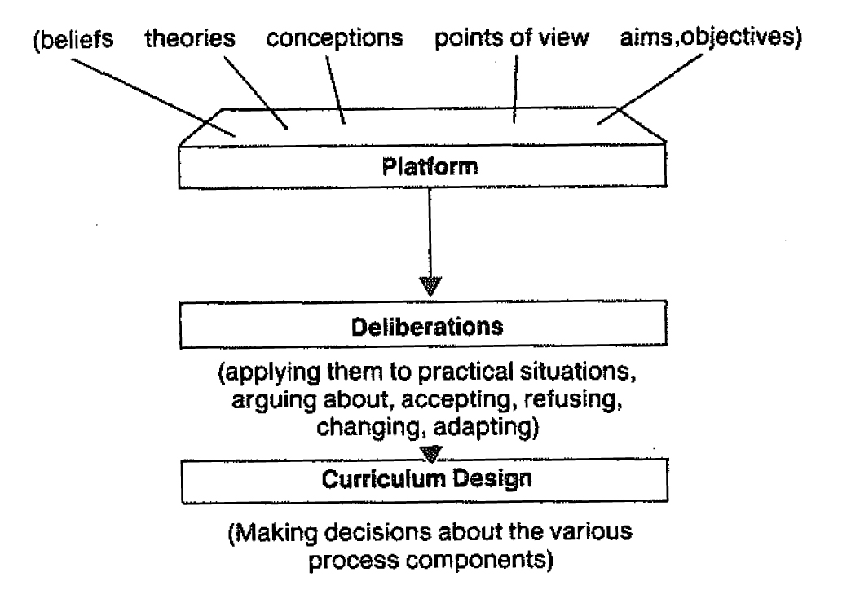
These computerized assessments are critical to the larger plan to collect student identifiable data which will be sent to the US Department of Education and from there distributed to other governmental agencies thanks to changes made by the US Department of Education to the Family Education Rights Privacy Act. These changes, made by a regulator to a Congressional Act, were made after states were directed to collect this data in a certain format.

Transference of these data outside of the school district violates Missouri Statute 160.522 which says, “3. The report card shall permit the disclosure of data on a school-by-school basis, but the reporting shall not be personally identifiable to any student or education professional in the state.”

DESE has admitted to collecting 61 out of the full 418 data points included on the national data quality campaign set. Was the legislature aware that this data was being collected and shared? What process is in place to make public when other data points become activated in the future?

Standards Development Authority

DESE does have statutory authority to develop state standards for education. However, the statute does not grant them total autonomy over this process. Section 160.526 states, ". . . in establishing the academic standards and statewide assessment system, the state board of education shall adopt the work that has been done by consortia of other states and, subject to appropriations, may contract with such consortia to implement the provisions of sections 160.514 and 160.518.". They have made no presentations or requests to the budget or appropriations committees for funding implementation of Common Core or the assessments.

DESE has been aware for many years that Massachusetts has scored number one on the NAEP test to which our own MAP tests were benchmarked. There are ten years worth of scoring data to demonstrate that MA standards produced high student performance on the NAEP. Massachusetts makes their standards available for free to any state who would like to consider incorporating them into their own standards. Likewise, Indiana who has nationally recognized standards, has made their standards available to other states to share. In the last decade, with data available to demonstrate their effectiveness, DESE did not consider adopting the MA, IN or CA standards.

A note about Massachusetts’ adoption of Common Core standards: Their adoption by MA should not be considered an endorsement of the quality of the standards. CC were adopted by MA in 2010 before the standards had been seen or approved by the validation committee. Initially the MA Department of Elementary and Secondary Education tried to get out of adopting CC, but with $250 million, a lot of political pressure and a governor, Patrick Duvall, who is on the board of Achieve Inc., they had little choice but to go along. The proponents of CC knew that if they could get MA to adopt, the other states would fall in line.

Missouri Coalition Against Common Core

