By
Gerald V Barta
Senior Instrumentation Specialist
June, 2022

Instrument Specs and Index
INTEGRATED OR STANDALONE INSTRUMENT INDEX TUTORIAL

Table of Contents
Table of Contents 1
1 OVERVIEW 1
1.1 WHAT IS AN INSTRUMENT INDEX? 1
1.2 WHAT IS AN INTEGRATED INSTRUMENT INDEX? 1
1.3 INTENSION AND OBJECTIVES 1
1.3 HISTORICAL PERSPECTIVE 2
1.5 LIFE-CYCLE DOCUMENTATION ACTIVITIES 2
1.6 EFFECTIVE USE OF ELECTRONIC FILES 2
1.6.1 Data Validation 3
1.7 INTEGRATED FORM LOADER DASHBOARD 3
1.7.1 Standalone Instrument Index Loader 4
2 INSTRUMENT INDEX DATA SPREADSHEET INTERFACE 4
2.1 INSTRUMENT INDEX DATA WORKSHEET 4
2.1.1 Instrument Specification Document Sourced Data 5
2.1.2 Extended Manual Data Entry Instrument Index Fields 5
2.1.3 Manual Data Entry Sourced Data 5
2.1.4 Custom Views of Instrument Index Data 5
2.1.5 Data Groups with Alternating Color Coded Header Names 6
2.1.6 Sorted Integrated Multi-Sourced Spreadsheet 7
2.1.7 Sort and Filter Options for Each Field 8
2.1.8 Calculated % Complete for Each Field 9
2.1.9 Review for Inconsistencies 9
2.2 VIEW ADMINISTRATIVE USERFORMS WORKSHEET 9
2.3 VIEW USERFORMS WORKSHEET 10
2.4 DROP-DOWN LIST WORKSHEET 11
2.5 INSTRUMENT INDEX CUSTOM REPORTS FOR DELIVERABLES 11
ANNEX A INSTRUMENT INDEX DATA LIST 12
Table 1 Instrument Specification Forms Integrated Data 12
Table 2 Extended Manual Data Entry Properties of Instrument Index 16
Table 3 – Typical Manual Entry Instrument Index Property Dropdown List 19

OVERVIEW

WHAT IS AN INSTRUMENT INDEX?

Index Definition: “an alphabetical list of names, subjects, etc., with references to the places where they occur.”
An “Instrument Index” (Instrument schedule) can refer to a simple report document of very limited fixed content, or an extensive database of instrument devices and software functions cross-referenced to their related work activities and the milestones and status of such activities.

WHAT IS AN INTEGRATED INSTRUMENT INDEX?

An Integrated Instrument Index (database) is a single file and user interface which consolidates (several data sources) into a single more effective or coherent whole, designed to meet the data management requirements of multiple stakeholders over the consecutive and interlinked stages of instrument devices or functions.

The terminology “Integrated” in this context, generally implies software automated work processes that automatically manage data entry or copying of major portions of the data to ensure completeness and accuracy between a work process data entry source and the content of the instrument index file.

1.3 INTENSION AND OBJECTIVES

InstrumentSpecsandIndex.com is a website which aims to publish and solicit FREE crowdsourced information about:

- Instrument Index integration with ISA TR20 style specification forms
- ISA-5.1-2009/2022 Instrument Identifications Number administration and generation
- Standalone instrument index with fields and drop-down list equivalent to those in ISA TR20 forms
- Coordinated Instrument Index fields including typical P&ID properties such as:
  - Drawing number, Tag number, Failure mode, and Line number properties
  - International standard location properties and relative location description
  - Related Equipment number and Service description
  - Drawing status and data checking status
- Documented Safety classifications such as Hazardous Area Classification and Criticality Classification
- OSHA required Design Operating conditions and Device performance ratings
- Instrument Calibration ranges and signal Action mode
- Loop and additional tag properties
- Cross reference to related drawings, systems and packages used for sorting information
- Milestone and Status fields to analyze work requirements and completion status
- Maximized default amalgamation of proven index content which can be easily simplified by HIDING columns that are not going to be used for specific projects
- Default Custom Views of Instrument Index data to facilitate efficient work processes and reviews
- Capability to easily revise or add new Custom Views by users

HISTORICAL PERSPECTIVE

In My experience:
- Initially projects maintained a cross-reference ledger book of reserved instrument numbers, subjects, etc., with references to the places where they occur.
- Availability of electronic files of Instrument Index cross-references with alphabetical ordering based on Tag Number, was instrumental to the index inclusion of records unrelated to data sheets.
- Index content was soon expanded to include documentation of control loops and all their tagged child instrument devices
- With the advent of Computer Aided Engineering (CAE) applications, their Instrument Index content was expanded to cross-reference all tagged devices or software functions and their related work products.
- Efficient data retrieval in CAE applications generally requires Relational Database technology preceded by standardizing/normalizing and enforcing many work processes and naming conventions.
- Significant demand still exist for a simpler flat file data structures to cross-reference index data without the structured procedures required for automatically establishing complex data relationships
- Our previously published Integrated Instrument Index Data file, addressed the content and viewing of the data. The addition of standardized Instrument Identification numbers allows data retrieval and editing in an efficient user interface.

1.5 LIFE-CYCLE DOCUMENTATION ACTIVITIES

An instrument index (database) is typically managed over the “Life Cycle of an Engineering Project” and frequently is turned over to the client for integration into a much wider scoped database of physical hierarchy and timeline. Environmental and Safety regulations may require “cradle-to-grave” documentation for some physical instrument devices.

1.6 EFFECTIVE USE OF ELECTRONIC FILES

The Instrument Index column names and data types are coordinated with those of the Instrument Specification Forms Content Controls, such that Electronic Data Exchange will occur during saving operations whenever matching names are identified in both applications. Therefore, additional exchange data can be implemented by simply adding a new column to the Excel spreadsheet with the coordinated name, without the need for any VBA code changes.

1.6.1 Data Validation

Electronically Data Interchange (EDI) with external files requires coordinated data names and data types. Consistency of data values can significantly enhance the effectiveness of data sorting and searching.
ANNEX A INSTRUMENT INDEX DATA LIST identifies the property names and validation criteria used in the Excel spreadsheet to maximize compatibility with EDI effectiveness.

1.7 INTEGRATED FORM LOADER DASHBOARD

A Form Loader Dashboard is included as the common interface for access to all templates, forms, Instrument Index files and their data storage folders.
Use the Form Loader Dashboard by double clicking the 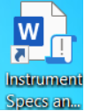 Desktop shortcut to activate the dashboard interface.

When the integrated interface opens, scroll through the list of Instrument Index Data files, and click the window row for the Excel® spreadsheet of interests:
- Common index for normal operations
- Import Temp index for processing files returned form external parties
- Project 1…. Indexes for separate data files per project
- Typical Forms index used to copy consistent default data into a specification form

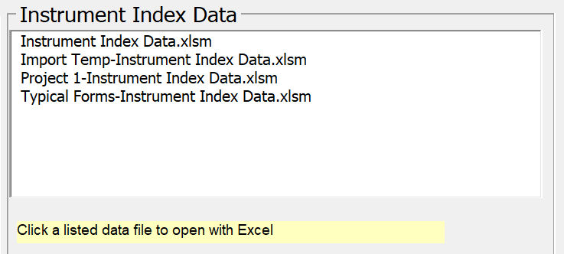

- Note: See Quick Start Tour document paragraph 3 for step-by-stem actions to work with these spreadsheets!

1.7.1 Standalone Instrument Index Loader

Drag-and-drop or copy the Instrument Index Data.xlsm shortcut to the desktop for standalone Instrument Index applications. Double click the 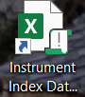 Desktop shortcut to activate the Excel spreadsheet application.

2 INSTRUMENT INDEX DATA SPREADSHEET INTERFACE

The Instrument Index Data spreadsheet opens with a pop-up window to select a Custom View or Close the window.

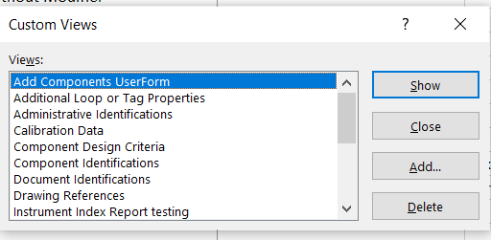

If the intent for this user’s session is to:
- Add new records, then the default “Add Components UserForm” should be enabled by clicking the Show Button. This will allow the appropriate viewing of the data that will be added with the UserForm.
- Edit or review existing records, then highlight the view name for the appropriate work process, and then click the Show Button to open that view
- The other configuration or administration activities can click the Close button

The spreadsheet will open showing the Instrument Index Data worksheet and the 4 workbook tabs.

2.1 INSTRUMENT INDEX DATA WORKSHEET

If a Custom View has been selected, the Instrument Index Data worksheet tab will be highlighted and the data for that view will be displayed.

2.1.1 Instrument Specification Document Sourced Data

Integrated or Standalone Instrument Index Excel Template Supports all 258+ Instrument Specification Forms

Over 100 fields from each instrument specification form are automatically copied to the Excel Instrument Index Data spreadsheet, whenever a specification document is saved. The Instrument Index Data table has one record for each specification document number and that record will be updated with the latest data at each saving of the specification document.

2.1.2 Extended Manual Data Entry Instrument Index Fields

Over 50 additional typical Instrument Index Fields, related to the specification form’s tagged device, are provided, and can be managed if desired. They can be easily accessed by selecting the “Manual Data Entry of Index” custom view. This data will NOT be overwritten when specification documents are revised and saved.

2.1.3 Manual Data Entry Sourced Data

Records can also be created within the spreadsheet using the Excel UserForm or directly entering data on the next available empty line of the spreadsheet.

2.1.4 Custom Views of Instrument Index Data

Seventeen default custom views of the Instrument Index Data are provided.

- Any view can easily be simplified by hiding unused columns and resaving the modified view.
- New views can be added by modifying any similar view and saving the Custom View with a new name.

Note: The “Normal View (All for design)” contains all fields and can be used to ensure that hidden fields of other views are not overlooked when considering creating a new view.

Note: Do not delete any column because that deletes the data and will result in all other views failing to retrieve their data.

CUSTOM VIEW NAME
Add Component UserForm
Additional Loop or Tag Properties
Administrative Identifications
Calibration Data
Component Design Criteria
Component Identifications
Document Identifications
Drawing References
Instrument Index Report testing
Instrument Specification Form Data
Manual Data Entry of Index
Milestones and Status
Modeling Physical Data
Normal View (All for design)
Process Data Comparison
Process Specification Form Operating Parameters
Procurement Properties
Safety Classifications
System Properties

Note: Any additional Custom View can be added to the Excel file columns.

2.1.5 Data Groups with Alternating Color Coded Header Names

The spreadsheet fields are identically sequenced for all views where they are present in data groups of related work process activities or subject matter.

Data Group Title | Data Group Description
Frozen Critical Columns (Always present) | 4 Fields frozen to always be present for all views, Document Number, Loop Name, Keywords, and Component type1
Document Identifications | 11 Fields identifying document Meta Data, Responsible Organization, File name and location, and any Reference Specification
Administrative Identifications | 8 Fields identifying Project and hierarchical location modeling data
Service Identifications | 12 Fields identifying main component Tag no/Functional ID, Related equipment, Service, P&ID reference number and Line properties
Safety Classifications | 13 Fields identifying Hazardous Area classification, Testing/Listing agency, Criticality classification, Signal failure modes, GHS Health hazard and Type of protection
Component Design Criteria | 14 Fields identifying process limit pressure and temperature design conditions and corresponding component maximum working conditions
Modeling Physical Data | 7 Fields identifying component weight and dimensions suitable for preliminary loading and modeling volume interference analysis
Calibration and Test | 8 Fields identifying input measurement range, control action, output signal range for component's primary signal and test pressure requirements
Component Identifications | 3 Fields identifying the primary component's instrument type, Manufacturer and robust intelligent model number
Location Properties | 4 Fields identifying relative locations as visible on P&ID drawings plus three fields identifying specific locations, generally within the hierarchical locations.
Additional Loop or Tag Properties some text | 6 Fields identifying Loop properties, alternate tag ID, Interlock number and external power requirement
Milestones and Status | 23 Fields identifying major deliverable required dates and status used to quantify work activities and progress completions
Procurement Properties | 6 Fields identifying parties responsible for supplying components the requestion and purchase order identification and package assignments and expected delivery date
Drawing References | 13 Fields identifying drawing numbers for major deliverables
System Properties | 5 Fields identifying instrument system and I/O assignments, plus turnover and commissioning system assignments

2.1.6 Sorted Integrated Multi-Sourced Spreadsheet

All existing records originating from either data entry source, should by default be sorted by Loop Name and Keywords (Formatted Identification/Tag Number).
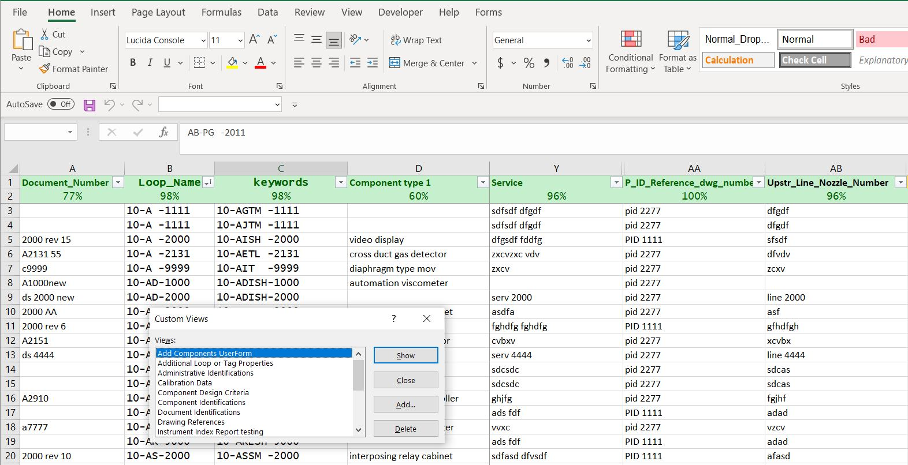

2.1.7 Sort and Filter Options for Each Field

The spreadsheet header row (1) identifies the field names and provides an icon to open the Sort and Filter options for that field, such as:
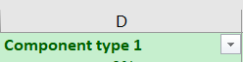

Clicking the icon will open the Sort & Filter options for convenience in reviewing the list of unique values or limiting the view for review.
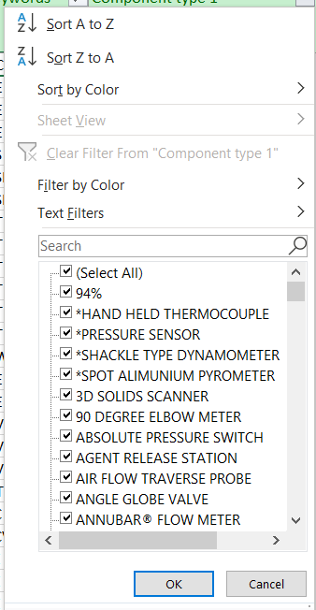

2.1.8 Calculated % Complete for Each Field

The status of data entry activities of blank cells cannot generally be ascertained. Therefore, calculating the percentage of cells with data approximates the % completion when we assume that all record fields should contain values. This assumption is particularly valid for text fields when the recommended practice of entering “NA” (Not Applicable) is used to document when data is not expected to be provided. This recommended practice has been made available for specification form drop-down list and for most text fields in this spreadsheet.

Notes: If filter criteria is activated as identified previously, the calculated % completion will represent the query result set of values.

2.1.9 Review for Inconsistencies

This tabular data presentation can be instrumental in review for inconsistencies

Notes: See Quick Start Tour document, paragraph 8.6 Integrated Instrument Index Data Browser for step-by- step usage.

Note: Data changes made in the Instrument Index Data table are NOT propagated to the Specification Form documents. Therefore, any changes identified by review of the index table must be corrected on the individual document, which when saved will update the Instrument Index Data file.

2.2 VIEW ADMINISTRATIVE USERFORMS WORKSHEET

If the Close Custom View buton was enabled, the User can select the Administrative UserForms worksheet tab, unless it has been hidden subsequent to completion of the configuration of the Identification Number Enabler.

This enabler configuration MUST be completed before the Add Components UserForms of either the Instrument Specification forms or the Excel Instrument Index Data are used to enter project data.

ISA-5.1-2009_2022 Instrument Identification Number Enabler Administration Tutorial.docx provides detailed procedure for managing this critical activity.

2.3 VIEW USERFORMS WORKSHEET

If the Close Custom View buton was enabled, the User can select the View UserForms worksheet tab

The View UserForm tab opens and displays the command button to open the Add Components UserForm.
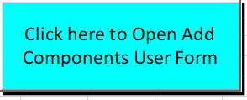

Click this button to access the Add Components UserForm for data Entry
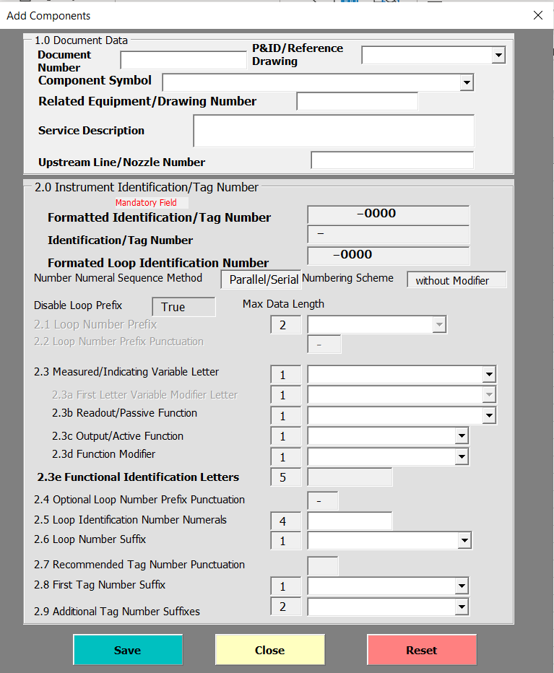
ISA-5.1-2009_2022 Instrument Identification Number Enabler Tutorial.docx provides detailed procedures for using the UserForm to enter data into the Excel spreadsheet.

2.4 DROP-DOWN LIST WORKSHEET

If the Close Custom View buton was enabled, the User can select the Drop-down List worksheet tab, unless it has been hidden subsequent to completion of the configuration of the data validation drop-down list configuration.

Named-Ranges of values and their descriptions used for drop-down list can be manged in this worksheet. Editing of the values in these named-ranges will immediately result in the changes being available at all spreadsheet locations using that named-range.

See example below:
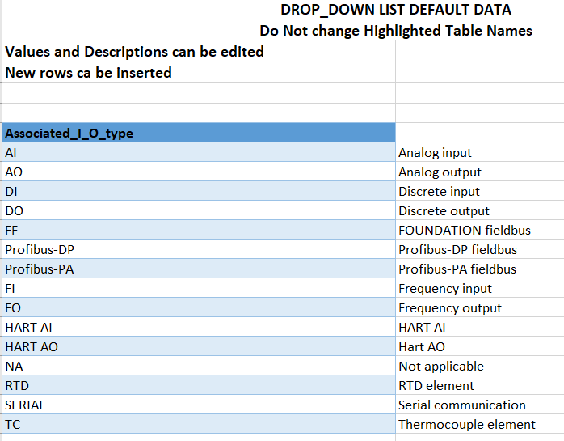

See TABLE 3 - Manual Entry Instrument Index Property Dropdown List Details

2.5 INSTRUMENT INDEX CUSTOM REPORTS FOR DELIVERABLES

Although no custom reports are presently included, such reports can be designed to produce special listings of data, such as:
- Calibration data report
- Safety instrument report
- Document status report
- Reports filtered by Physical Model properties such as Unit number
- etc.

ANNEX A INSTRUMENT INDEX DATA LIST

Table 1 Instrument Specification Forms Integrated Data

About 104 fields are automatically copied from the ISA TR20 style instrument specification Form to an Excel Instrument Index Data spreadsheet, whenever a specification document is saved.
Property Name | Data Description | Data Validation
Document Identifications (11)
Document_Number | Specification Document number (must be unique) | Any value
Form_rev | Specification form number plus revision | Any value
Latest revision | Document latest revision identification | Any value
Publish Date | Date of document publish | Date >1/1/2000
Status | Status of document issue | Document status-Warning
Spec Id attri1value | Specification Identifications section definable field name | List-Warning
Spec id attribute 1 value | Specification Identifications section definable field value | List (NA)
Subject | Specification form title (document Subject description) | Any value
Company | Responsible Organization company identification | Any value
Comments | Word/SharePoint document comment | Any value
File Name | Document full path or file name | Any value
Reference specification | External document that applies to device requirements | List (NA)
Administrative Identifications (8)
Project number | Project number | List (NA)
Sub project no | Sub project number | List (NA)
Project | Project title | List (NA)
Enterprise | Enterprise identification | List (NA)
Site | Site name | List (NA)
Area | Area identification acronym | List (NA)
Unit | Unit identification acronym | List (NA)
Admin Def attribute 1 name | Administrative Identifications section definable field name | List-Warning
Admin Def attribute 1 value | Administrative Identifications section definable field value | List (NA)
Service Identifications (12)
Keywords (Tag no/Functional ID) | Primary Tag no/Functional identification | Any value
Related equipment | Related equipment identification | List (NA)
Service | Service description | Any value
Application service | Service description using manufacturer’s terminology | List (NA)
P_ID_Reference dwg number | P&ID or Reference drawing number | List (NA)
Upstr line_nozzle number | Upstream line or nozzle number | List (NA)
Upstr line pipe spec | Upstream line pipe spec | List (NA)
Upstr line nom rating | Upstream line nominal rating | List (NA)
Upstr line conn type | Upstream line connection type | List-Warning
Upstr line termn style | Upstream line termination style | List (NA)
Upstr line material type | Upstream line material type | List-Warning
Primary construction material | Material of pressure containing shell component | Any value
Safety Classifications (13)
Inline hazardous area cl | Inline or Local Hazardous Area Class | List-Warning
Inline hazardous Div_Zone | Inline or Local Hazardous Area Division or Zone | List-Warning
Inline hazardous gr | Inline or Local Hazardous Area Group | List-Warning
Inline T Code | Inline or Local Hazardous Area Temperature Code | List-Warning
Environmental area | Description of environmental conditions at site of device | List-Warning
Testing/Listing agency | Suitable 3rd party listing agency identification | Any value
Criticality classification | Criticality classification | List-Warning
Safety integrity level | Safety integrity level for Safety Class devices | List-Warning
Safety category | Safety category for Safety Class devices | List-Warning
Signal loss failure mode | Signal loss failure mode | List-Warning
Supply loss failure mode | Supply loss failure mode | List-Warning
Material name | Process Material name | Any value
GHS health hazard | International ratings of material Health Hazards | List-Warning
Compliance standard | Compliance standard identification | Any value
Type of protection | Type of protection classification | List-Warning
Component Design Criteria (14)
Design Inlet press max | Design Inlet pressure maximum value | Decimal <1000000
Design inlet press units | Design Inlet pressure maximum value units | List-Warning
PC Max press at design temp | Performance Characteristics Max pressure at design temp | Decimal <1000000
PC Max press at design temp units | Performance Characteristics Max pressure at design temp units | List-Warning
Design Inlet temp max | Design Inlet temperature maximum value | Decimal <1000000
Design inlet temp units | Design Inlet temperature maximum value units | List-Warning
PC Max design temp | Performance Characteristics Max design temp | Decimal <1000000
PC Max design temp units | Performance Characteristics Max design temp units | List-Warning
Inlet temp min cond | Inlet temperature minimum flow condition | Decimal >-1000000
Inlet temp max cond | Inlet temperature max flow condition | Decimal <1000000
Inlet temperature units | Inlet temperature units | List-Warning
PC Min working temp | Performance Characteristics Min working temperature | Decimal >-1000000
PC Min working temp units | Performance Characteristics Min working temperature units | List-Warning
PC Max working temp | Performance Characteristics Max working temperature | Decimal <100000
PC Max working temp units | Performance Characteristics Max working temperature units | List-Warning
Minimum ambient temp | Minimum ambient working temperature | Decimal >-1000000
Minimum ambient temp units | Minimum ambient working temperature units | List-Warning
PC Min ambient working temp | Performance Characteristics Min ambient working temperature | Decimal >-1000000
PC Min ambient working temp units | Performance Characteristics Min ambient working temperature units | List-Warning
Maximum ambient temp | Maximum ambient working temperature | Decimal <100000
Maximum ambient temp units | Maximum ambient working temperature units | List-Warning
PC Max ambient working temp | Performance Characteristics Max ambient working temperature | Decimal <100000
PC Max ambient working temp units | Performance Characteristics Max ambient working temperature units | List-Warning
Operating Def attribute 1 name | Operating Parameters section definable field name | Any value
Operating Def attribute 1 value | Operating Parameters section definable field value | Any value
Signal power source | Signal power source required for the device | Any value
Digital communication std | Digital communication standard for device | Any value
Modeling Physical Data (7)
Estimated weight | Modeling Data Estimated weight | Decimal <100000
Estimated weight units | Modeling Data Estimated weight units | List-Warning
Face-to-face dimension | Modeling Data Face-to-face dimension | Decimal <100000
Face-to-face dimension units | Modeling Data Face-to-face dimension units | List-Warning
Overall width | Modeling Data Overall width | Decimal <100000
Overall width units | Modeling Data Overall width units | List-Warning
Overall height | Modeling Data Overall height | Decimal <100000
Overall height units | Modeling Data Overall height units | List-Warning
Overall depth | Modeling Data Overall depth | Decimal <100000
Overall depth units | Modeling Data Overall depth units | List-Warning
Removal clearance | Modeling Data Removal clearance | Decimal <100000
Removal clearance units | Modeling Data Removal clearance units | List-Warning
Mfr reference dwg | Identification of manufacturers drawing showing dimensional data | List (NA)
Calibration and Test (8)
Prim Tag no Input_Output | Tag number or functional identification of the primary input or output signal | Any value
Prim_CAL_Input_Output Desc | Primary Calibration Input-Output Description | Any value
Prim_CAL_Input_LRV | Primary Calibration Input LRV | Decimal >-1000000
Prim_CAL_Input_LRV units | Primary Calibration Input LRV units | Any value
Prim_CAL_Input_URV | Primary_CAL_Input_URV | Decimal <100000
Prim_CAL_Input_URV units | Primary_CAL_Input_URV units | Any value
Prim_CAL_Action | Primary Calibration Action | List-Warning
Prim_CAL_Output LRV | Primary Calibration Output LRV | Decimal >-1000000
Prim_CAL_Output LRV units | Primary Calibration Output LRV units | Any value
Prim_CAL_Output URV | Primary Calibration Output URV | Decimal <100000
Prim_CAL_Output URV units | Primary Calibration Output URV units | Any value
Test pressure Input URV | Test pressure value | Decimal >-1000000
Test pressure Input URV units | Test pressure units | List-Warning
Component Identifications (3)
Component type 1 | Primary Component type name | Text length <= 27
Component Manufacturer 1 | Primary Component Manufacturer name | List (NA)
Component Model number 1 | Primary Component Model number | Any value

Note: Any additional Content Control property titles can be added to the Excel file columns and subsequent document savings will copy such additional data to the modified Instrument Index table.

Table 2 Extended Manual Data Entry Properties of Instrument Index

About 56 additional manual data entry properties can be managed in the Instrument Index Data table:

Extended Index Property Title | Data Description | Validation
Location Properties (4)
Relative instrument location | Relative location such as field, local panel, remote panel, I/O building, etc. | List-Warning
Building number | Location building number | Any value
Floor/Elevation | Location Floor/Elevation | Any value
Storage location | Storage Location identification | Any value
Additional Loop or Tag Properties (6)
Loop_Name | Loop name identifying parent common to all members of the Loop | Any value
Sequence order | Loop sequence order of individual member of a loop | Whole number =>0
Identification_Tag_Number | Unformatted Instrument Identification/Tag Number | Any value
Functional_Identification_Letters | Functional Identification letters subset of Tag number | Any value
Alternate tag ID | Alternate tag identification of a device such as assigned by package equipment manufacturer, electrical interface equipment number or of a renamed device | Any value
Interlock number | Name/number common to all members of the interlock | Any value
Requires power supply | Requires power independent of their signal wiring | List-Stop
Installation package number | Construction installation package number | Any value
Loop check package | Construction loop check package number | Any value
Milestones and Status (23)
P&ID status | Status of P&ID activity such as future work, work on hold, pending deletion or pending scope change | List (Data issued status)-Warning
P&ID Checked date | Date of latest approval of P&ID Index data for completeness and consistency | Date >1/1/2000
Instrument status | Status of device such as existing, new, spare, abandoned in place, to-be-removed, etc | List-Warning
Process data owner | Organization responsible for providing process data such as Process, Mechanical, Vessel, Electrical or packaged equipment | List-Warning
Process data required | Date for required process data specifications | Date >1/1/2000
Process data status | Status of process data | List (Document status)-Warning
Requisition required | Date for issuing specification requisition | Date >1/1/2000
Specification package status | Status of specification package | List (Package issued status)-Warning
Required on site | Date for receiving device on site | Date >1/1/2000
Purchase order status | Status of purchase order | List (Package issued status)-Warning
Cause & Effect diagram status | Status of Cause & Effect diagram | List (Document status)-Warning
Logic diagram status | Status of Logic diagram drawing | List (Document status)-Warning
Junction box drawing status | Status of Junction box wiring drawing | List (Document status)-Warning
3D model status | Status of 3D model activity | List (Data issued status)-Warning
Location drawing status | Status of location drawing | List (Data issued status)-Warning
Loop diagram status | Status of loop diagram activity | List (Document status)-Warning
Air/Purge connection status | Status of Air/Purge connection detail | List (Document status)-Warning
Electrical/Signal con status | Status of Electrical/Signal connection detail | List (Document status)-Warning
Environmental protect status | Status of Environmental protection detail | List (Document status)-Warning
Process connection status | Status of process connection detail | List (Document status)-Warning
Support/Mounting status | Status of Air/Purge connection detail | List (Document status)-Warning
Piping isometric status | Status of isometric drawing | List (Data issued status)-Warning
Construction package status | Status of construction package | List (Package issued status)-Warning
Procurement Properties (6)
Supply responsibility | Organization responsible to supply the device such as instrumentation. piping, electrical, packaged equipment, etc. | List-Warning
Requestion number | Requisition number | Any value
Purchase order number | Purchase order number | Any value
Specification package | Specification package ID | Any value
Expected delivery date | Date of expected delivery | Date >1/1/2000
Construction package date | Date of expected construction package | Date >1/1/2000
Drawing References (16)
3D model drawing | 3D drawing number | Any value
Air/Purge connection | Air/Purge connection detail drawing | Any value
Cause & Effect diagram | Cause & Effect diagram or chart document | Any value
Control strategy diagram | Control strategy diagram for complex loops | Any value
Electrical location drawing | Electrical location drawing primarily for instruments needing external power provided by others | Any value
Electrical/Signal connection | Electrical/Signal connection detail drawing | Any value
Environmental protection | Environmental protection detail drawing | Any value
Instrument Location drawing | Location drawing number showing the device relative location | Any value
Junction box | Junction box detail drawing | Any value
Logic diagram | Logic diagram number for process operations | Any value
Loop diagram | Loop diagram drawing | Any value
Piping isometric | Piping isometric drawing number | Any value
Process connection | Process connection detail drawing | Any value
Process data sheet | Process data sheet/specification number | Any value
Process Flow Diagram | Process Flow Diagram number | Any value
Support/Mounting | Support/Mounting detail drawing | Any value
System Properties (5)
Instrument system | Abbreviation for the digital system which the device signal is connected to, such as DCS, PLC, ANALYZER, ESD, etc. | List-Warning
Associated I/O type | Associated digital system I/O component such as AI. AO, DI. DO, HART®, etc. | List-Warning
Associated I/O location | Location of associated I/O component such as building number, cabinet/rack number, panel number, etc. | Any value
Turnover System | Data packaging identification for transfer to the owner | List (Package issued status)-Warning
Commissioning system | Construction and startup commissioning system | List (Package issued status)-Warning

Note: Any additional manual entry property titles can be added to the Excel file columns.

Table 3 – Typical Manual Entry Instrument Index Property Dropdown List

Supply responsibility
By electrical | Furnished by electrical discipline
By instrument | Furnished by instrument discipline
By mechanical | Furnished by instrument discipline
By vessel | Furnished by vessel discipline
By others | Furnished by others
NA | Not applicable
Instrument status
By instrumentation | New instrument by instrumentation
By others | Furnished by others
NA | Not applicable
Relocate | Existing device to be relocated
Reuse in place | Existing device to be reused in place
Vendor package | New instrument in packed equipment
Relative Instrument location
actuator | Mounted on actuator
analyzer house | Located in a analyzer house
close coupled | Close coupled element or gauge
equipment mounted | Directly inserted in or on equipment
external mount | Mounted external to a vessel (bridle)
In-line | Directly inserted inline
in vessel | Located in vessel/connection
local panel | Visible on front of panel
MCC | Motor control center
main panel | Located on the front of a panel
NA | Not applicable
non-process | Field located without process connections
on process line | Mounted on-line (non-intrusive)
rear panel | Mounted rear of main panel
rear sec panel | Mounted rear of secondary panel
Remote | Remote transmitter from primary element
secondary panel | Mounted front of secondary panel
shared control | Integral to instrument system shared control
Shelter | Located in a local instrument shelter
SIS | Safety Instrumented System
video display | Integral to instrument system shared display
Instrument system
ACS | Analyzer Control System
AS | Alarm System (panel)
BMS | Burner Management System
BPCS | Basic Process Control System
CCS | Computer Control System
CEMS | Continuous Emissions Monitoring System
DCS | Distributed Control System
ECS | Electronic Control System
FGS | Fire & Gas System
LOCAL | Self-contained instrument or loop
MCS | Machinery Control System
NA | Not applicable
PLC | Programmable Logic System
Associated I/O type
AI | Analog input
AO | Analog output
DI | Discrete input
DO | Discrete output
FF | FOUNDATION fieldbus
Profibus-DP | Profibus-DP fieldbus
Profibus-PA | Profibus-PA fieldbus
FI | Frequency input
FO | Frequency output
HART AI | HART AI
HART AO | Hart AO
NA | Not applicable
RTD | RTD element
SERIAL | Serial communication
TC | Thermocouple element
Process data owner
Instrumentation | Instrumentation department
Line list | Line classification list
Mechanical | Mechanical engineering department
NA | Not applicable
Package vendor | Packaged equipment vendor
Process data sheet | Process design department
Vessel | Vessel design department
Requires power supply
No | No external (non-loop) is required
Yes | External (non-loop) is required

Package issued status
Issued for Approval | Package issued for approval
Issued for Bid | Package issued for bid
Issued for Construction | Package issued for construction
Issued for Procurement | Package issued for procurement
Issued for Record | Package issued for record
NA | Not applicable

Data issued status
Approved | Data revision approved
Future work | Data revision future work
Hold work | Data revision work on hold
NA | Not applicable
Pending change | Data pending change
Pending deletion | Drawing revision pending deletion
Pending scope change | Data revision pending scope change

Document status
Issued for Approval | Document issued for Approval
Issued for Bid | Document issued for Bid
Issued for Construction | Document issued for Construction
Issued for Procurement | Document issued for Procurement
Issued for Record | Document issued for Record
NA | Not applicable

