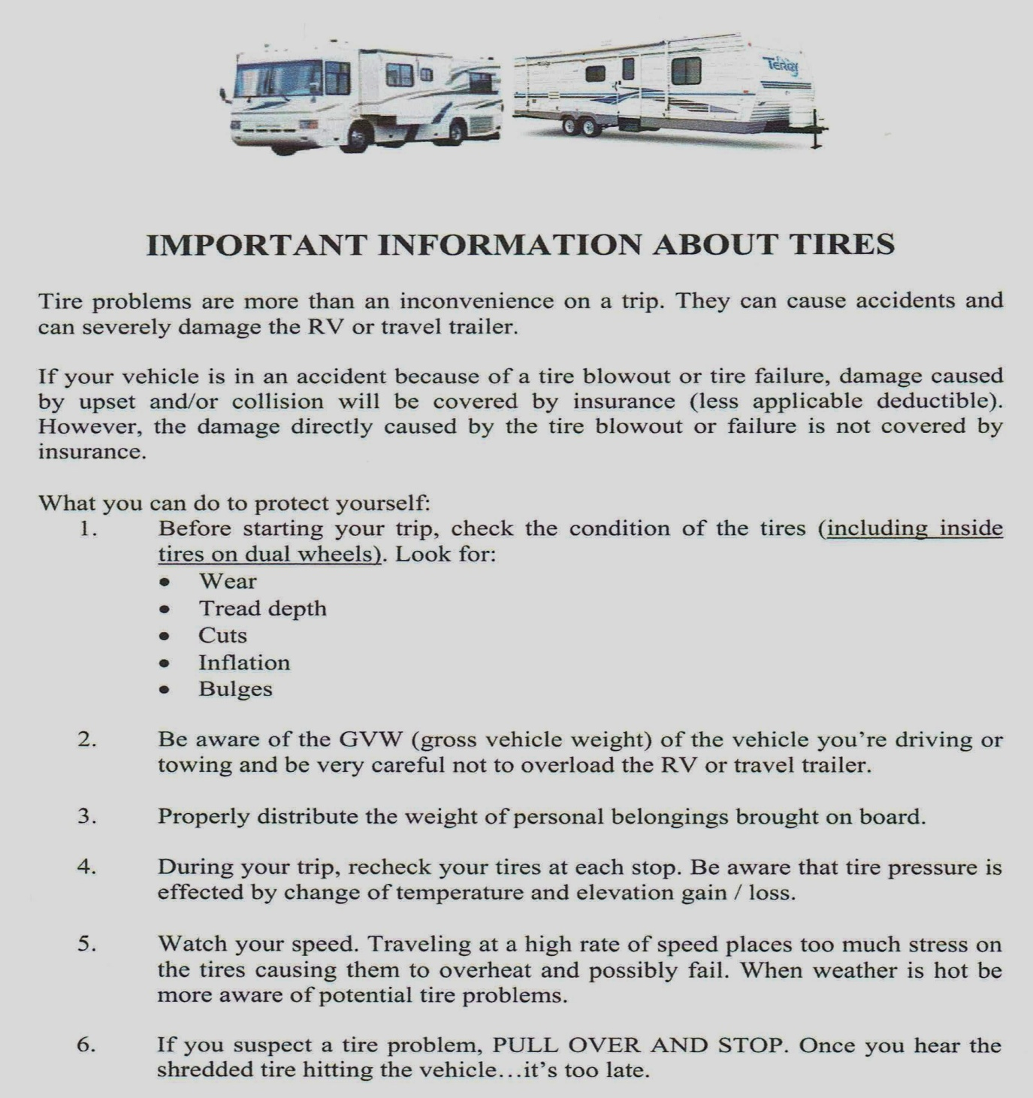
The summer heat can put extra strain on tires – Here are tips in case of a blowout:

Two important Don'ts:
-Don't step on the brake. This can reduce vehicle stability.
-Don't abruptly take your foot off the accelerator as this can cause loss of control.
Steps to follow if you have a tire blowout:
-Slowly step off the accelerator.
-Regain control and stability of the vehicle by correcting the steering.
-Pull off the road when you determine it is safe to do so.

Under inflation is the leading cause of tire failure. Google tire pressure demos. You can easily see how a tire can be as much as 50% under inflated before it is visibly noticeable. Not only are under inflated tires more prone to damage and failure, but they can lead to higher fuel costs by as much as 3 to 5¢ per gallon.
Please research driving destinations to figure out if tire PSI may need to be lowered or increased based on terrain and temperature changes. Avoid road debris as it can damage tires.
______________________ _____________________________
Tire Blow Out can cause an accident and possibly damage to the rv.
DO
NOT
DRIVE
MORE
THEN
55 – 65
MPH
WITH
RV

Renters Signature Renters Printed Name

