Pastor’s Corner “If you really keep the royal law found in Scripture, ‘Love your neighbor as yourself,’ you are doing right. […] Show me your faith without deeds, and I will show you my faith by what I do.” (James 2:8, 18b)
2020 has, thus far, been an incredibly strange year for Grace Hills, and for all the churches around us. We have had to significantly change our rhythms of gathering; indeed, being physically together has not been an option for a good chunk of the year. Some days, when I go past our empty sanctuary or realize that there are members I haven’t laid eyes on in-person since mid-March, I can become a bit down.
Then, I remember: the church isn’t the building. The church is the people – and the people of God at Grace Hills, like the people of God in many other churches, haven’t stopped being the church. We have been caring for others and serving our neighbors and loving others as ourselves in so many ways – indeed, in new and exciting ways because we’ve had to get creative!
I ran across this cartoon on Facebook about a week ago, from CartoonChurch.com, and it encouraged me – because I see our wonderful congregation reflected in it.
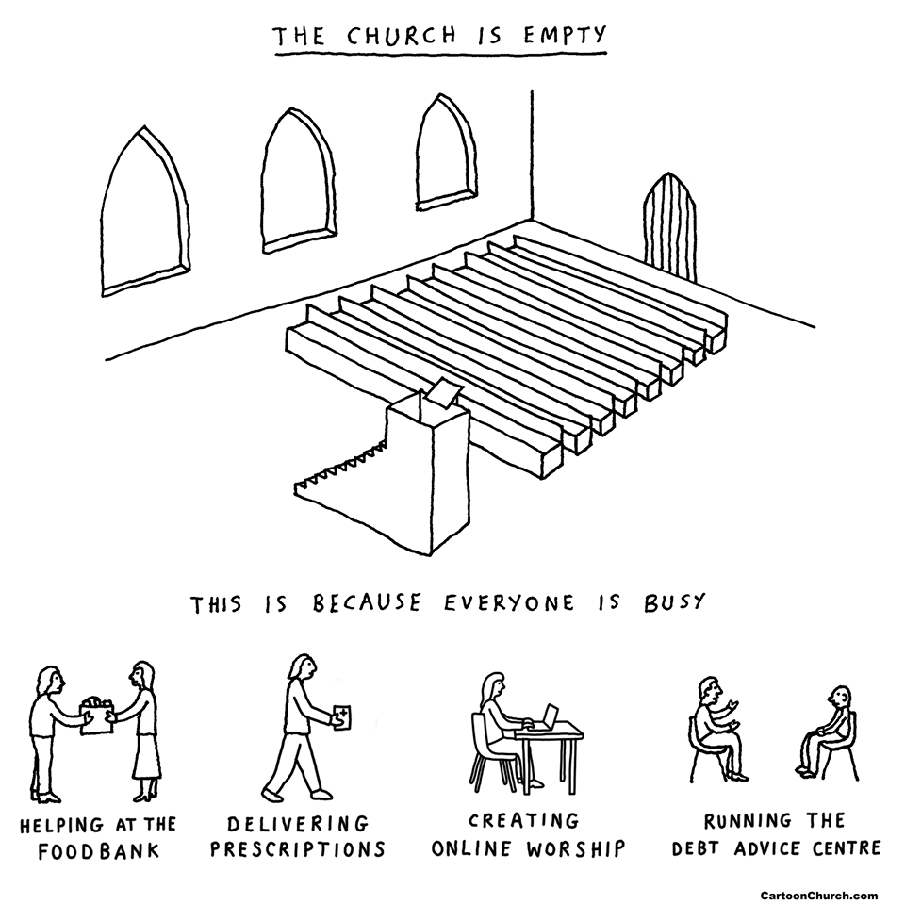
Thank you for being the church, especially in this difficult time. Let’s keep it up!
Be well, friends,
Pastor Adam
_________________________________________________________________________________________________________________________
Worship Plan for July
For the month of July, we will meet for worship on our front lawn at 9:30 AM.
For our Front Lawn services, let us know if you have a pop-up tent we can use!
At services, we will continue to practice social distancing and highly encourage the wear of face masks
In the event of inclement weather, we will post plans on our Facebook page
and send it on our robocall system.
From the Deacons
Summer is moving quickly! We hope all this chaos will send soon and we can be together again. With social distancing still required, it remains difficult for us to see each other in person. (I miss being with all of you!)
Deacons continue to minister to our congregation with Christian love and kindness though notes, cards, calls, and personal contacts, when possible. Our latest way of meeting as a council has been through Zoom. It’s not the same as being together in person but is the best we can do for now. At the June meeting, we focused on particular needs of those in the Grace Hills congregation, particularly those facing health issues. We also discussed the upcoming deacon election and options for what to do until we are able to get back together. We’ll be sharing ideas from the deacons with Church Council and the membership soon.
Deacons are also seeking your help in outreach. We ask that each of you select one member of Grace Hills to regularly keep in contact with through calls, notes, cards, or other contacts. Those you might wish to consider are individuals at home alone or in help care facilities, or with ongoing health or personal needs. Select a friend or neighbor if you prefer. Your involvement multiples the Grace Hills ministry during this challenging time.
Several calls for assistance have been received this month. Tim Peterson is currently serving as our main benevolence contact at this time. We are also addressing ongoing needs of several families.
The Deacon Council is a ministry of service and love. Our work is an extension of all the other good things that are happening in our church. Please let us know if you are aware of those for whom we should pray, visit, or assist.
May the grace and peace of God and His great blessings be with you. Stay well and safe.
Janice Marston, Chair
_______________________________________________________________________________________
🎶 🎶 MUSIC NOTES 🎶 🎶
Brandon Loving will sing for us once more on July 5th. Our plans for the remaining worship hours in July will be altered according to church's council's decision to stay outside (weather permitting), meeting at 9:30 a.m. on Sundays during July. We will not bring in handbells for outside worship. Flexibility must be our motto. Thanks to all of you who have come out for front lawn worship; it has been lots of fun to see you there. Continue to bring sunscreen and sunglasses, and water for yourselves, comfortable lawn chairs, and umbrellas. Casual dress is definitely "in" for summer at Grace Hills. Thanks to Steve and Adam who do a lot of the moving of chairs and equipment out, and back in (and to choir members who help with the back in part). Hopefully we can get the low-power radio transmitter back online this Sunday, so that those of you who do not wish to leave your cars may tune in as we worship.
"I will sing to the Lord all my life; as long as I live I will sing praises to my God. May He be pleased with my song,
for my gladness comes from Him". Psalm 104:33-34 TEV
Sing in your hearts!
Nancy Williams
…Let us love one another.
1 John 4:7

Here we are in the middle of summer and not quite sure where the past few months have gone. Good Neighbor is continuing to be alert to the needs of those in our community. Although we are not staffing the center at this time, we are regularly checking and responding to messages left on the answering machine.
The Good Neighbor Council will meet during July to focus on upcoming plans and ways to assist others. We know the needs of our community will become greater the longer this pandemic continues. We ask that you join with us in prayer for those who are ill, lonely, experiencing financial and personal struggles, and dealing with significant changes in life. We also pray for a time of “normalcy” for all of us.
If you are seeking help or know someone in need, call us. If you want to help in efforts to reach others, you may use a direct cell phone number (434-660-4873) as an immediate contact. The Good Neighbor Council and volunteers will continue to communicate on a regular basis.
We pray God’s protection and blessings for wellness and safety for all.
Prayer: Father, help us to always realize that we are on a mission for You.
Blessings,
The Good Neighbor Team
_______________________________________________________________________________________________________________
GRACE HILLS YOUTH
1. We will not have a traditional VBS this year due to Covid 19. Instead, we will host a live streaming of Impact Kids on July 13th, 15th and 17th from 5:45 to 8:00 in the evening. There will be a live streamed worship service, games, food, a mission project and fun. We will have a smaller event for everyone's safety. Impact Kids will be for children entering Kindergarten through children entering 5th grade. Invite a friend, but please contact Lara Peterson by July 3rd if you plan to attend.
2. We will also be hosting Impact VA for the youth (rising 6th graders through rising 12th graders) on July 27th, 29th and 31st starting at 5:45 in the evening. We will have a live streamed worship service, Bible study, food, a mission project and fun! I'm ordering T-shirts for participants, so please let me know by Wednesday, June 24th, if you want a shirt. Invite a friend, but please contact Lara Peterson by July 20th if you plan to attend.
3. We will be having 2 movie nights before Impact. We'll watch Dumbo (all GHBC children and youth will be invited), and we'll watch Just Mercy (just youth invited). More information to come!
____________________________________________________________________________________
Report of the Church Council and Ministries of Grace Hills, June 21st, 2020
A report from the church council, deacons, essential church leaders, and church staff covering the activities of Grace Hills in the past three months is available to view online at gracehillsbaptist.com/announcements.
Grace Hills Early Learning Center News
Director: Leslie Galloway Bookkeeper: Lisa Dawson
Phone: (434) 352-2273 Email: gracehillselc@aol.com
Temporary Attendance: Full Time Students: 55 School Age Students: 30

Praying all is well with everyone during these unpredictable times.
Some of what we have been learning?
- Infant classes have been learning to kick and throw balls.
- Tot’s and 2’s classes have been busy exploring the great outdoors.
- Red 3’s class has been reading The Old Mermaid Who Swallowed a Shark, they sorted what she swallowed and did not swallow.
- Blue 3’s class have been busy reviewing their colors, shapes, numbers, letters, months of the year and seasons.
- Pre-K classes have been learning Bible Stories about David and Goliath.

Each month all of our Preschool classes have colors, numbers, shapes, and letters they work on to prepare them for the next class. Each class also has monthly Bible Verses!
_______________________________________________________________________________________
Dear Grace Hills Baptist,
Thank you so much for all your prayers. I had to do 2 funerals within 15 days. It really is hard when you can’t even hug the family when giving condolences.
Blessings, Marisa 😊 (This was a note received from our missionary to the Eastern Shore, Marisa Sanchez)
_______________________________________________________________________________________
Grace Hills Baptist Church
gracehillsbaptist.com
PO Box 807 (for mail) (434) 352-8847
4320 Pumping Station Road ghbcoffice@yahoo.com (Monica)
Appomattox, VA 24522-0807 gracehillsbaptist@gmail.com (Ruth)
Monica Ewer’s (Financial Secretary) office hours: Mondays and Wednesdays, 9:00am-5:00pm
Ruth Perry’s (Administrative Assistant) office hours: Tuesday and Thursdays, 9:00am-5:00pm

