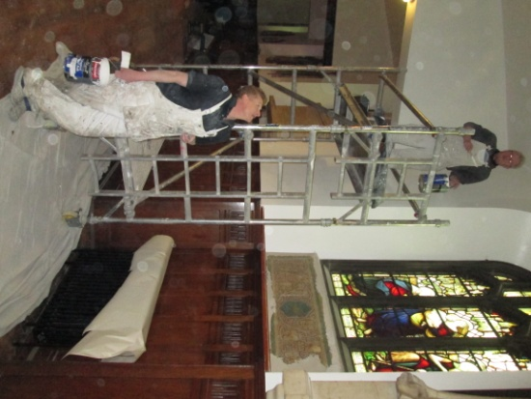
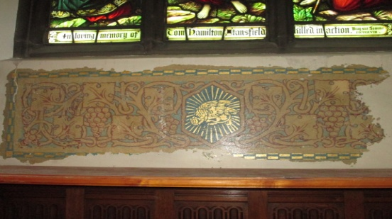
The decorating in the south aisle is more or less complete, leaving on show the stencilled work damaged beyond repair on previous refurbishment attempts.

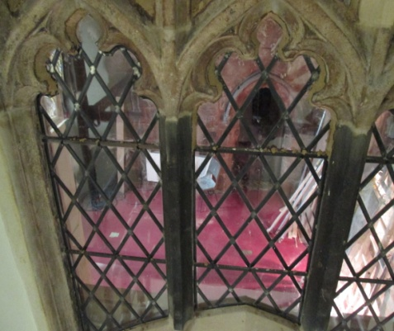
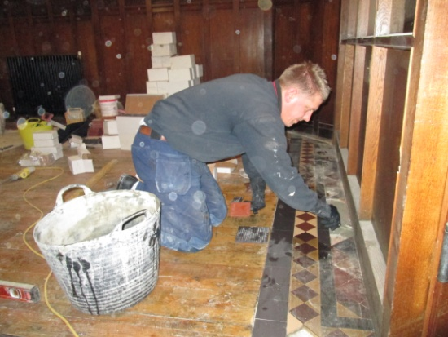
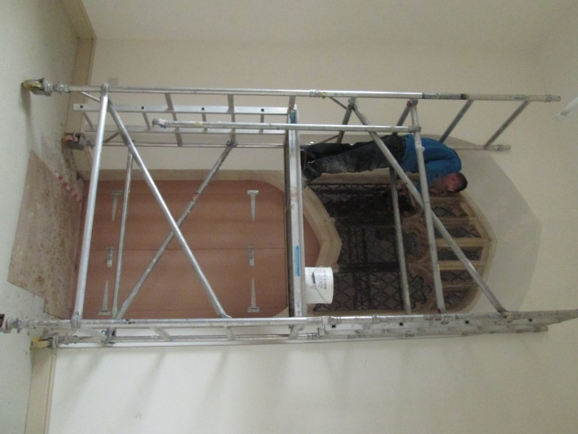
The window over the new arch between Heritage and the old Choir vestry is being pointed and now in place the temporary doorway allowing for an emergency exit to be put in place once the new SHT area is open to the public. The vestry area(s) will otherwise remain closed for the foreseeable future. We look forward to setting up the new “Church Office” in the south aisle – once the tiles are finished.

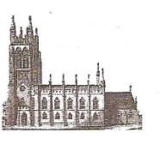
Mary’s in the Marketplace.
Issue No 34 (10th March 2013)

“Securing the future for the next 100 years”
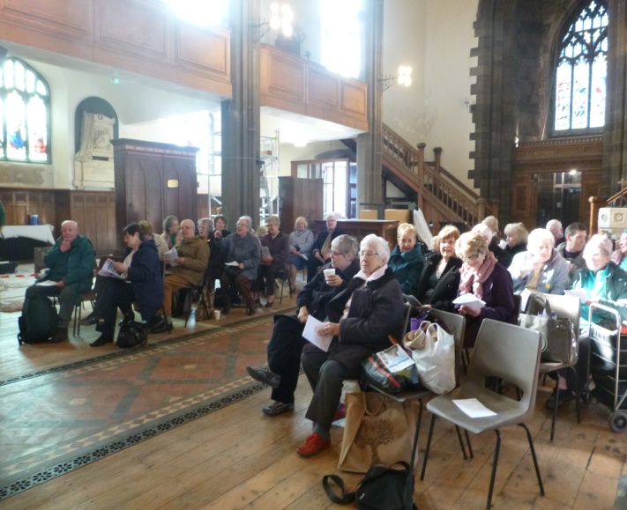
Open for Sunday and Tuesday services – it was wonderful to open the doors again and welcome everyone back both on Sunday and Tuesday. As everyone could see for themselves there is still plenty of work to be done before this part of the refurbishment of the interior is complete.
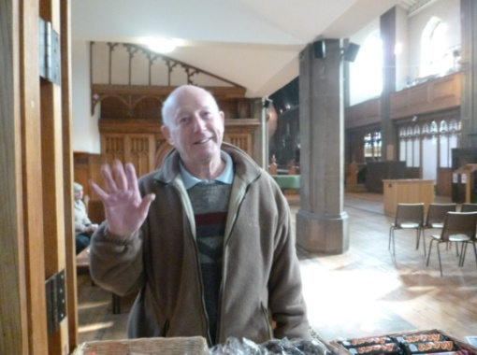
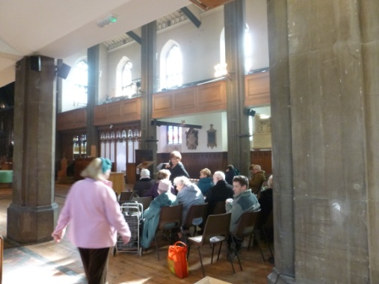
So temporary closure arrangements during the week will continue a little longer giving our contractors more time to themselves to get on with the work. Our next site meeting (and potential part-handover) is scheduled for the 15th March, so fingers crossed there is no more slippage on the time-scale.

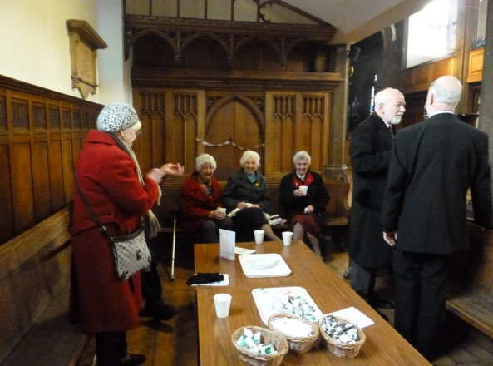
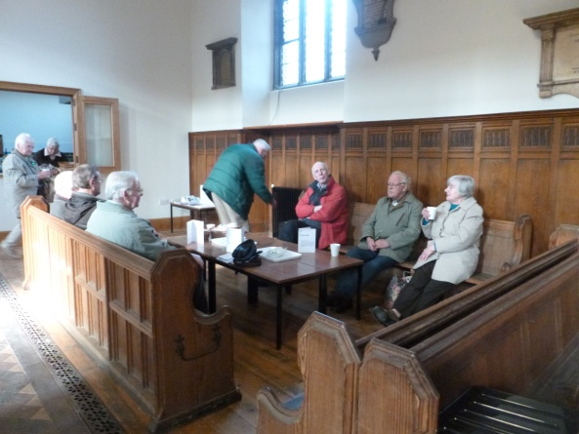
Our hospitality area has returned to the north aisle and the new kitchen is partially operational – in that we are able to serve the usual tea/coffee/Bovril and hot-chocolate with a limited amount of pre-packed food. Enough to keep us going until we are open properly.
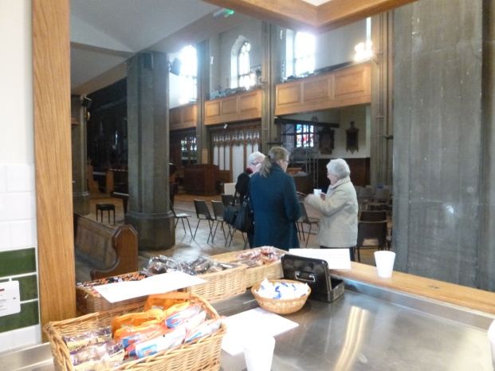

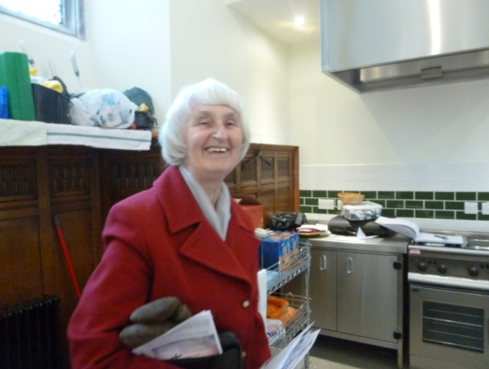

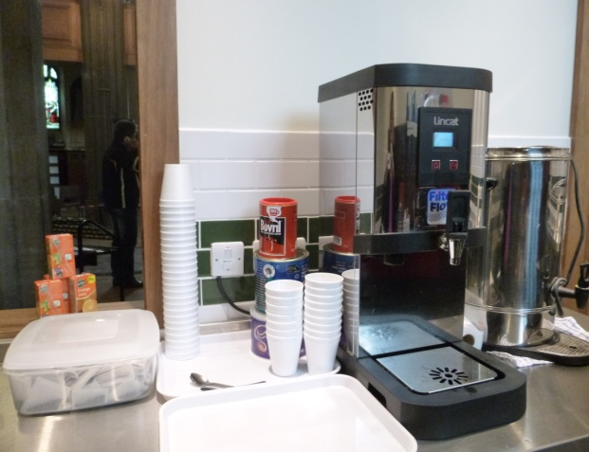
We will dispose of the disposable foam cups in due course and replace them with cups/saucers and mugs! Other items of kitchen equipment will follow shortly.
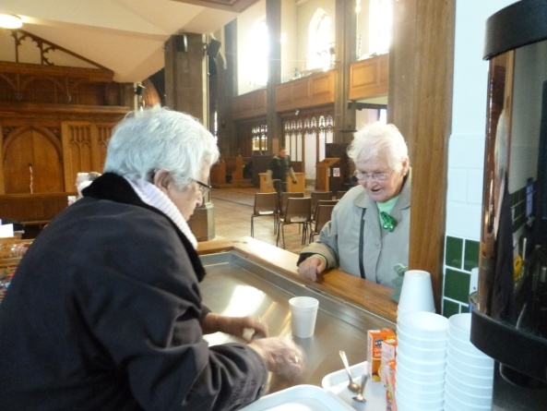

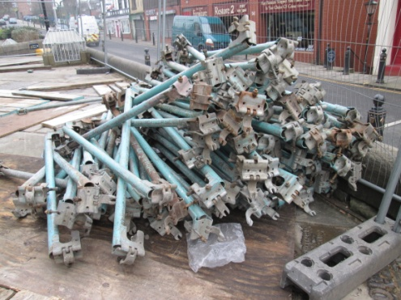
Our next priority is to order the new Alpha Winchester chairs – 180 ordinary stackable chairs with an additional 20 (also stackable) with arms. Each will have protective plastic runners to protect the floor and enable them to be linked as necessary. Anticipated delivery to be around the end of April. We are also looking closely at quotations for the pew cushions – for the chancel and hospitality area as well as new cushions for the Sedilia.
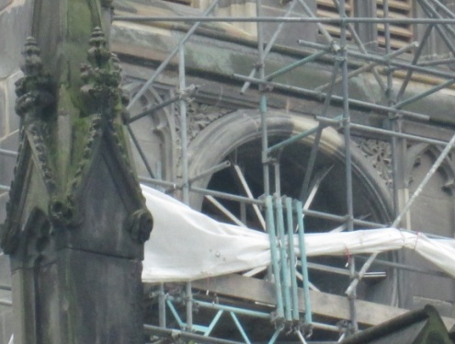
The scaffolding is coming down quickly now leaving only enough for the restored clock face to be fitted on the 13th March when it returns from Smith of Derby.

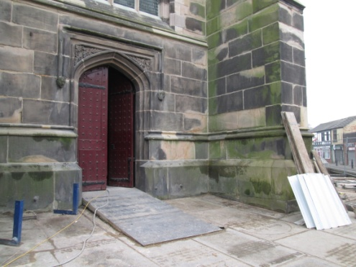

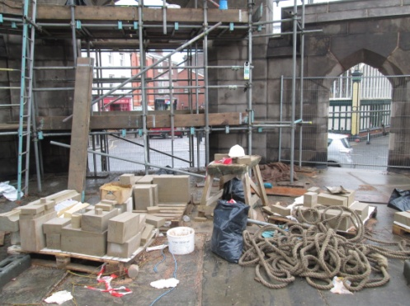
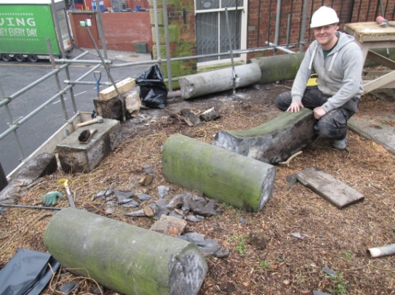
Work continues on the Churchyard Arch with new stone now being put in place.

