13 DOWNLOAD AND APPLICATION INSTALL

13.1 WEBSITE DOWNLOAD OF INSTALLATION FILES

Instrument Specs and Index Setup.zip file can be downloaded from the Website https://instrumentspecsandindex.com and saved to the computer’s Downloads folder.

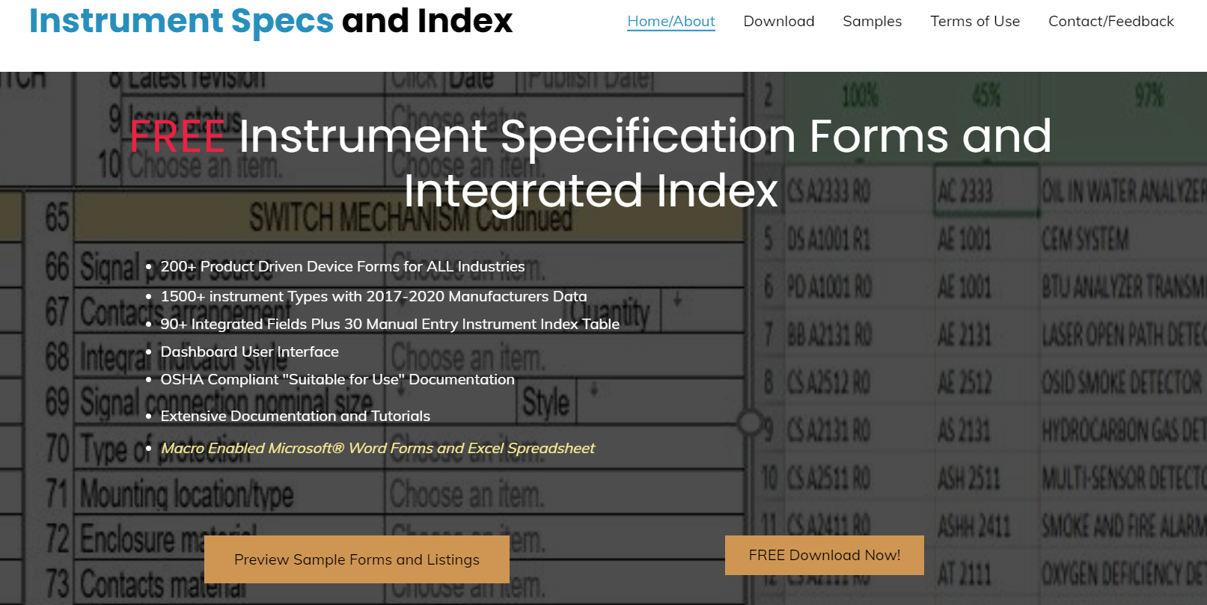

- Clicking the “FREE Download Now!” button will open the Download Page.

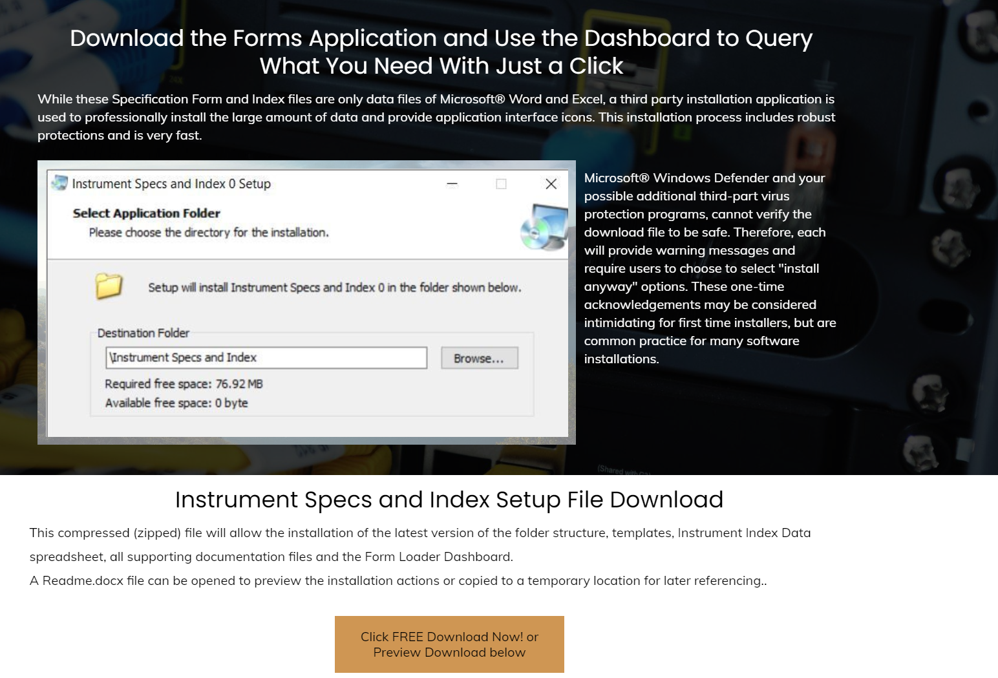

- Clicking the “Click FREE Download Now! or Preview Download Below” Button”, will open the Website Download - OneDrive download tab while the download process automatically proceed.
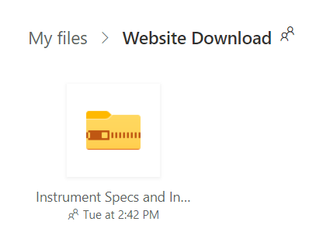
Note that on fast systems, this screen may flash by and not be noticed by users.

- When the download is complete, the status message window will display the Open file option.

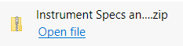

- Clicking the Open file icon will open the Computer’s Downloads folder.

13.2 WORKING WITH THE DOWNLOADED INSTALLATION FILES

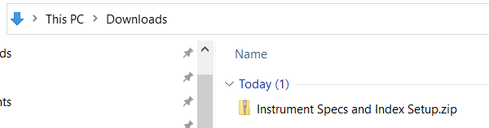
- The computer’s Downloads folder will allow access to the Instrument Specs and Index Setup.zip file.

- Double clicking, or right mouse click and choose the “open” menu option of the Instrument Specs and Index Setup.zip file, will open the compressed file and display its content.

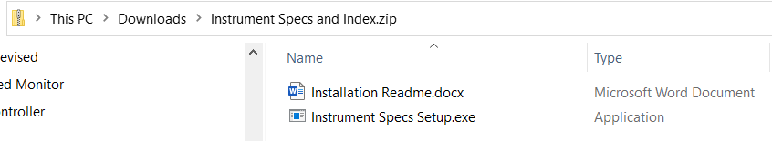

- This Installation Readme.docx file can be opened to preview the installation actions or returned to for later referencing.

- Double clicking on the Instrument Specs Setup.exe file, will open the Compressed (zipped) folders action window.

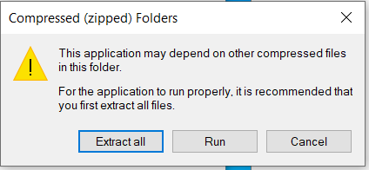

This information warning does not apply to our application, therefore clicking on the “Run button” will open the “Windows Protected your PC” window.

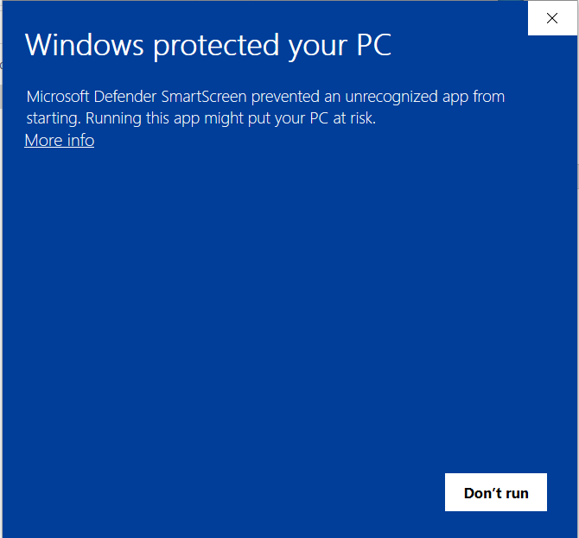

This well intended warning does not apply to our application, therefore Clicking the “More info” icon will add our desired option to “Run anyway”.
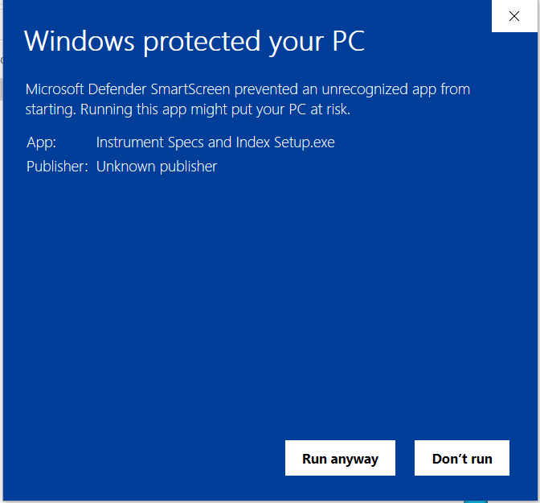

- Note: If your computer has an additional third-party virus protection, then you may get an additional window offering the option to “Run this program anyway”.
- A warning message about unknown source material may appear depending on computer operating system and virus protection software.
- Click “Run anyway” to proceed with the installation.

13.3 INITIAL INSTALLATION

After all the virus protection software has been acknowledged, the Instrument Specs and Index Setup “Readme information” window will open.

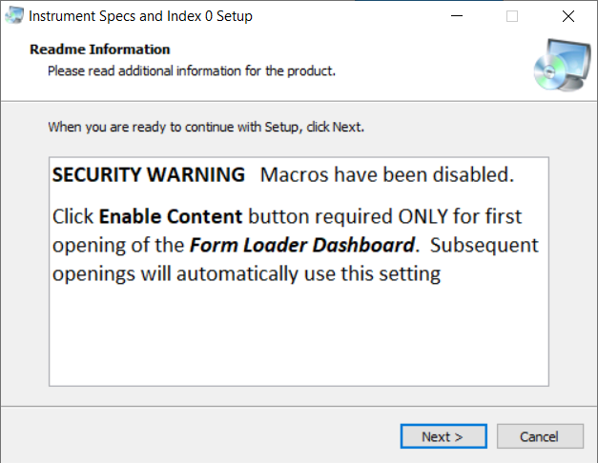

This information window is warning that the application files include Microsoft® macros that will be disabled during installation, but will need to be enabled by the user, the first time that the application is run, as shown below.
- Clicking the Next button will open the “Select Application Folder” window.

- Note: These Microsoft® Word specification forms are designed for electronic file editing and integration with Microsoft® Excel and external software applications, using integrated XML technology. For their effective use, all files need to be located at a drive and folder location accessible to all intended internal project users.

- If a network location is appropriate for multiple users, then use the Browse button to navigate to that drive/folder location.

- The default installation is in the root directly of the active drive/folder. This should be appropriate because there are no “Program Files” present in this application. (Microsoft® Word and Excel are the associated application program files)

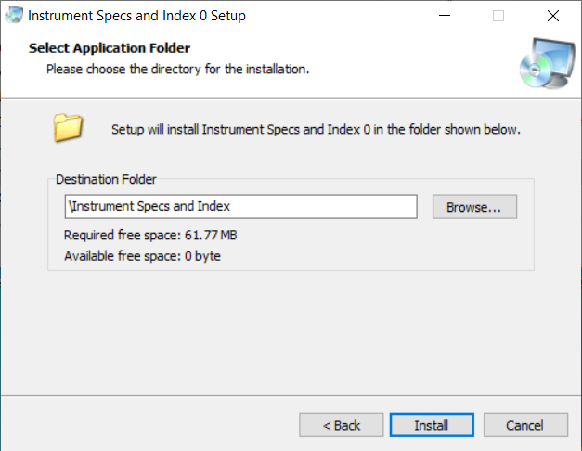

- Click the Install button to proceed with copying the files to the drive

- The Installation complete window will display.

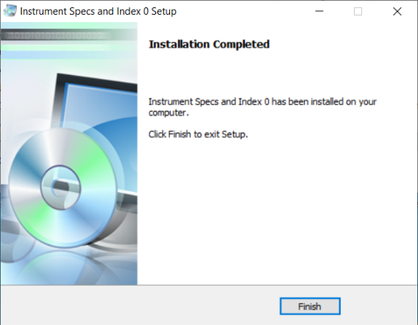

- Click the Finish button to return to your Desktop and verify the application shortcut.

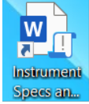

- Click the Instrument Specs and Index icon to Open Word’s Enable Content window.

- 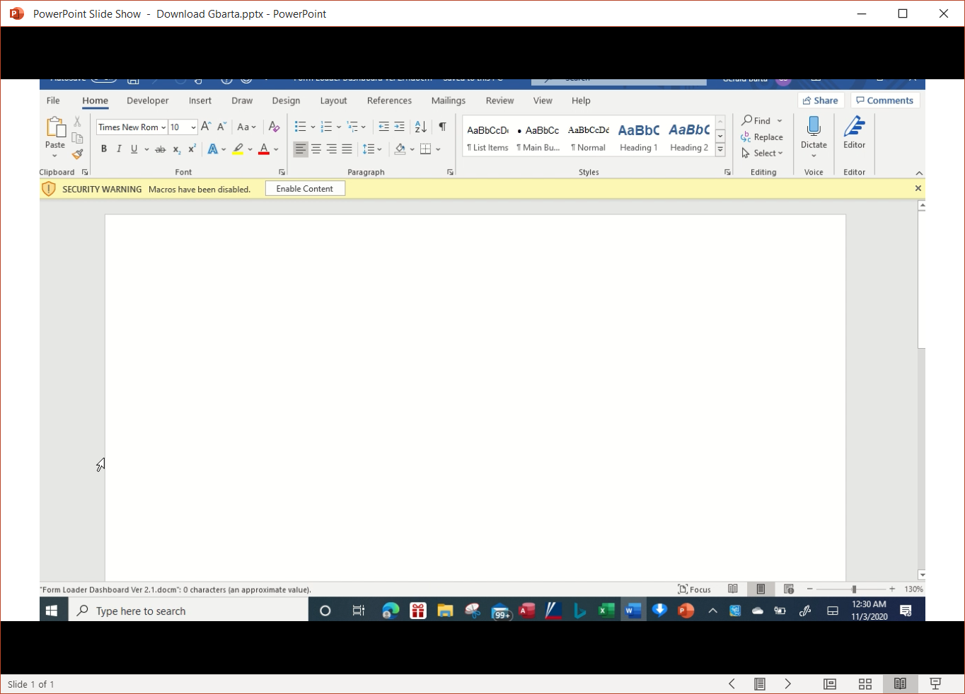

- Clicking the “Enable Content” button will result in Windows storing this file in its enabled file list, which will result in bypassing this Enable Content step for all future openings. The Form Loader Dashboard window will display the status of the default files.

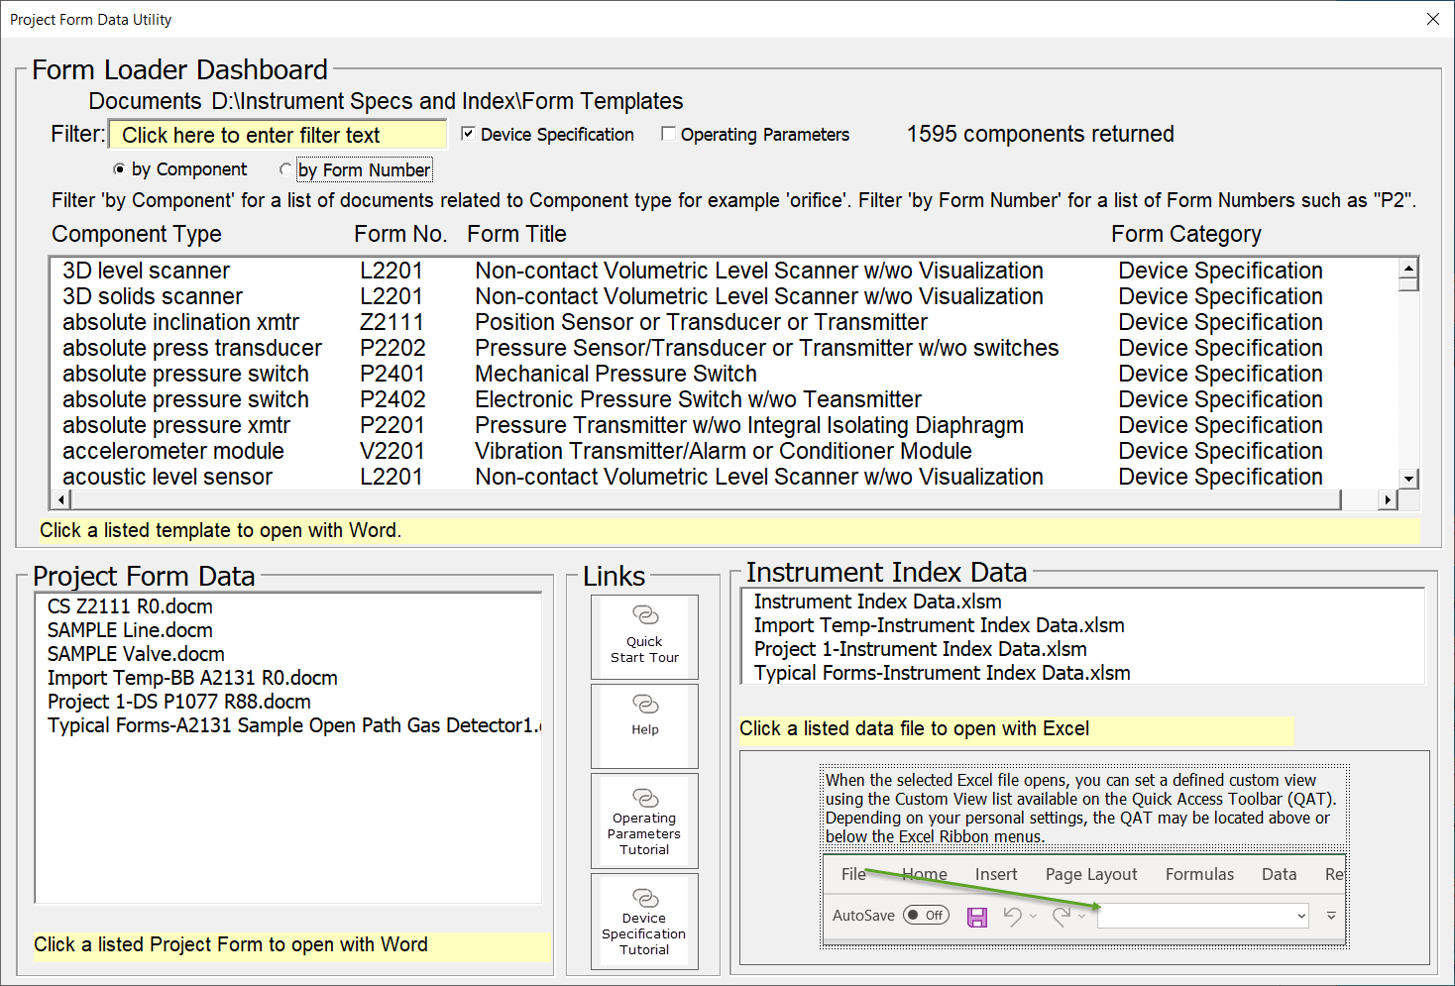

- The installation is complete, and the Form Loader Dashboard can be closed by clicking the “X” close icon.

