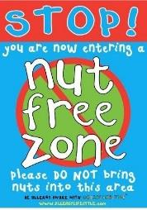
Holiday Club Booking Form. OCT 24th -27th
Costs; Full Day; £33. Early Bird Rate; £35 Normal rate.
Half Day; £19 Early Bird Rate; £21 Normal rate.
9/3 School day. £25 Early Bird Rate; £28 Normal Rate.
Early Bird Rate; given to bookings received before Monday 4th Ocober

Child/ren………………………………………………………………………………………………………… Year group:…………………………
Monday 24th |  |  |  | Tuesday 25th |  |  |  | Wednesday 26th
8.30/1pm | 1/5.30 | 9/3 | 8.30 / 5.30 | 8.30 /1pm | 1/5.30 | 9/3 | 8.30 /5.30 | 8.30 /1pm | 1/5.30 | 9/3 | 8.30 /5.30

Thursday 27th
8.30/1pm | 1/5.30 | 9/3 | 8.30 / 5.30
Terms and conditions
PLEASE ENSURE PACKED LUNCHES DO NOT CONTAIN ANY FOODS THAT CONTAIN NUTS. THANK YOU.
You will be invoiced and expected to pay for all sessions that are booked regardless of whether your child attends. Please note: bookings are subject to minimum numbers.

Signed (parent or carer) ……………………………………………email address…………………………………….……………………......Date received………………………

