health-fitness

4 Calorie-Torching Exercises To Do... While Sitting
by Lexi Petronis
Comment posts (20,090)Thursday, 10/ 4/2012 3:30 PM
We're all guilty of sitting for a few more hours a day than we really ought to--but between work and school, there's a lot of time that's devoted to spending time on our tushes. Luckily, if you're stuck in a seat for most of the day, you can still exercise... with Sitacise.
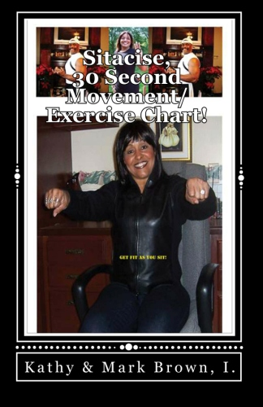
According to Sitacise founders Kathy and Mark Brown, sitting sit for six or more accumulative hours your risk for heart disease increased by 54 percent. But if you do "NEAT"--non-exercise activity thermogenesis movements--you can help reduce your risk (and, bonus: burn lots of calories). Here are four exercises--er, Sitacises--that you can try from your chair, right this second. it's better then a regular workout-- and you can do something when you're sitting, anywhere and anytime!
Seated Water Bottle Curl
This tones the biceps, forearms, and wrists.
* Fill two water bottles.
* Plant your feet firmly on the floor. Hold the bottles to your sides near the top of your thighs.
* Slowly raise the bottles until they're shoulder high.
* Return to the starting position and repeat for up to 30 seconds.
Seated Leg Extension
Firms, shapes, and strengthens the front of the thighs and knees.
* Plant your feet firmly on the floor. The small of your back should be pressed firmly against the seat back.
* Extend one leg at a time, but don't lock out your knees.
* Return to starting position and repeat with your other leg; alternate legs as long as you can (or up to 30 seconds).
Water Bottle Bench Press
Tones the chest, shoulders, and upper back.
* Start with feet firmly on the floor.
* Hold bottles chest high and push straight out, but do not lock out your elbows.
* Slowly return to the starting position and repeat as often as desired (up to 30 seconds).
Seated Calf Raises
*Works the lower legs and helps recirculate blood back through the veins (this is good for helping prevent swollen ankles and feet, or deep vein thrombosis).
* Plant your feet firmly on the floor.
* Raise your heel while keeping your toes on the floor.
* Slowly return to the starting position and repeat until finished (or 30 seconds are up).
How many hours do you usually sit in a day? You have to do in-chair exercises that can help you? How else do you offset a long day of sitting?

