Nutrition Plus, Inc.
121 Mays Rd., Winfield, KS. 67156
Emily Roark Patti Brenn Susan Morrell
(620) 221-2777 (620) 218-1811 (785) 230-7441
roark2@cox.net pattibrenn@cox.net smorrell12@gmail.com
www.nutritionplusinc.com
April is:
2nd – National Peanut Butter and Jelly Day
5th – National Deep Dish Pizza Day
12th – National Grilled Cheese Sandwich Day
15th - National Glazed Spiral Ham Day

Important dates:

April 30th – Checks/Direct Deposits go out

Training Updates!
Since the gathering limits haven’t been raised yet, we have purchased a Zoom subscription for the remainder of the program year (through September). We will be training on this in our spare time, so we can bring trainings to you quickly. I know the Zoom meetings can be annoying, and not as fun as in person, but we have to adapt to the circumstances. With that in mind, I will be offering several opportunities for you to join one before the end of September. My plan is to do it in the evenings at least once a month for a while. Please remember it is a requirement of the program that you do at least 2 hours of nutrition training each program year. “Feeding Infants in the CACFP” is what we are doing first. There are other topics to train on, but the infant feeding directly effects menus and reimbursement. I appreciate your patience with this, as I am not a fan of online trainings either.
April 2021

Let’s get physical!

The weather is starting to warm up, finally! I know we will probably have that renowned “final winter storm”, but for the most part, we can start thinking about spring. It’s time to shake off the dust and get our sunshine on!
The benefits to physical activity are countless. We already know this as adults. It is important that we teach our kiddos this as well. To keep it simple:
- Being active makes us feel better by improving anxiety and depression
- Being active helps us sleep better
- Being active helps keep us healthy by improving our strength and keeping our bodies healthy.
The CDC (Centers for Disease Control) recommends preschool-aged children ages 3-5 get physical activity every day throughout the day. They also recommend children age 6+ get a minimum of 1 hour of moderate-to-vigorous intensity activity daily. This includes: running, soccer, climbing, push-ups, gymnastics or jumping rope. Varying these activities focuses on different goals like cardio health, strengthening muscles, and strengthening bones.
Also, according to the CDC, spending time outdoors can improve overall health and wellness. Time outdoors may also promote mental health and stress reduction. While enjoying the benefits of being outdoors, people can decrease skin cancer risk by using sun protection. Protect yourself and others by staying in the shade, wearing protective clothing, and applying and re-applying a broad- spectrum sunscreen with a sun protection factor (SPF) of 15 or higher. It’s time to get out and enjoy the spring!!!
Outdoor activities for kids
(social distancing approved)

Simon Says
This helps children learn the importance of listening to instructions but also that mistakes happen and it’s ok. It will help them accept that they aren’t perfect and help them self-regulate. This will come in handy when they are in school or other situations where following instructions is important.

To play: Stand 6 feet apart. Someone is Simon. Simon gives an instruction by saying “Simon says…” and the participants do the task. If they don’t, they sit down until the game starts over. Simon says some instructions without saying “Simon says” and if the participants do it, they sit down until the game starts over. Eventually, there is only one participant left standing and the game begins again.

Animal Kingdom
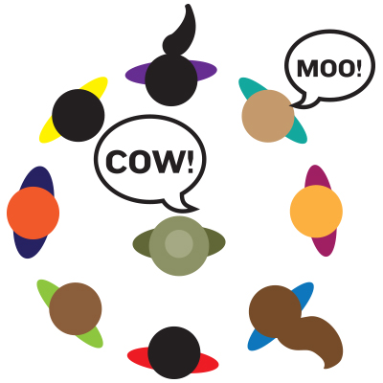
This helps children with listening, following instructions and thinking quickly. It also helps with patience and taking turns.
To play:
*Form a circle and stand 6 feet away from each other. Select one player to be the zookeeper, who will stand in the middle of the circle.
*The zookeeper will close his or her eyes and instruct other players how to move around the circle (skip, run, jump, etc.). Make sure to keep your distance.
*When the zookeeper is ready, he or she says, "freeze," points to someone, and shouts out an animal.
*If you are chosen, you have to make the sound of an animal that the zookeeper says.
*The zookeeper has three chances to guess who made the sound.
*The player who made the animal sound switches places with the zookeeper.
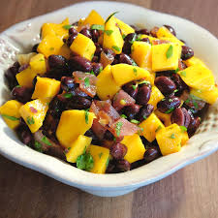
Tropical Bean Salad
This tangy salad is delicious as a side dish or as
a topping for tacos, chicken, or fish.

Ingredients:
3½ cups black beans, low-sodium, canned,
drained, and rinsed; or black beans, dry, cooked
1½ cups mango, canned, drained, diced
¾ cup tomato, fresh, ¼" diced
1 tablespoon canola oil
2 tablespoons apple cider vinegar
½ teaspoon oregano, dried
¼ teaspoon black pepper, ground
3 cups lettuce, Romaine, raw, chopped

Instructions:
1. In a medium bowl, mix together black
beans, mango, and tomato to make a
salad.
2. Prepare dressing: In a small bowl, whisk
together canola oil, apple cider vinegar,
oregano, and pepper.
3. Toss black bean salad with dressing.
4. Cover and refrigerate. Chill for at least 2
hours to allow the flavors to fuse.
5. Serve 1 cup black bean salad over ½ cup
lettuce.
Critical Control Point: Hold at 40 °F or lower.
Makes: 6 servings. [1 cup bean salad over ½ cup lettuce provides legume as meat alternate:
1½ oz equivalent meat alternate, ⅜ cup
vegetable, and ¼ cup fruit; or legume as
vegetable: ⅞ cup vegetable and ¼ cup
fruit.]
Thanks for all you do for your families!
Emily, Patti & Susan

