500 SPECIAL PURPOSE
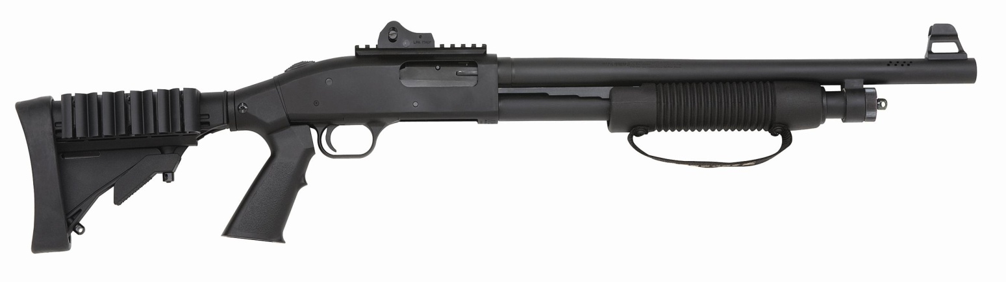
500 SPX – 6 Shot
12 Gauge, 18.5” Barrel/Matte Finish, Adjustable Black Synthetic
Tactical Stock, Picatinny Rail, LPA Ghost Ring Rear Sight,
LPA M16 - Style Front Sight

(SPECIFICATIONS)
- 6, 8 AND 9 shot capacity with 2-3/4” shells
- 18-1/2” or 20” barrel lengths
- Blue, matte or Marinecote finishes
- Bead front or Ghost Ring sights
- Rugged synthetic stock and forearm
- Ambidextrous, thumb-operated safety
- Proven Mil-Spec & NIL performance
- Pistol grip models available
- Twin action bars
- 20-gauge and .410-bore models also available
- Includes free gun lock

Guard dogs have to be fed, walked
groomed, trained. These you just oil.
High security is fine; high maintenance isn't. Enter the Mossberg® 500® and 590® Persuader® shotguns -- the pump-action shotguns you can count on for your security needs. They have the credentials and track record to prove it. In their commercial form, the Persuaders are virtual duplicates of the proven Mossberg® military 500® and 590® models -- the only pump-action shotguns ever to pass all stringent U. S. Military Mil-Spec 3443 standards. Use the 500® Persuader® at home and the Mariner® on the water – these guns are dependable and economical. Especially when you don't have to cover the added expense of chew toys.
Available in a full range of popular models. Persuader® shotguns are available in both 18-1/2” and 20” barrel lengths, traditional blued or non-glare matte finishes, a four-shell capacity Speedfeed® stock and Ghost Ring® sights for quick target acquisition.

