
Kingston Single Malt Society
A social club for the appreciation of Single Malt Whisky since 1998
FEBRUARY 22, 2010 VOLUME 2; NUMBER 5

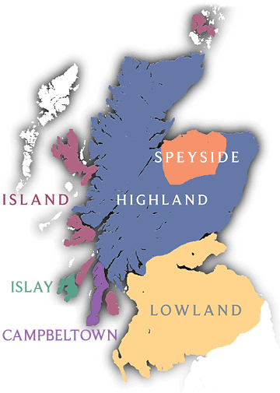

This evening's

menu in the

company of

Single Malts from

the HIGHLANDS

----------------------------
Soup: Sweet Green Pea with Mint Pesto

1st Nosing: EDRADOUR 10 YEARS OLD
(introduced by: Frank DuBois)

Salad: Spring Mix
Dressing: Seasonal Fruit Topping

2nd Nosing: TULLIBARDINE PORT WOOD FINISH
(introduced by: Sylvain Bouffard)

Entree: Lamb Chop, with Red Wine Sauce
Infused with Thyme
Vegetables: Butter Carrot with Tip
Potato: Goat Cheese Mashed Potato

3rd Nosing: CLYNELISH CONNOISSEURS CHOICE SINGLE MALT 1993
(introduced by: Andrew Gault)

Dessert: Cranachan

----------------------------
----------------------------
COST OF THE MALTS
I know members are always interested in the cost of the single malts we taste. Plus the $75 Special Occasion Permit and the 16% levy charged by the LCBO for all alcohol served at the dinner.

- EDRADOUR THE DISTILLERY EDITION 10 YEARS OLD HIGHLAND SINGLE MALT VINTAGES 904995 | 700 mL bottle Price: $ 74.95 Spirits, Scotch Whisky, 40.0% Alcohol/Vol.

- TULLIBARDINE PORT WOOD FINISH CASK (Distilled in Perthshire in 1998), Bottled in 2008, non-chill filtered, Price: $ 83.49 Spirits, Scotch Whisky, 46.0% Alcohol/Vol.

- CLYNELISH CONNOISSEURS CHOICE SINGLE MALT 1993 Btld. 2009 (Gordon & MacPhail) VINTAGES 0158147 | 700 mL bottle Price: $ 119.00 43% Alc./Vol.

----------------------------
Results of THE BALVENIE 30 YEAR OLD Raffle
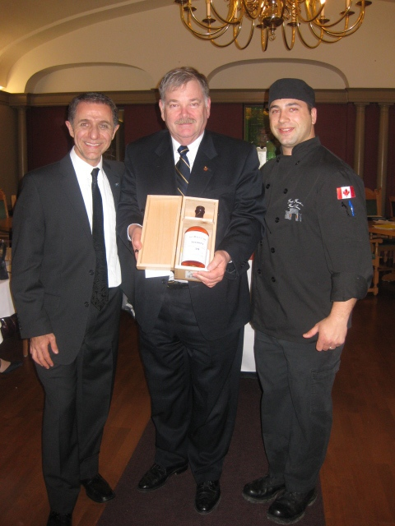
Congratulations to our winner: Jack Johnston holding his newfound prized possession here in the company of our chef for the Robbie Burns dinner, Keven Lemay and yours truly.
As you know the bottle cost us $640.95. Add to that the 16% levy charged by the LCBO and the final price was $743.50. Thanks to a last minute burst by January attendees we collected a total of $988 during the course of the raffle.
KSMS benefited by having $244.50 added to its coffers!! Job well done. Thank you one and all.

----------------------------

Dinner dates for KSMS 2009-2010
March 22, 2010 – St.Patrick's (Irish)
April 26, 2010 – Island
May 17, 2010 – Islay
June 21, 2010 – BBQ (Final Exam)

----------------------------

----------------------------

JANUARY - KSMS Financial Statement
(Money raised by January attendees) = $5420.00
January dinner 85 persons = $42.42/ea = $3605.38
Special Occasion Permit @ LCBO = $75.00
(Money remaining for buying Single Malts) = $1739.62
Cost of Single Malts: = $916.28
KSMS Monthly operational balance = $823.34
Cost per person (All inclusive) = $56.43

----------------------------

Membership and Dinner prices for 2009-2010
Membership Fees: $40 (singles)
$60 (couples)
One Time Initiation Fee $15
Standard Dinner Fee: $50 (member)
$60 (non-member)
Dinner only - No Single Malt: $45 (member)
$55 (non-member)
Robbie Burns Dinner Fee: $60 (member)
$70 (non-member)
(includes $5 donation per attendee to RMC Pipes &
Drums with Highland Dancers)
June BBQ Dinner Fee: $60 (member)
$70 (non-member)

----------------------------

Whisky Makers Spend $800 Million to Age Scotch for China, India
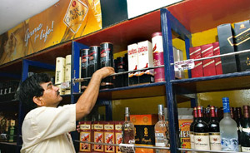
(http://www.bloomberg.com/)
By Rodney Jefferson Dec. 2 (Bloomberg) Ninety years after Johnnie Walker stopped making Scotch in Annandale, David Thomson wants to put the distillery back on the whisky map of the world.
The plant, 12 miles from where he grew up in southern Scotland, closed in 1921. With 5 million pounds ($8.3 million) in cash, Thomson plans to open it up again in 2011.
“We can make so much more of malt whisky as an industry,” said Thomson, 54, who submitted plans for local government approval on Nov. 12. “We haven’t even begun to tap into the potential interest.”
More money is being invested in whisky than at any time since the late 1960s, according to the Scotch Whisky Association in Edinburgh. The reason, producers like Diageo Plc say, is to make sure they have enough of it to serve China and India, as well as to cater to the growing demand among malt buffs.
“The Chinese have bought into Scotch whisky,” Gavin Hewitt, chief executive officer of the association, said at his office in the Scottish capital. “There’s a huge new middle class and they want to make a statement about themselves.”
Companies announced expansion plans during the past two years costing more than 500 million pounds, according to the industry group. Whisky is Scotland’s biggest export, excluding oil and gas, it said.
Ageing Process The liquor being distilled today can’t be called Scotch whisky until it’s three years old and then often has to age for at least another seven before it’s bottled as a single malt. It also has to be made in Scotland.
The largest single investment during the past two years was by London-based Diageo, the world’s largest liquor maker and biggest producer of Scotch. Its net revenue from whisky, including top brand Johnnie Walker, rose 7 percent to 2.42 billion pounds for the 12 months to June 30, the company said.
Diageo, whose best-selling malt is Talisker, spent 40 million pounds on a plant at Roseisle in northern Scotland, part of 100 million pounds of investment.
“It’s about growth over the next two or three decades,” said Ken Robertson, Diageo’s head of corporate relations for whisky. “You have to lay products down well in advance.”
Glenmorangie, which Paris-based LVMH Moet Hennessy Louis Vuitton SA bought in 2005 for 300 million pounds, is increasing capacity at its plant at Tain in the Highlands by 50 percent. Along with new bottling and warehousing, the investment over two years amounts to 45 million pounds, Glenmorangie said.
Pagoda Turret. Thomson said he first had the idea to go into the whisky business in the late 1980s and early 1990s when 25 distilleries closed as more liquor was produced than the world could drink. He didn’t have the money at the time to snap one up, he said.
There are currently seven new distilleries being planned, including Thomson’s, the association said. Since 1995, 18 plants that were dormant have been brought back to production.
At Annandale, the buildings from the 19th century remain intact, complete with a pagoda-style ventilation turret and a beige brick chimney next to a small stream, or burn.
Glasgow University archaeologists are digging out the foundations of where the whisky stills once stood so Thomson can restore the plant to how it was originally.
Exports totaled a record 3.1 billion pounds last year. Total sales this year in volume terms are up about 2 percent, while the value of bottles sold declined about 4 percent, Hewitt said. The biggest markets are France and the U.S., though sellers are counting on Brazil, Russia and Asia for growth.
“The decisions companies make now are for 10 or 15 years ahead,” Hewitt said. ‘Keeping Alive’ Most malt whiskies, typically drunk in Scotland with a few splashes of water, are made in the Highlands, with a cluster of producers in Speyside near Inverness. Should it come to fruition, the Annandale plant would be one of only half a dozen in what are known as the Lowlands.
The risk for new producers is how they fund themselves before their whisky makes it into the bottle and how they differentiate themselves from existing malts, Robertson said.
“Keeping alive for the first few years is the tricky thing,” Robertson said at Diageo’s Edinburgh offices. “The threat to the mainstream is: can it continue to expand into the markets it’s earmarked for itself?”
A professor of consumer psychology based near Oxford in England, Thomson bought Annandale for 1 million pounds from a local farmer in April 2007 and is spending 2.8 million pounds on refurbishment, installing the plant and groundwork. He then reckons it will cost another 500,000 pounds a year until he bottles whisky in 2013 or 2014.
Annandale will include a visitors’ center and store to cater to tourists whose revenue Thomson hopes will help fund the plant. Thomson’s planning application will be heard in January amid potential problems with the access road, he said. The Scottish government granted aid for the project in April 2008.
“If you ask me what I’d like my legacy to be, it would be to bring back a distillery to life,” Thomson said. “And leave it as economically viable.”
To contact the reporter on this story: Rodney Jefferson in Edinburgh at r.jefferson@bloomberg.net

----------------------------

Win Me !!

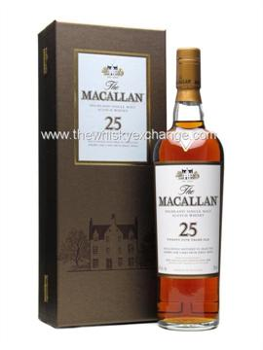
THE MACALLAN 25 SHERRY OAK
SINGLE MALT WHISKY
VINTAGES 283283 | 750 mL bottle Price: $649.95
Spirits, Scotch Whisky, 43.0% Alcohol/Vol

Starting February 22nd, 2010 tickets can be purchased for a chance to win this bottle. Tickets will be $3 each or two tickets for $5. Tickets will be on sale at each dinner until the June 21st, 2010 BBQ Dinner when the bottle will be raffled. The winner must successfully answer the skill testing question: What country does single malt come from?

----------------------------
Whisky Recipe
Cranachan
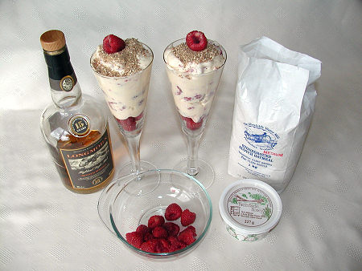
Ingredients:(Makes 2 servings)
- Approx 300g/10½oz raspberries (strawberries can also be used).
- 280ml/10 floz/one cup double (heavy) cream.
- 2 tablespoons good quality honey.
- 2 tablespoons single malt whisky.
- 2-3 tablespoons of oatmeal.
Directions:
1. Place the oatmeal in a cool, dry pan and turn on the heat to simmer. Stirring occasionally, toast the oatmeal until it is golden brown. This process could take between 10-20 minutes.
2. Once the oatmeal is brown, turn off the heat and let it cool in the pan.
3. Place the cream in a bowl and whisk up until soft and relatively thick.
4. Add the honey and single malt whisky and fold it in with a whisk, until it is soft and creamy.
5. Pick out some of the best raspberries for decoration and add three or four to the bottom of each serving glass, leaving a few for final decoration.
6. Add the rest of the raspberries to the cream mixture and fold in carefully, breaking up a few of the raspberries to obtain a slight colouring to the cream.
7. Spoon the mixture into the serving glasses, then add cream to the top to make an even base for the oatmeal.
8. By now the oatmeal will be cooler. Using a teaspoon, evenly sprinkle the oatmeal over the dessert. Add a raspberry for the finishing touch and chill for about three hours, or overnight.
Serving:
Cranachan can be served on its own, or with double cream and more raspberries. For an extra treat, make up the cream and add the raspberries as in 3, 4 and 6 above. Then freeze in a container for a yogurty fresh ice cream.

----------------------------

16th Annual Malt Advocate Whisky Awards winners are being announced one per day through February 11th. John has been busy posting and receiving comments on each of the categories. Come on in, take a look around What Does John Know and be sure not to leave without sharing your thoughts. And the winners announced to date are:

Scotch Whisky: "Single Malt of the Year": Ardbeg Corryvreckan
Scotch Whisky: "Blend of the Year": Compass Box, "The Peat Monster"
"Irish Whiskey of the Year": Jameson Rarest Vintage Reserve (2009 release)
"Canadian Whisky of the Year": Crown Royal Cask No. 16
"American Whiskey of the Year": Parker's Heritage Collection "Golden Anniversary" Bourbon
"Artisan Whiskey of the Year": Stranahan's Colorado Whiskey
"Best Buy Whisky of the Year": The MacPhail's Collection
"Pioneer of the Year": Whisky Bloggers!
"Industry Leader of the Year": Mark Brown (Buffalo Trace Distillery)
The $2 Million Scotch Whisky Gift Experience

----------------------------
by Jared Paul Stern www.luxist.com
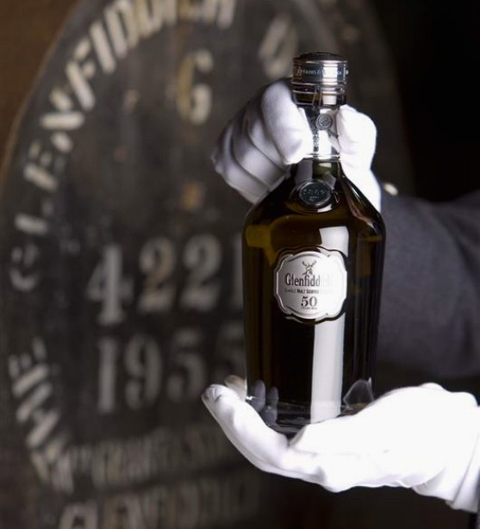
Continuing our series on the seasonal smorgasbord of over-the-top exclusives offered by that glossy chronicle of the filthy rich Robb Report, we present their $2 million single malt Scotch experience. The profligate publication's gift package includes the following: a private tour of the Glenfiddich Distillery in Dufftown, Scotland, conducted by their malt master Biran Kinsman, where the recipient and a guest will learn firsthand how the famed single malt is produced before selecting a personal vintage cask of their own; a rare bottle of Glenfiddich 50 Year Old (above); two nights' accommodation at Ballindalloch Castle, home since 1546 to the Macpherson-Grant family, who will host a dinner in the recipient's honor; first-class roundtrip air travel for two from any U.S. city to Edinburgh; one night's stay and dinner at Edinburgh's renowned Prestonfield Hotel, plus a guided tour of Edinburgh Castle; private roundtrip helicopter rides from Edinburgh across the Scottish Highlands to the Glenfiddich Distillery; and a private tour of the historic Johnston's Woolen Mill and a traditional Scottish lunch with the owner.

----------------------------

Fine Scotch whisky pleases more Asian palates
By James Pomfret (http://www.reuters.com/)

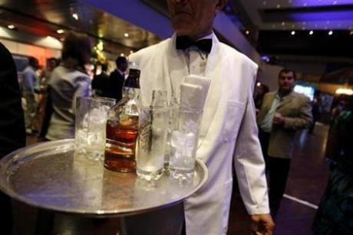
HONG KONG (Reuters Life!) - From ancient, windswept Scottish distilleries to the bustling neon-lit cities of Asia, the flow of fine whisky to the region has been steadily growing as Asians acquire a taste for the so-called water of life.
Not the easiest of drinks to appreciate with its strong, smoky aroma and high alcoholic content, Asians, particularly those in South Korea, Singapore and China have been increasingly drawn to the tipple, accounting for around 20 percent of the 3 billion pound ($5 billion) a year industry in 2008. "It's huge and vital. Asia is the future," said James Espey, an industry veteran and founder of The Keepers of the Quaich, an elite clan devoted to promoting Scotch whisky heritage worldwide. "Europe has plateau-ed, whereas America was the leading market for years, but then there was a white spirits explosion of vodka and rum," added Espey who runs one of the world's most exclusive whisky brands The Last Drop, which was rated "blended Scotch whisky of the year" in Jim Murray's 2009 Whisky bible.
In Hong Kong, which has been gaining traction as an Asian wine hub after abolishing wine duties, auctioneers Bonhams recently held the city's first ever whisky auction, putting up for sale part of the Willard Folsom collection, considered one of the best private stashes of rare whiskies in the world. The sale, which attracted mostly Asian and Chinese buyers in a packed auction room, was 82 percent sold by lot in a sale worth around $70,000, though like many other places in Asia such as India and China, high import duties weighed on demand. "Local collectors are willing to pay the 100 percent duty to secure fine and rare vintages. If (Hong Kong) creates a brilliant market development initiative as they did with fine wines a year ago, the whisky market could grow equally dramatically in Hong Kong," says Colin Sheaf, chairman of Bonhams Asia.
SIPPING HISTORY In recent years, global thirst for rare, quality single malts has grown strongly, with an exceptional bottle of Dalmore Oculus selling for 27,600 pounds at an Edinburgh sale in November. Other single malts with a cult following include Black Bowmore, whose 1964 first edition can fetch over 2,000 pounds.

Despite the hype, overall Asian whisky demand hasn't yet sky-rocketed like wine and remains a much smaller market. Exports to Asia only grew from 524 million pounds in 1997 to 598 million pounds in 2008, according to The Scotch Whisky Association (SWA). "Premium blended whisky brands like Chivas Regal & Johnnie Walker are doing very well (in Asia)," said Sukhinder Singh, director of the London-based Whisky Exchange. "The malt whisky market will take time, but the people with disposable income are starting to try malts, and we as a business have some good private customers," Singh added. While demand in more mature markets like South Korea and Taiwan has been steady -- in China, where single malt whiskies are often mixed with green tea and are popular prestige orders in karaoke lounges and clubs -- the market has raced ahead.
According to the Scotch Whisky Association, 80 million pounds of Scotch were exported to China last year, an 80-fold increase from 2000, though the actual amount could be far higher with much also distributed via Singapore.
"Scotch in China is still largely consumed in major cities like Beijing and Shanghai," said David Williamson, a spokesman for the Scotch Whisky Association.
"But with a whole range of metropolitan areas with populations larger than Scotland, whisky is set to grow in popularity so there are undoubtedly opportunities there."
Despite the ramped up prices, experts say the value of rare whiskies, which can be opened and slowly drunk over years, is still cheaper than many vintage wines that have to be drunk in one sitting, making whisky a sound potential investment.
"This is an enduring quality category, which will be there forever," said Espey who has begun to sell his $2,400-a-bottle The Last Drop blend to aficionados in Hong Kong and China.
"The patience, the peace, the tranquility. Scotch is unique. This industry is over 500 years old. There's quite an art form to the production of it. It's very quality controlled ... (and) that's what makes it so special," Espey added.

----------------------------

Reservation policy
- Our contract with the Officer's Mess Kitchen requires that we provide seven (7) business days notice for them to guarantee accommodation for our requested numbers. Each month an invitation will be sent out to all members of the Society in the first week of the respective month in which the dinner will be held. To accommodate the Kitchen's needs and meet our contractual obligation with them; our members are requested to respond to the emailed invitation seven (7) business days prior to the respective dinner to guarantee a seat at the dinner. After that members will be placed on a waitlist.
- For these individuals the process will be as follows, using the February 22nd dinner date as an example:
- Dinner invitations will be sent out Saturday January 30th, 2010. Please respond to me (rdifazio@cogeco.ca). I will then acknowledge that you have a seat. Please understand that if you do not receive a response you are not guaranteed a seat at the respective dinner. In such circumstances (e.g., computer glitches) please e-mail me again or call me at (613-634-0397).
- Accommodation at the dinner will be guaranteed for a member who responds by Wednesday February 10th, 2010 midnight.

Cancellation policy
- Using the same example as above, anyone who cancels anytime prior to Wednesday February 10th, 2010 midnight will be removed from the list.
- Anyone canceling between Wednesday February 10th, 2010 midnight and Monday February 22nd, 2010 will be expected to pay for the cost of the dinner and scotch ($50). It is the responsibility of the member who cancels their reservation to find a replacement. If I can substitute an individual from the wait-list, then the member will not be asked to pay for their cancellation.
- Anyone who fails to attend the Monday February 22nd, 2010 dinner without having cancelled and been successfully replaced will be expected to pay the full cost ($50). A member will be responsible for their guest's cancellation.
- If a member asks to be included at the dinner between Wednesday February 10th, 2010 midnight and Monday February 22nd, 2010, your name will be placed on a wait-list and be accommodated on a first-come first-serve basis.

----------------------------
You may have noticed some little tweaks in the newsletter all in an effort to make it look nicer. Thanks go out to my daughter, Gabriella, for the computer expertise !
----------------------------
If you have any questions or comments please free to contact me. Thank you for your understanding, Roberto

