STUDENT ESSAY/EXHIBIT APPLICATION
Upon completion of this form, please return it and the manuscripts to:

Insert Convention Chairperson Name and address here:

DEADLINE FOR SUBMISSION: February 15th
TITLE OF ESSAY:
ESSAYIST:
PROFESSIONAL STATUS:
VISUAL AID EQUIPMENT:

I am aware that four (4) hardcopy manuscripts or 1 hard copy and 3 separate electronic files must be
prepared and mailed to the convention advisor no later than March 1. I understand that I must be a North Dakota Society of Radiologic Technologists member by this deadline in order to participate.
By submitting this document, I do so with the understanding that if it is accepted for the
scientific program at the annual meeting, I will be present to read the paper at my own expense. I have fully read and understand the rules and regulations governing the essays.

Signature of Applicant:

Date: _____________________

PLEASE: Include verification of current membership with this application.

Hardcopy membership application may be obtained at:
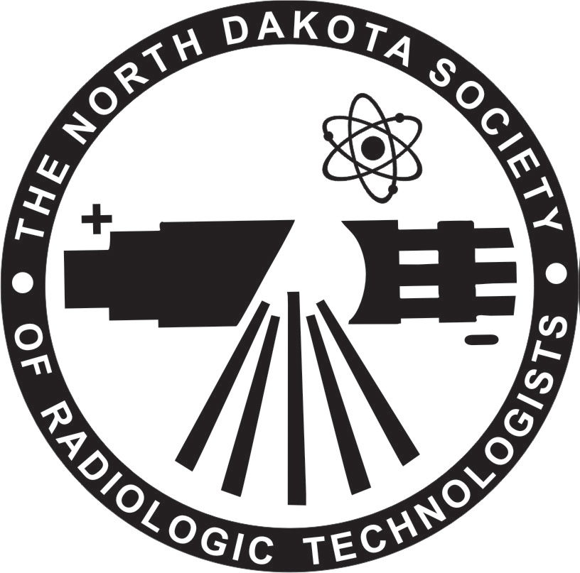
http://ndsrt.org/files/NDSRTMembershipForm.pdf

