Rate Your Experience with National Interpreting Agency
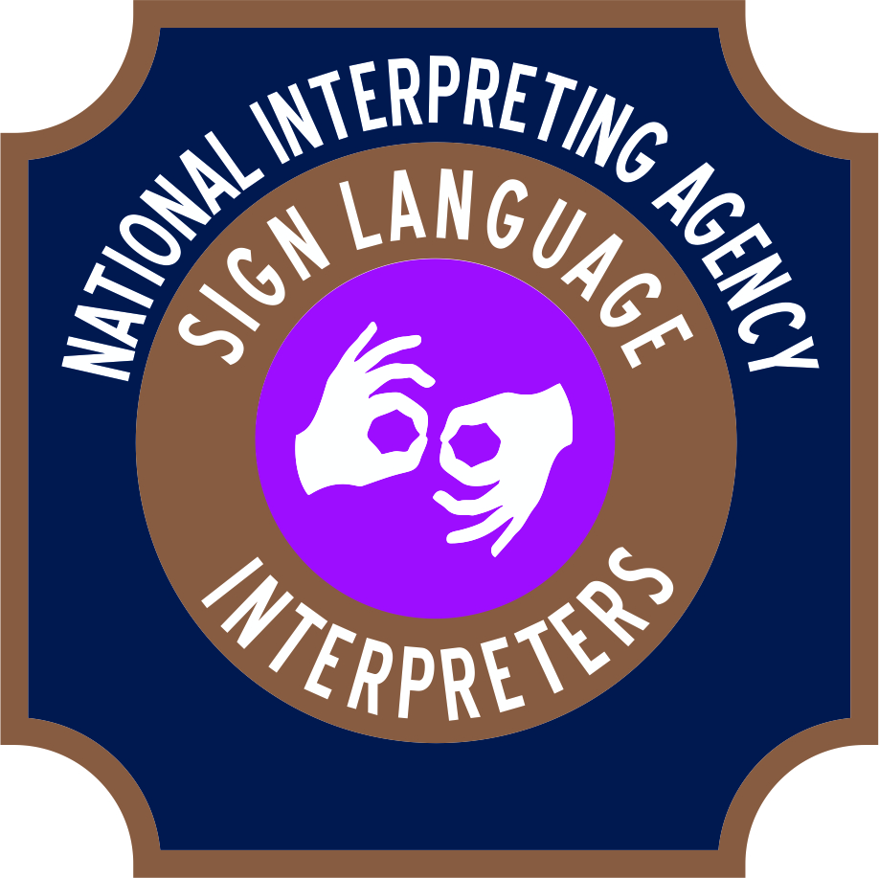
During your experience working with NIA, please offer us some valuable feedback to allow us to continue in keeping our clients satisfied and to continue to offer our highest quality of services.
- Was the booking process understandable and simple?
YES/NO
- Was your interpreter professional and appropriate for your assignment?
YES/NO
- Did the scheduled interpreter arrive on time? YES/NO
- Did the interpreter provide the skills and services needed for the assignment?
YES/NO
- Would you recommend NIA to a friend or colleague?
YES/NO

