Name:

A Picture Paints a Thousand Words
You Can’t Judge a Book by Its Cover…or can you?

Read All Directions: Closely read the following introduction to this inference and prediction mini-lesson and assignment. When you have finished reading, look carefully at the artwork chosen for this edition of Steinbeck’s Of Mice and Men. After studying the cover, think about why the publisher chose such a seemingly simple image for this classic novel.
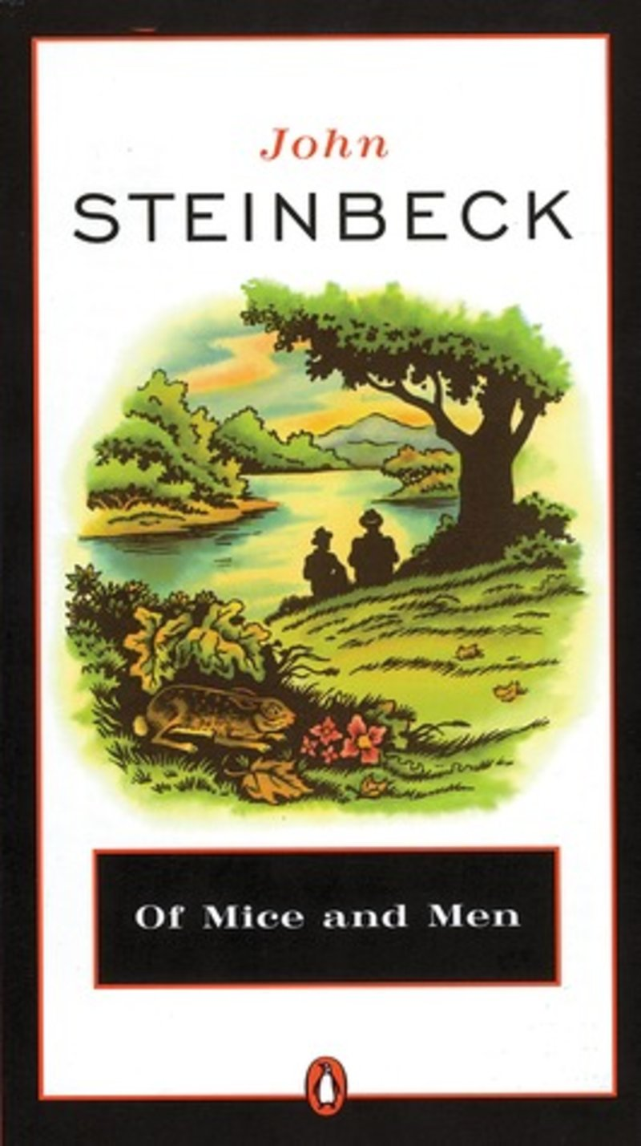
Lastly, use the space provided to record inferences and predictions you make about this novel. Please note this is not about being right, it is about tapping into your ability to connect the chosen art and the elements of the novel. Please type parentheses around your name at the top of the page to indicate that you read and understand these directions. Meanwhile, have a look at a few other book covers chosen for this classic novel.

Lesson Introduction: We have all been told not to judge a book by its cover, but every single part of a book is important in deciding which book we will select or purchase. What draws your attention to a book? Do you ever pass up a book based on the title or the cover? We all have. There’s no shame in it.
When browsing the library or bookstore aisles, people tend to have the same approach: the casual stroll, gazing up and down the stacks (a college library term for book aisles) until something grabs their eye. The index finger pulls the top edge of the spine forward as the remaining digits work together to reveal the hidden roots of this portable adventure or escape into another world or time or someone else's life. A glance at the cover. A flip to the back. Scan the synopsis on the dust jacket. Looks good. Worth a read. Let’s go.

Assignment Task: What can we infer about the characters, plot, setting, etc. of the Of Mice and Men book cover? Look carefully at the details of the painting and make predictions based on the image, colors, objects, and the position of people or objects, etc.

↓ Type your response below. ↓ (Size 11 font)

●

