By
Gerald V Barta
Senior Instrumentation Specialist

June, 2022

ISA-5.1-2009 INSTRUMENT IDENTIFICATION NUMBER ENABLER
TUTORIAL

Instrument Specs and Index
Contents
1 OVERVIEW 1
1.1 HISTORICAL PERSPECTIVE 1
1.2 USERFORM OBJECTIVES 1
2 USING THE INSTRUMENT INDEX DATA View USERFORMS WORKSHEET 1
2.1 INSTRUMENT INDEX DOCUMENT DATA FRAME 3
2.1.1 Document Number 3
2.1.2 P&ID/Reference Drawing 4
2.1.3 Component Symbol 4
2.1.4 Related Equipment/Drawing Number 4
2.1.5 Service Description 4
2.1.6 Upstream Line/Nozzle Number 5
2.2 INSTRUMENT INDEX INSTRUMENT IDENTIFICATION/TAG NUMBER FRAME 5
2.2.1 Managed Identification Numbers Segment Structure 5
2.2.2 Rule Generated Identification Numbers 7
2.2.3 Command Button Actions 7
3 USING THE INSTRUMENT SPECIFICATION FORMS USERFORM 7
3.1 INSTRUMENT SPECIFICATION FORMS DOCUMENT DATA FRAME 7
3.1.1 Document Number 8
3.1.3 Component Type Field More Precise Than Component Symbol Field 8
3.2 INSTRUMENT IDENTIFICATION/TAG NUMBER FRAME 8
3.2.1 Managed Identification Numbers Segment Structure 8
3.2.2 Rule Generated Identification Numbers 8
3.2.3 Command Button Actions 8

1 OVERVIEW

1.1 HISTORICAL PERSPECTIVE
In My experience:
- With the advent of Computer Aided Engineering (CAE) applications, their Instrument Index content was expanded to cross-reference all tagged devices or software functions and their related work products.
- Efficient data retrieval in CAE applications requires Relational Database technology preceded by standardizing and enforcing many work processes and naming conventions.
- Significant demand still exist for a simpler flat file data structures to cross-reference index data without the structured procedures required for automatically establishing complex data relationships
- The previously published Integrated Instrument Index file, addressed the content and viewing of the data, but without standardized Instrument Identification numbers, its data retrieval and editing can be cumbersome.

1.2 USERFORM OBJECTIVES

The View Add Components UserForms worksheet allows a configured Identification Numbers generator to produce:

- Identical Identification/Tag number on specification Documents as those directly entered in the Instrument Index Data file, so that data will be documented on a single coordinated Instrument Index Data record respective of the origination source.
- Separate the activity and technical specialty of configuring the formatting and content of Instrument Identification numbers, from the P&ID/Reference Drawing interpretations and efficient data entry.
- Training utility for reinforcing the meaning of the coded letters in their functional context.

Note: This can be especially effective in engineering organizations that manage multiple client or project files, with different requirements.

2 USING THE INSTRUMENT INDEX DATA View USERFORMS WORKSHEET
The Instrument Index Data spreadsheet opens with a pop-up window to select a Custom View or Close the window. If the intent for this user session is to add new records, then the default “Add Components UserForm” should be enabled by clicking the Show Button. This will allow the appropriate viewing of the data that will be added with the UserForm.

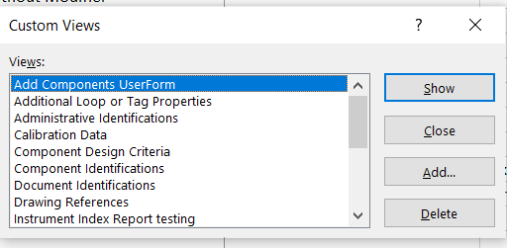

A spreadsheet will open showing the Instrument Index Data worksheet and the 4 workbook tabs. Click on the “View UserForms” tab to open that worksheet!

The View UserForm tab opens and displays the command button to open the Add Components UserForm.
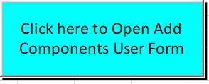

Click this button to access the Add Components UserForm for data Entry.
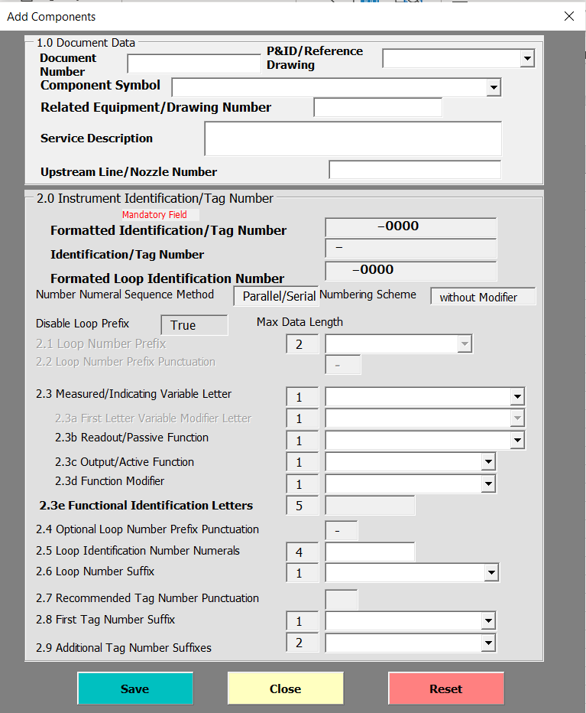

2.1 INSTRUMENT INDEX DOCUMENT DATA FRAME

The 6 fields of the Document Data frame are generally incidental to the process of creating Identification Numbers.

All the fields of this frame are important accompanying data that is frequently available or can be inferred form a P&ID/Reference Drawing and is efficient to be entered in the same work process as creating the Identification Numbers.

2.1.1 Document Number
Many devices are entered into an Instrument Index which are not specified on an Instrument Specification forms or other project documents that apply to the device’s specific location or application. Therefore, the Document Number field is NOT enforced as required data for records entered in the Instrument Index Data spreadsheet.

Note: However, if the Instrument Index Data is entered before the Instrument Specification form has been saved with its document and tag number, for a device that is expected to later have a specification form document, the Instrument Index Document Number field MUST BE consistent with that which will be used on the specification document. This will allow the single instrument index data record to contain the data from both the specification form and the Instrument index data entry work processes.

2.1.2 P&ID/Reference Drawing
Customer/Client specified P&ID/Reference Drawing numbers often are lengthily and containing coded segments, which makes their unassisted data entry effort prone to error. Therefore, the UserForm field, provides a P&ID query results of unique existing values for consideration of the user.

Note: After selecting a similar value from the Drop-down list, that selected value can be edited to establish the edited desired number, before the UserForm data is saved.

2.1.3 Component Symbol
When P&ID/Reference Drawings are generated, they should use the device type or function standardized graphic symbols documented in ISA-S5.1-2009. At early stages, these drawings may utilize “generic” instrument graphic symbols which should be updated after the specific instrument type has been determined.

A Drop-down list is provided on the Instrument Index Data UserForm, of the most common graphic Component Symbols, which can be used to document the expected device component symbol.

2.1.4 Related Equipment/Drawing Number
The Related Equipment/Drawing Number field should be used to document the numbering practice when "Coded digits related to drawing numbers, unit numbers, equipment numbers, etc.”, are used for the Loop Identification Number Numerals Basis.

The data storage for “Related Equipment” is “normalized” in its own field so that it is available to filter loops and tags that are related to the operation of a specific equipment, for purposes of safety reviews or issuing various work activity packages. Therefore, it should not be imbedded or repeated in the Service Description.

2.1.5 Service Description
ISA 5.4 Loop Diagram Standard defines Service as “Word description of loop functions. Identify any special features or functions of shutdown and safety circuits”. Most CAE software applications automatically propagate the Loop Service Description to all tags of that loop.

Legacy project requirements for Service Description have endless variety, so determine the recommended project format and content before entering significant number of records.

2.1.6 Upstream Line/Nozzle Number
The associated line number as shown on the P&ID/Reference Drawing or Line List, that is the data source of the Line size, Line schedule, and can be the source of the process data.

2.2 INSTRUMENT INDEX INSTRUMENT IDENTIFICATION/TAG NUMBER FRAME

2.2.1 Managed Identification Numbers Segment Structure
The application Administrator must have previously configured the formatting options and their cell drop-down list to implement the project specific requirements. Therefore, the Instrument Identification/Tag Number frame, work activities can concentrate on entering the appropriate values into the following 10 or less fields.

Note: Loop Prefix and/or First Letter Variable Modifier Letter fields, may be disabled and grayed-out if the project’s configuration has enforced such options.
Clicking the drop-down list icon on the right side of the cell will open the list of configured options. Values other than those on the list will also be accepted if the length of the value does not exceed the configured Max data Length.

- Loop Number Prefix, if enabled
- Measured Initiating Variable Letter
- First Letter Variable Modifier Letter, if enabled
- Readout/Passive Function
- Output/Active Function
- Function Modifier

The Functional Identification Letters is a concatenation of values from 5 Functional Identification fields. However, most project requirements restrict the Functional Identification Letters acceptable length, for the text to fit within the boundaries of the P&ID/Reference drawing tagging “Bubble” or graphic symbol.

Common project practices to achieve restricted length, frequently include:
- Eliminating the “Indicate” readout letter for devices with Output/Active function
- Minimize or eliminate Function Modifiers that designate the relative value of the measured or initiating variable that actuates the instrument or function, for example for Function Modifier low [L]:
- Other legacy practices that may or may not be documented in the Drop-down list values

- Loop Identification Number Numerals

The configured and displayed Number Numeral Sequence Method, determines if the Loop Identification Number Numeral must be unique for:
- All loops (Serial)
- When combined with the Measured/Initiating Variable (Parallel)
- When combined with the First-Letters (Parallel)
- Any of the above combined with the Loop Prefix (Parallel)

If this uniqueness requirement has not already been documented on the P&ID/Reference Drawing, them the user must establish the correct value.

- Loop Number Suffix
Enter data if needed for Loop Number uniqueness where more than one, exist.

Recommended Tag Number Punctuation Suffixes are automatically managed by the application. Generally, a device does not need a Tag Number suffix or additional Tag Number Suffixes to be unique, therefore the “Recommended Tag Number Punctuation” field is grayed and locked out. In cases where a Tag Number suffix or additional Tag Number Suffixes are required, the user can enter the appropriate tag data in the First Tag Number Suffix and/or Additional Tag Number Suffixes fields.

When the UserForm Save Button is clicked, the software will check for any such entered Tag Number suffixes and automatically:
- Insert the STD Recommended Tag Number Punctuation in the Formatted Identification/Tag Number field
- Insert the STD Recommended Tag Number Punctuation in the Identification/Tag Number field
- Update the Recommended Tag Number Punctuation field
- Provide an Information message to the user
.
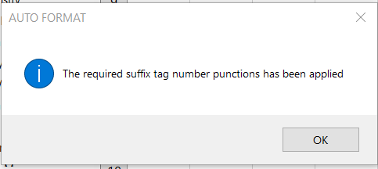

- First Tag Number Suffix Length
- Additional Tag Number Suffixes Length

2.2.2 Rule Generated Identification Numbers
The three rule generated Identification Numbers will have their data built as each keystroke or click event occurs in the UserForm fields:
- Formatted Identification/Tag Number
- Identification/Tag Number
- Formatted Loop Identification Number

Note: that the “Recommended Tag Number Punctuation” is automatically applied by the application’s Save command. Therefore, tag numbers with suffixes can only be fully viewed AFTER clicking the Save button and AUTO FORMAT information window.

2.2.3 Command Button Actions
The Save button initiates validation for missing data and provides INCOMPLETE FORM DATA messages if problems are identified:
- Loop Identification Number Numerals are not defined
- One or more Functional Identification Segment fields is not completed
- A component with the keyword defined already exists in the database

If no problems are identified, the Userform’s data is saved to the underlying spreadsheet, with a completion message.

The UserForm remains open to allow the user to reuse as much of the data as applicable and then edit one or more values of a related device tag’s values. Clicking the Save button will again check for tag number uniqueness and provide a message window if problems are identified.

- The Close button is clicked to remove the UserForm when further additions are not appropriate.
- The Reset button is clicked to keep the UserForm open while clearing all previous data, for editing a new record with substantially different data values.

3 USING THE INSTRUMENT SPECIFICATION FORMS USERFORM
When creating a new specification document using the Instrument Specification Form work activity, the UserForm automatically opens after the user has confirmed the Component type data.

3.1 INSTRUMENT SPECIFICATION FORMS DOCUMENT DATA FRAME

This UserForm is identical to that used in the Instrument Index Data application, except for the elimination of the Component Symbol field in the Document Data frame.

The 5 fields of the Document Data frame are generally incidental to the process of creating Identification Numbers.

All the fields of this frame are important accompanying data that is frequently available or can be inferred form a P&ID/Reference Drawing and is efficient to be entered in the same UserForm interface as created in the Instrument Index Data application.

3.1.1 Document Number
Specification Forms are documents that generally are retrieved by a Document Management System based upon their document number. Therefore, the Document Number field must be present before the specification form’s data can be saved.

3.1.3 Component Type Field More Precise Than Component Symbol Field
In the process of initializing an Instrument Specification document, the user selects from a list of very specific component types, which is saved on the document and subsequently in the Instrument Index. If this value is inconsistent with the documented P&ID component symbol, consideration should be made to update the P&ID symbol.

3.2 INSTRUMENT IDENTIFICATION/TAG NUMBER FRAME

3.2.1 Managed Identification Numbers Segment Structure
The application Administrator must have previously configured the formatting options and their drop-down list to implement the project’s specific requirements. Therefore, the Instrument Identification/Tag Number frame, work activities can concentrate on entering the appropriate values into the following 10 or less fields.

The data entry is identical to that described above for the Instrument Index Data UserForm. However, since the Tag Number is NOT a required value because, it is a common work process to bulk order devices which will have their tag specific specification form completed after their process application is known.

3.2.2 Rule Generated Identification Numbers
The Rule generated Identification Numbers will be identical to those produced in the Instrument Index Data UserForm!

3.2.3 Command Button Actions
- The Save button initiates validation for missing data and provides informational or confirmation messages as described above for the Instrument Index Data. Except, since the Tag Number data is NOT required for all specification form documents, the user can Click the Save button without providing data for the Tag Number fields.

If Tag Number data is not present the application will provide one or more confirmation messages, before proceeding with saving the UserForm data.

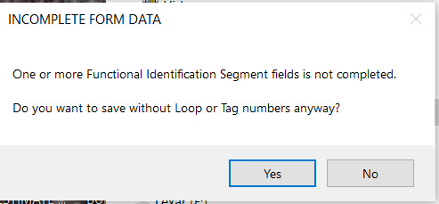

If Tag Number data is present other validation checks for completeness will provide informational messages. If no problems are identified the Userform’s data is saved to the underlying specification document, with a completion message.

The UserForm is automatically closed after saving its data, since only one Tag Number can be saved to a specification document.

The UserForm’s data will be visible within the instrument specification document tables, except for the three informational fields that are NOT properties of the device specification. Those 3 fields are in the footer of the first page.
- Loop Name
- Tag Number (unformatted)
- Functional ID

When the specification document user saves the document’s edited data, all data including the 3 footer located fields will be saved to the Excel Instrument Index Data file. A saving progress bar will be displayed during the saving process.

- The Close button can be clicked to remove the UserForm when if the user decides to proceed to edit directly in the specification document.
- The Reset button is clicked to keep the UserForm open while clearing all previous data, for revised editing record with substantially different data values.

