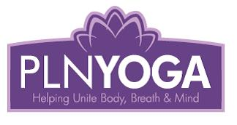 | PLN Yoga  Pamela Nelson  Box 393  Christopher Lake, Sk.  S0J 0N0  www.plnyogastudio.com

Waiver/Release Form

Time & Class Attending:______________________________________
Please put if online or in-person:_______________________________

First & Last Name:______________________________________________
Contact Number:_________________________________________________
Email:___________________________________________________________

I _______________________________ (print name) am aware that, as with any form of exercise, the risk of injury can never be entirely eliminated and that I am responsible for recognizing my own physical limits.

I understand that yoga is not a substitute for medical attention, examination, diagnosis, or treatment.
If I have any concerns about whether yoga is suitable for me, or if I have a particular injury or medical condition, I will consult my physician before participating in yoga class.

I will make my yoga teacher aware of any injuries or medical conditions before participating in a class.

I am aware of the risks associated with or related to participation in yoga classes and workshops, and the use of yoga equipment and facilities, particulars of which include but are not limited to the risk of injury from coming into and out of a yoga pose, and using props to assist in attaining certain yoga poses.

Signature of student, parent or guardian: ___________________________________________

DATED: ______________________________________________________________

*Please return this form prior to class or scan and email back to: plnyogastudio@gmail.com

