Pregnancy & Infant Loss
Virtual Walk
October 2021

Our Pregnancy & Infant Loss Virtual Walk is a month-long event to spread awareness and start conversations about Pregnancy & Infant Loss. The virtual walk will take place during the entire month of October, Pregnancy & Infant Loss Awareness Month.

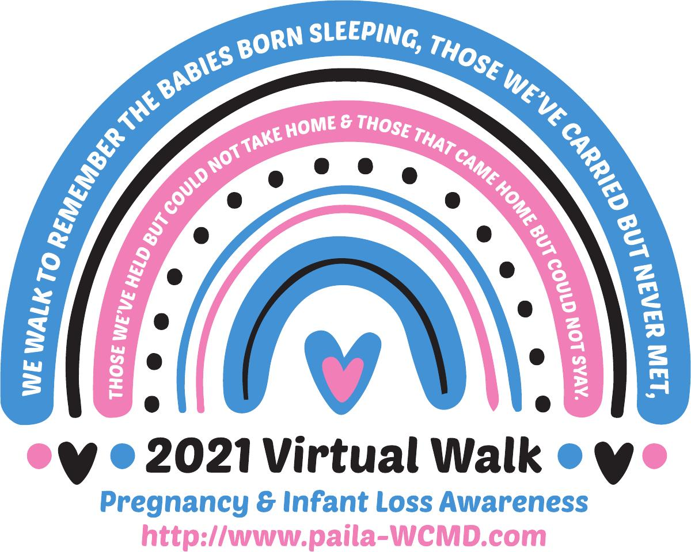
What is a virtual walk?
A virtual walk is a unique way to get
involved on your own terms. It is a walk that
takes place anywhere at any time. No need to
sign up for a specific location. You can walk
when it works best for you. Walk as far as you
want at any location. Join a group of friends
and/or family and walk together. Run if you
want. The goal is to spread awareness about
Pregnancy & Infant Loss.

How does it work? Do I need to register?
No registration necessary! Purchase a shirt or
sweatshirt at the link provided. Take pictures
during your walk. Send your pictures to us and
we will post them on our social media pages
and website. Post your pictures to your social
media pages too. You can also talk to people
you meet during your walk and tell them why
you are walking, share your story.

How do I purchase a shirt or sweatshirt?
http://anythingprinted.biz/virtualwalk
Shirts and sweatshirts are available in white and charcoal. You can also personalize the back of your items with your baby’s name. Purchase a shirt or sweatshirt by September 15 to receive your items by October 1. All orders will be printed and shipped after September 15.

* You will have a second chance to purchase shirts and sweatshirts October 1 to October 18. All orders will be shipped after October 18. A second link will be posted by October 1 on our website. www.paila-wcmd.com/virtual-walk

