*Mobile Food Pantry* **www.linkagainsthunger.org  
 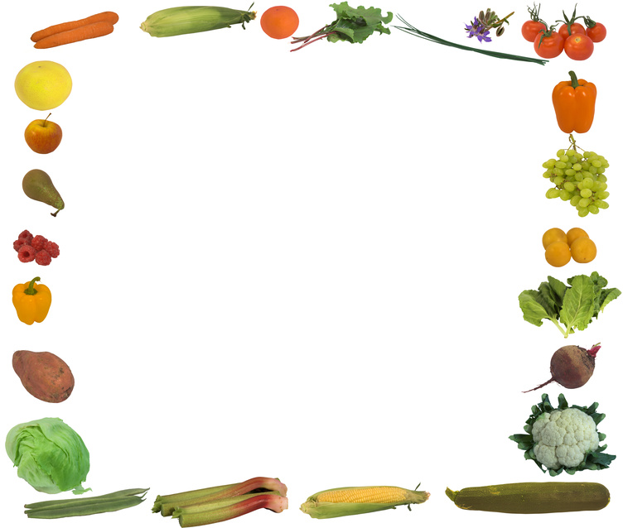**

*LINK* is partnering with the National Area Food Bank to provide free fresh produce.   
***Volunteers are also needed from 2 pm – 6 pm each month***

***WHEN***: Tuesday, November 13, 2012 &   
Tuesday, December 11, 1012

***Registration Begins***: 2:30 pm

***Food Distribution***: 3:00 pm – 5:00 pm  
***Weather***: *(*) Rain or Shine, or until we run out of food.* *Please bring recyclable shopping bags with you to carry the food home!*

***WHERE***: Christ the Redeemer Church rear parking lot  
46833 Harry Byrd Hwy   
Sterling, VA 20164

You may pick up for others who are unable to drive themselves. The only questions you will be asked are:

* For how many people are you picking up, and
* In what town do you live? (Sterling, Ashburn or Herndon)

**Please, bring your own bags.**