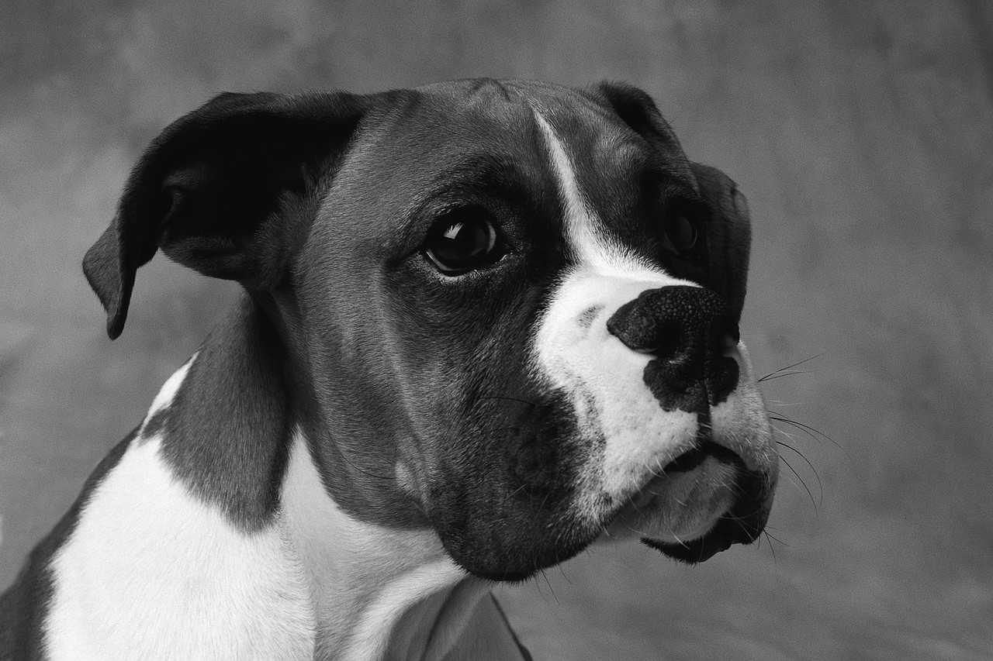
Obeng Boxers Unlimited
Sheila J Obeng
78 N. 21st Street Columbus Oh 43203
614-515-3498
Paypal- obengboxersunlimited @yahoo.com

Your name: ________________________________________________________
Your home address: _____________________________________________________________ ______________________________________________________________________________
City: ________________________________________ State: __________ Zip: ____________
Your email address: ____________________________________________________________
Your phone number: ___________________________________________________________
"I AM PLACING a NON-REFUNDABLE HOLDING DEPOSIT ON PUPPY" unless something happens to the puppy under breeders care. Deposit are transferable to future litters.
Sired by:_____________________________ Dam________________________________
Puppies name: ____________________________ Date of birth: _______________________ Male:__________________ Female:____________________ Color:___________________
Or if placing a deposit on a future litter: Sired by: ______________________________ Dam:______________________ Male: _______Female: ________No preference:______
Color: _________No preference: __________________ * CLASSIC FAWN * * FAWN AND WHITE * * CLASSIC BRINDLE * * BRINDLE AND WHITE * * WHITE *SEAL BRINDLE
Buyers Signature: _____________________________________________________________
Date: _____________________
Dedicated to raising Loyal Companion

