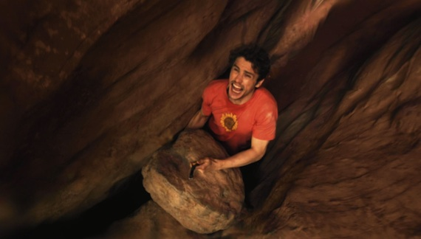

Exodus 14:1-13

God told Moses to tell the people of Israel to camp in the valley between two mountains; the red sea was in front of them and an angry Egyptian army in hot pursuit behind them. They couldn’t go over, under, through or around the mountains or the sea. It appeared there was no way out.

But verse 13 says “Tell the people be not afraid. Stand still and (See) the salvation of the Lord.

How do you know when God is ready to break through your rock and a hard place situation? You know, because He will invade your ordinary with something extraordinary. He will come to your normal with something abnormal. He will create a scenario that doesn’t make sense.
When God creates a scenario that doesn’t make sense, it is not supposed to make sense.

God shows up in a way that you can’t explain. And the reason you can’t explain it, is because it is God showing up in it. The Bible is full of examples of when God was getting ready to move in a rock and a hard place situation and the thing that He did was show up in a way that human understanding couldn’t explain.

My advice to you is that, if you are going through a wilderness experience, or if you are between a rock and a hard place and can’t find a good way out of this situation, look for God to show up in a way that you can’t explain.

Isaiah 55:8 says “His ways are not your ways. His thoughts are not your thoughts. God is not like you or me. He can show up in ways that will blow your mind.

Increasing In Him
Pastor Ron Suttles Sr.

