Trinity Times
Volume 9-10, Issue 7
September & October 2020

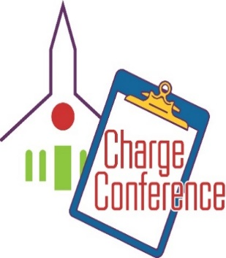
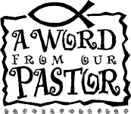

Holy Conferencing
For just as each of us has one body with many members, and these members do not all have the same function, so in Christ we, though many, form one body, and each member belongs to all the others. Romans 12:4-5

In what is an annual custom in the United Methodist Church, we will soon hold our Charge Conference. It will be held at Trinity on November 8 at 4PM. As we move from this very unusual summer and look forward to the cooler days of Fall, we once again exercise our denomination’s most basic level of connection with other Methodists and other churches. This year’s conference will be different. We have gotten used to doing the work of the church in different ways this year. This pandemic has forced us to find a new normal for carrying on the activities of the church. This year’s charge conference will be held in strict observance of virus precautions. Although we will meet in a face-to-face conference, only the chairs of committees and the lay leader of each church will be urged to attend. Although it will be different, our Charge Conference will be as important as ever.

Methodists have been meeting in conference since the 1730’s. It is a uniquely Wesleyan idea. John Wesley believed so much in the power of conferencing that he considered it one of the most important ways that we can remain strong in community. Preparing for Charge Conference helps our church look to the future with more confidence and with more clarity. Preparing for Charge Conference affords us the opportunity to determine how our church will accomplish our goals for the coming year. Doing that work together keeps us united.

John Wesley believed that meeting regularly in conference was essential to the effective functioning of the church. He called it “holy conferencing.” That is, the act of meeting together in conference is a way of joining as one in common purpose, in strengthening our call to discipleship. The United Methodist Church meets in conference at the local church level (Charge Conference); at the Conference level (Annual Conference); regional level (Jurisdictional Conference); and denomination-wide level (General Conference). Although we have had to adjust this year to make them happen the outcome is the same. Through these conferences our denomination cements together our connection. Through these conferences we celebrate what brings us together. At these conferences, we work through problems that might threaten our unity. At these conferences we produce the “glue” that holds us all together. These conferences serve as vehicles of God’s love and grace.

Be in prayer this year for the success of our Charge Conference. Pray for those who will be attending. Lift up Trinity and the Trinity family as we work hard together for the future of our church.

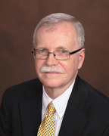
Blessings,
Charles

. 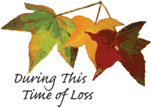
The Trinity UMC family would like to extend its sincerest condolenscences to the family of David C. Waldrop, Jr. Dave was a life long member of Trinityand was an integral part of our leadership team here at Trinity, serving as the Chairman of the Administrative Council.. He will be greatly missed. We extend our sincerest sympathy to his wife Debbie, nephew Craig Kesler, and all of his family and friends who loved him.

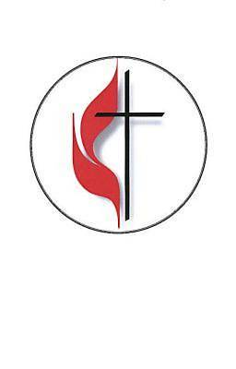
Pastor – Charles Wilbanks
Trinity United Methodist Church

1160 Trinity Church Road
Newberry, SC 29108
803-276-1245 Office
803-206-4623 Pastor Cell

clwilbanks@bellsouth.net
trinityumcnewberry@gmail.com
www.trinityumcnewberry.net
PLEASE VISIT OUR WEBSITE
AS OFTEN AS YOU CAN!
Peggy Bogart, Church Secretary
GREETERS AND USHERS NEEDED!!!

We need ushers and greeters who will be attending In-Person church service. Please let Pastor Charles know if you would be willing to help. Thank you. WE ALSO NEED MORE
TECHNICIANS.

Head Usher: Harry Longshore
Choir Director: Jane Pollard
Organist: Eddie Welborn
Video Board: Josh Pitts, Caroline Senn, Bryan Waldrop
Acolytes/Cross Bearers Coordinator: Eli Martin
Newsletter Editor: Harriet Stevenson

We are a caring church and want to share your concerns. Let us know if you or someone you know would like to share a prayer request with us. We will be happy to pray for you. Contact Peggy Bogart, Church Secretary, or Pastor Charles, to add or remove names from the Church Prayer List.
Trinity Member Prayers: Family of Dave Waldrop, Jane and Robert Pollard, James and Jeanette Poag, Shirley Berry, Alice Longshore, Cheryl Longshore, Gloria Brehmer, Rebecca Bundrick, Johnnie and Beverly Pitts, Bridget Pitts Bouknight, Shin Wilbanks.
Family and friends of Trinity: Larry DeHart, Sandra Kenney, Robert Duffie, Kerry Franklin, Blake Hendrix, Jennie O’Shields, Phillip Sanders, Neal and Irene Whatley, Eddie Sisk, Joye Irons, Wade Pitts

Jane Pollard would like to thank everyone for the cards, calls and prayers during her recent hospitalization and illness. They were very much appreciated.

13 – Ruthie Jane Spicer
22 – Andrew Morris 4 – Robert Pollard
24 – Colton Poag 14 - Marie Somers
24 - John Pollard 17 – Laura Mohler
26 – William “Boo Boo” Johnson 21 -John Longshore
22 - Barbara Carter
25 - Rebecca Bundrick
26 - Bryan Waldrop
30 - Frieda Kesler
30 - Johnnie Pitts Jr

Christian Symbol for September
Cross Crosslet
This cross is formed of four smaller Latin crosses joined
at their overlapping bases. The cross as a whole
represents the spreading of the gospel to the four corners
of the earth. This cross is often used in recognition of
missions.

Christian Symbol for October
Plow
This farming implement is mentioned frequently in the
Bible, often in verses about the harvest. Plowing
symbolizes preparing the heart to receive God’s truth,
or the “seed” of God’s word. The plow also represents
commitment; Jesus says, “No one who puts a hand to
the plow and looks back is fit for service in the
kingdom of God” (Luke 9:62). The prophet Elisha burns
his plow to show his commitment to answer God’s call.

Budget for 2020 - $142,011.50
Weekly Offering Needed - $2,730.99
2020 Avg. Weekly Offering YTD - $2,520.00
Thank you for your faithful giving.

OCTOBER is Breast Cancer Awareness Month.
It is alarming to know that 1 in 8 women will be
diagnosed with breast cancer in their lifetime. While
you can’t prevent cancer; it is important to be proactive
about your health. In fact, there are things you can do
to help reduce certain types of cancer. Pick up a packet
after church on October 25th with information about
the signs, symptoms and prevention of breast cancer.
Thanks to Harriet Stevenson for this information.

September October
7 – Labor Day Pastor Appreciation Month
11 – Patriot Day Breast Cancer Awareness Month
13 – Grandparents Day 4 – World Communion Sunday
22 – Adm. Council Meeting 25 – Reformation Sunday
22 – 1st Day of Autumn 31 – Reformation Day

Watch live streaming of our church
service from our Facebook page,
trinityumcnewberry every Sunday
at 11:00 a.m. Special thanks to
Eddie Welborn, our organist, and
JOSH PITTS, Bryan Waldrop and
Caroline Senn for making it possible
every Sunday.

Also watch Pastor Charles and his
Seeds of Faith video on our Facebook
page every morning, Monday
through Saturday, for a scripture
reading and words of wisdom.

Trinity held a drive-by Back to School Blessing
prior to the start of school. Students and teachers
were given “goody bags” containing school
supplies and other goodies after Pastor Charles
blessed them with a prayer. Thanks to Pastor
Charles, Clarissa Hendrix, Phyllis Sanders and
Harriet Stevenson for putting it all together.

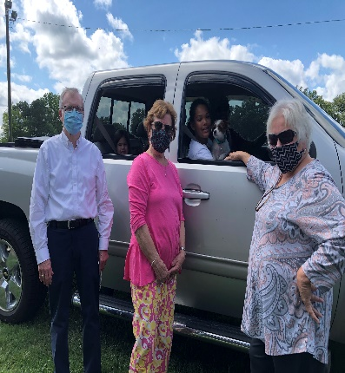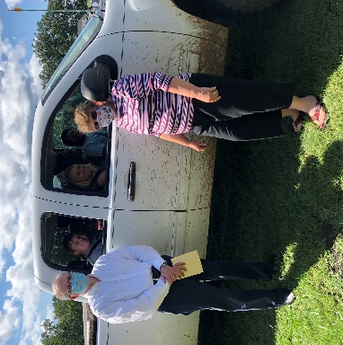

Administrative Council News
The Administrative Council met on Sept. 22 for the first
time since March 2020. Frieda Kesler was elected to be
the Chairperson of Council, filling the space left vacant
by the passing of our longtime chairman, Dave Waldrop, Jr.
Her position will be approved at the Charge Conference.

A Blessing Box was approved by Council to be built.
This will be a place for you to pick up newsletters,
bulletins, Upper Rooms, etc. if you are unable to attend
church. This will be an extremely useful addition and
will be located outside of the church. It will look similar
to one of these Blessing Boxes.
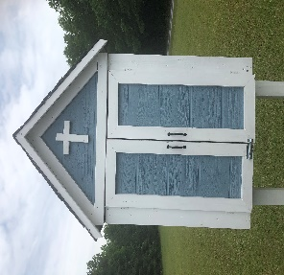

October is Clergy
Appreciation Month.A
great way to show Pastor
Charles that we appreciate
him is to send him a card or
letter expressing our love

and gratitude to him for his service
and leadership to Trinity. Just drop
it in the mail any time during October
to the church address:
1160 Trinity Church Road
Newberry, SC 29108.

DRIVE BYCARavan HALLOWEEN TREAT TENT

FRIDAY, OCTOBER 30, 6:00 TO 7:00 PM

Drive by in front of the church and stop at our Halloween Treat Tent. You will remain in your car. This will be a contactless event. Children dress in costume (or not) but please wear a mask. Also bring something for us to drop your “goodie bag” into. Goodies are prepared and delivered wearing gloves so this will be a safe environment for everyone. Have a spookily good time and enjoy Halloween! Kids will be sure to remember the fun and not what they may have missed out on. Thanks to Josh & Erin Pitts for organizing this event.

NOTE of INTEREST:

Our former Pastor, Ken Carter, has accepted a one year appointment in the Marion District at Christ UMC in Bennettsville, SC. He and Barbara will still maintain their residence in Myrtle Beach.

Trinity United Methodist Church
1160 Trinity Church Road
Newberry, SC 29108

