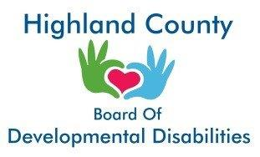
Highland County Board of Developmental Disabilities
Acknowledgement of Receipt of Privacy Notice

I have received a copy of the privacy notice from Highland County Board of Developmental Disabilities.
☐YES
☐ NO

Signature of Individual Receiving Notice Date
Or Legal Guardian/Representative

