Kingston Single Malt Society
A social club for the appreciation of Single Malt Whisky since 1998
SEPTEMBER 21, 2009 VOLUME 3; NUMBER 1

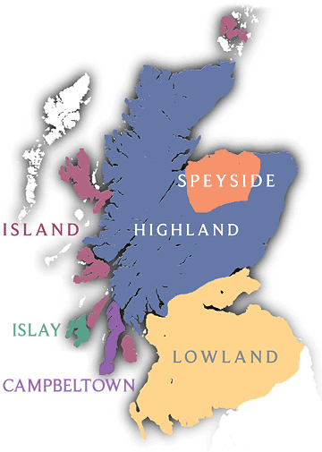
----------------------------
This evening's menu
in the company of Single Malts from CAMPBELTOWN and LOWLAND

Soup: Tomato Roasted Red Pepper Bisque

1st Nosing: SPRINGBANK 10 YEAR OLD
(introduced by: Stephen Ambury)

Salad: Classic Caesar

2nd Nosing: INVERLEVEN 1990 (BOTTLED 2007)
(introduced by: Sylvain Bouffard)

Entree: VOM Chicken (stuffed with sun dried tomatoes, roasted red peppers and cheddar cheese)
Vegetables: Seasonal
Potato: Seasoned Oven Roasted Potatoes

3rd Nosing: AUCHENTOSHAN 21 YEARS OLD
(introduced by: Philip Henderson)

Dessert: Homemade Apple Crisp

----------------------------

COST OF THE MALTS
I know members are always interested in the cost of the single malts we taste. Plus the $75 Special Occasion Permit and the 16% levy charged by the LCBO for all alcohol served at the dinner.

- SPRINGBANK 10 YEAR OLD SINGLE MALT SCOTCH VINTAGES 708362 | 750 mL bottle Price: $89.95 Spirits, 46.0% Alcohol/Vol.

- INVERLEVEN 1990 (BOTTLED 2007) 700 mL bottle Price: $83.09 Spirits, Scotch Whisky, 40.0% Alcohol/Vol.

- AUCHENTOSHAN 21 YEARS OLD SINGLE MALT VINTAGES 969493 | 750 mL bottle Price: $189.95 Spirits, Scotch Whisky, 43.0% Alcohol/Vol.

----------------------------

Dinner dates for KSMS 2009-2010
September 21, 2009 - Campbeltown / Lowland
October 26, 2009 - Speyside
November 23, 2009 – Speyside / Highland
January 25, 2010 – Robbie Burns Night
February 22, 2010 - Highland
March 22, 2010 – St.Patrick's (Irish)
April 26, 2010 - Island
May 17, 2010 - Islay
June 21, 2010 – BBQ (Final Exam)

----------------------------

Membership and Dinner prices for 2009-2010
Membership Fees: $40 (singles)
$60 (couples)
One Time Initiation Fee $15
Standard Dinner Fee: $50 (member)
$60 (non-member)
Dinner only - No Single Malt: $45 (member)
$55 (non-member)
Robbie Burns Dinner Fee: $60 (member)
$70 (non-member)
(includes $5 donation per attendee to RMC Pipes &
Drums with Highland Dancers)
June BBQ Dinner Fee: $60 (member)
$70 (non-member)

----------------------------

JUNE - KSMS Financial Statement
(Money raised by June attendees) = $3470.00
June dinner 46 persons = $35.86/ea = $2187.51
Special Occasion Permit @ LCBO = $75.00
(Money remaining for buying Single Malt) = $1207.49
Cost of Single Malts June: = $989.65
KSMS Monthly operational balance = $217.04
Cost per person (All inclusive) = $53.31

----------------------------

Results of the Cardhu 12y.o. Raffle
As you know the bottle cost us $200.95. Add to that the 16% levy charged by the LCBO and the final price was $233.10.
After paying for the cost of the bottle KSMS benefited by having $585.00 being added to its coffers!!
Job well done and thank you one and all.

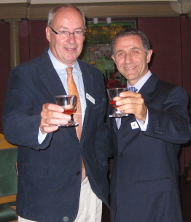----------------------------
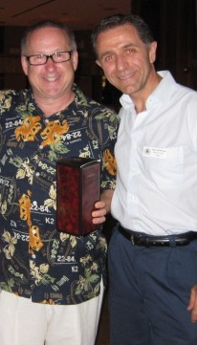
Winners at the June BBQ
GRAND PRIZE Winner
Michael Hartzman – Cardhu 12 y.o.

Final Exam Winners
Tom McCulloch – Arran Malt Tokaji Aszú
Mike Patchett – Robert Burns Single Malt
David Custers – Canadian Whisky Glass
Ainsley Creighton – Ardbeg 10
Ken Goodland – Connemera
Phillip Henderson – Redbreast
David Simourd – Ian Rankin Crime Novel
Mark Dryden – Glenmorangie Nectar D’Or
Christine Wasson – Glenkinchie 12
Frank Warnica - Ian Rankin Crime Novel
Susan Warnica - Robert Burns Single Malt
Chris Logan – Tobermory 10
Bruce Malcolm - Ian Rankin Crime Novel
Liz Savill - AnCnoc 12
Michael Hartzman – Springbank 10
Sylvain Bouffard – KSMS T-Shirt
Frank DuBois - Canadian Whisky Glass
Dave Bower – Inishowen
Conrad Falkson - Ian Rankin Crime Novel
Jack Gibbons - Ian Rankin Crime Novel
Pete McAffee – Grand Marnier

----------------------------

Premium Single Malt Night
Once again our Second Annual Premium Single Malt Night was a huge success. A good time was had by all. At the cost of $125 (drinkers) and $75 (non-drinkers) all 55 attendees enjoyed a fine meal and lovely single malts. Given the continued success of this event I look forward to the Third Annual Premium Single Malt Night next August (mark your calendars -- Thursday August 26th, 2010).
KSMS' 2nd Annual Premium Single Malt Night
Thursday August 27th, 2009 @ Fort Frontenac
MENU
Pre-Welcome Welcome:
Macallan 10 Year Old Fine Oak
(introduced by: Marc Laverdiere)
Welcome and 1st Nosing:
Highland Park 30 Year Old Orkney Single Malt Whisky
(introduced by: Marc Laverdiere)
Salad: Seafood on a Bed of Salad
2nd Nosing: Port Ellen Old Malt Cask 25 Year Old Islay
(introduced by: Bill Gorham)
Entree: Blue Cheese Crusted Filet Mignon
Vegetables: Glazed Carrots; Sautéed Tri-Color Peppers with Portobello Mushroom and Snowpeas
3rd Nosing: Macallan 25 Year Old Single Malt
(introduced by: Marc Laverdiere)
Dessert: Molten Lava Chocolate Cake
Cigar: Montecristo No. 4
4th Nosing: Dalmore Cigar Malt Single Highland Malt
(introduced by: Sylvain Bouffard)

Winners at the Premium Night
Single Malts
Jack Dingle – Arran Malt Tokaji Aszú
Ruth Kerr (Craig Kerr’s guest) – Arran Malt Tokaji Aszú
Dave Bowers – Arran Malt Sassicaia
Bruce Somers – Glenkinchie 12
Rob Arnoth – Glenlivet Nadurra
Susan Warnica - 250TH Anniversary Robert Burns Malt
Frank Warnica - Caol Ila 12y.o. (200 ml.)
Michael Hartzman – Talisker 10 y.o. (200 ml.)

Books & Magazines
Ken Goodland - Goodness Nose
Kevin Berube - Whisky Wit & Wisdom
Lana Di Fazio – Scotland Tour Book
Sylvain Bouffard – Whisky Magazine (Oct 2009 issue)
Paula Dryden – Whisky Magazine (August 2009 issue)
Tom Hogeboom (Tim Barber’s guest) – Whisky Magazine
(August 2009 issue)
Christine Wasson - Whisky Map

Gifts courtesy of Marc Laverdiere
Linda Simourd - set of six Macallan glasses
Fran Girven (Ken Goodland’s guest) – Macallan water pitcher
Bernie Tennenhouse (Michael Hartzman’s guest) – Highland Park water pitcher
Paul Charbonneau – Highland Park ice bucket

----------------------------
Spirit of Toronto – Saturday April 24, 2010
Spirit of Toronto is Toronto’s Annual Whisky Gala, a spectacular evening featuring more than 100 single malts and premium spirits, tutored tastings, live jazz, gourmet catering, food and whisky pairings, whisky cocktails and an outdoor cigar terrace on the lower level of Roy Thomson Hall.
Come and join KSMS as we travel to the gala event. Next year it will be occurring on Saturday April 24, 2010 at the Roy Thomson Hall in Toronto. I have made arrangements with McCoy’s Bus Service to shuttle us there and back. The bus will depart Saturday April 24th, 2010 at 8 a.m. and return Sunday April 25th, 2010 at 2 a.m. The cost of bus will be $40 per person and will be open to the first 27 people who express interest in the form of full payment.

----------------------------

How offal! English claim to have invented haggis
Dispute over origin of national dish of sheep heart, liver and lungs leaves bad taste in mouths of Scots
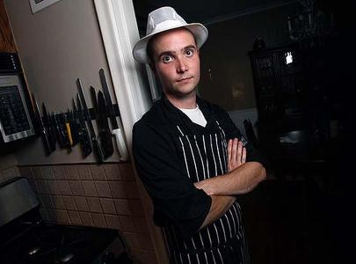
Toronto butcher Paul Bradshaw, wearing a Scottish butcher's uniform, trained in Scotland and says they are "pretty protective" of the dish.
RENÉ JOHNSTON/TORONTO STAR
Nancy J. White Feature Writer - Aug 12, 2009
Toronto butcher Paul Bradshaw's phone has been ringing with calls from outraged family in Scotland, all wanting to tell him the offensive news: The English are now claiming they invented haggis.
Och aye, haggis, the Scots' national dish of sheep heart, liver and lungs cooked with oatmeal in the animal's stomach, the traditional meal immortalized by the much-beloved Scottish poet Robert Burns in "Address to a Haggis."
A food historian is stirring up the controversy after discovering a printed reference to haggis in a recipe book, The English Hus-Wife, from 1615. The earliest mention in a Scottish book was 1747. Burns' poem was written in 1786.
"It's ridiculous," says Bradshaw, who trained in Scotland with an award-winning haggis-maker. "I've only ever met two or three English people willing to eat it. Everyone in Scotland does.
"It'll blow over – depending on how angry the Scots get. They're pretty protective of their haggis."
Not since the British government banned the wearing of kilts and the playing of bagpipes after the defeat of Bonnie Prince Charlie in 1746 have the Scots been so distraught about their national symbols.
"This haggis grab is akin to a land grab and it's a sign of its culinary success now as a swanky dish," Alex Salmond, the First Minister of Scotland, told the Sunday Mail.
In a New York Times op-ed piece called "Keep Your Hands Off Our Haggis," Scottish author Alexander McCall Smith explained to Americans that this insult was comparable to claiming that apple pie and turkey with cranberry sauce were really French.
Scots in Toronto are also offal-ly steamed.
"It's a sign of the inherent weakness in the English character that leads them to try and appropriate successes created by other nations," says book publisher Douglas Gibson.
"You wait. They'll be inventing golf next and developing whisky. They have no shame."
"England is happy to take anything Scottish and call it their own," says Patricia Main, president of the St. Andrew's Society, a philanthropic Scottish cultural group.
"They took our king way back, our Stone of Destiny, now our haggis, too."
So why is this sheep-innards sausage so central to the Scots?
"It's an example of Scottish defiance, prickliness, to have a national dish that turns most people's stomachs," explains Gibson, named Canada's Scot of the Year in 2005.
"The point is that haggis is the really, really cheap parts of meat and really, really cheap to make, and very nourishing."
Over the years, the origins of Scotland's other national symbols, the kilt and bagpipes, have also been debated, says Graeme Morton, the Scottish studies fFoundation chair at the University of Guelph.
"National symbols only became important with the idea of a nation-state in the 18th century," he explains. "And that's when the Scots claimed the kilt, bagpipes and haggis as their own."
He is not convinced by a 1615 recipe book that haggis is English. "It's hard to chart food. Recipes are passed on, not written down."
At the University of Toronto, Andy Orchard, professor of English and medieval studies, finds it more compelling evidence, although he wants to be diplomatic. After all, his father is English and his mother Scots-Irish.
"I don't want to go against Robert Burns and that pudding they seem to adore," says Orchard. "But unless the Scots come up with anything earlier, too bad."
At the But 'n' Ben, a Scottish bakery in Pickering that also sells haggis, Helen Tannahill wonders if the pride of Highlands kitchens might actually date back to the Romans or Vikings.
She's not disturbed by the English claim.
"I've been here (in Canada) since I was 13. My Dad would be more upset," she says, handing the phone to her 83-year-old father, explaining to him a reporter says haggis might be English.
"You been eatin' cheese," says Alex Baird in a thick Scottish brogue. "That means you been dreamin'."
----------------------------

Win Me !!


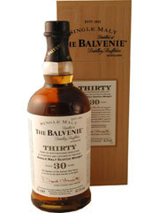

THE BALVENIE 30 YEAR OLD
SINGLE MALT WHISKY
VINTAGES 665091 | 700 mL bottle Price: $640.95
Spirits, Scotch Whisky, 47.3% Alcohol/Vol

Starting September 21st, 2009 tickets can be purchased for a chance to win this bottle. Tickets will be $3 each or two tickets for $5. Tickets will be on sale at each dinner until the January 25th, 2010 Robbie Burns dinner when the bottle will be raffled. The winner must successfully answer the skill testing question: What country does single malt come from?

----------------------------

Reservation policy
- Our contract with the Officer's Mess Kitchen requires that we provide seven (7) business days notice for them to guarantee accommodation for our requested numbers. Each month an invitation will be sent out to all members of the Society in the first week of the respective month in which the dinner will be held. To accommodate the Kitchen's needs and meet our contractual obligation with them; our members are requested to respond to the emailed invitation seven (7) business days prior to the respective dinner to guarantee a seat at the dinner. After that members will be placed on a waitlist.
- For these individuals the process will be as follows, using the September 21st dinner date as an example:
- Dinner invitations will be sent out Saturday August 30th, 2009. Please respond to me (rdifazio@cogeco.ca). I will then acknowledge that you have a seat. Please understand that if you do not receive a response you are not guaranteed a seat at the respective dinner. In such circumstances (e.g., computer glitches) please e-mail me again or call me at (613-634-0397).
- Accommodation at the dinner will be guaranteed for a member who responds by Wednesday September 9th, 2009 midnight.

Cancellation policy
- Using the same example as above, anyone who cancels anytime prior to Wednesday September 9th, 2009 midnight will be removed from the list.
- Anyone canceling between Wednesday September 9th, 2009 midnight and Monday September 21st, 2009 will be expected to pay for the cost of the dinner and scotch ($50). It is the responsibility of the member who cancels their reservation to find a replacement. If I can substitute an individual from the wait-list, then the member will not be asked to pay for their cancellation.
- Anyone who fails to attend the Monday September 21st, 2009 dinner without having cancelled and been successfully replaced will be expected to pay the full cost ($50). The member will be responsible for their guest's cancellation.
- If a member asks to be included at the dinner between Wednesday September 9th, 2009 midnight and Monday September 21st, 2009 , your name will be placed on a wait-list and be accommodated on a first-come first-serve basis.

----------------------------
Just a note because we care.
Please understand that for the purpose of each event you are advised to drink responsibly and refrain from excessive consumption. The dinners hosted by the Kingston Single Malt Society are sampling events. By agreeing to pay and thereby attend the dinner you agree to release from legal responsibility and hold harmless Kingston Single Malt Society, its President Roberto Di Fazio, and any other volunteers from liability or claims arising from these events.

----------------------------

If you have any questions or comments please free to contact me. Thank you for your understanding,
Roberto

