St Mary’s Appeal Concert
(all proceeds to the St Mary’s Interior Refurbishment Appeal) with the award winning
Affinity Show Choir
At St Mary’s in the Marketplace 15th November 2012 7.30pm
Tickets £10.00 (Concession/Students £7.00)
Available from St Mary’s Church (Tuesday, Thursday, Friday & Saturday - 10.00am - 3.30pm)
To reserve tickets:
Telephone: 0161 480 1815 / 0161 429 6564
or email st.marysstockport@gmail.com
St Mary’s Appeal Dinner at the Davenport Park Hotel
Thursday, 29th November 2012 7.00pm
DRINKS RECEPTION /FOUR COURSE DINNER / ENTERTAINMENT
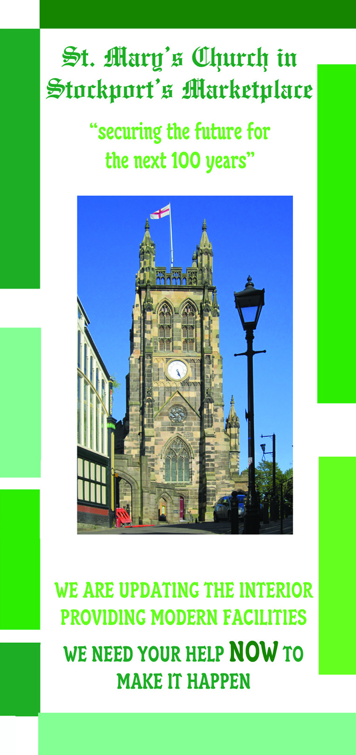
All proceeds to the St Mary’s Interior Appeal Fund
Tickets: £35 per person (tables of 10 £350)
Available from:
Rectory Office
St Mary’s Rectory
24 Gorsey Mount Street
Stockport
SK1 4DU Tel: 0161 429 6564
email: st.marysstockport@gmail.com
Securing the future for the next 100 years

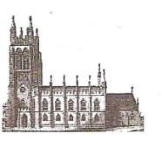
St Mary’s in the Marketplace.
Issue No 14 (21st October 2012)

“Securing the future for the next 100 years”

As our contractors continue to work on the tower and behind the black screens (knocking through into the Choir Vestry being the most note worthy activity), we are now very aware of the financial challenge we face between now and around Christmas to raise the balance of the funding needed to undertake all the work we have approval for at the present time. We have the majority of the money already – but we need to find the balance of around £80K – otherwise part of the work will have to be put on hold. If we cannot find the cash in the next few weeks we can’t instruct our Architect to authorise the work to be completed whilst Lambert Walker are on site – and although some of the tasks could be done at a later time – perhaps with minimal disruption – it will cost us more to bring everyone back on site. We aim to finish this first phase of the interior by February.
All our efforts are now required to make this happen…. Thank you to everyone who has to date contributed cash, every “£” counts and is greatly appreciated. We need to spread the message and look for funding from various sources. We have already held the official “launch” of the Appea, completed the first phase of an appeal mail-shot and are meeting with members of the business community towards “partnership working” and ways of improving our income stream. We are looking towards holding a series of fund-raising events and very much hope that everyone will be able to support us with some (if not all) of these. We will be inviting groups/organisations into Church to share with us our vision for the future.
We have prepared a presentation (to be shared with both the Sunday and Tuesday congregations of St Mary’s as well as being used at the official launch evening) to bring everyone up-to-date and we will be happy - for a small fee/donation (if anyone knows an organisation who is looking for lunch-time or evening speakers) to take it out and about! We also have a short appeal video – which we hope to show widely and make available on the internet.
Perhaps you would like to hold a fund-raising event of your own – a coffee morning, lunch with friends, quiz night or other such social event. Your efforts would be very helpful towards achieving our aims and objectives.

PEWS
Arrangements are now in hand to arrange viewings for the pews presently in storage at St Marks, Edgeley. Anyone interested in purchasing one (or more) and has not already done so, should complete an application form indicting their interest and return to St Mary’s Rectory Office as soon as possible.

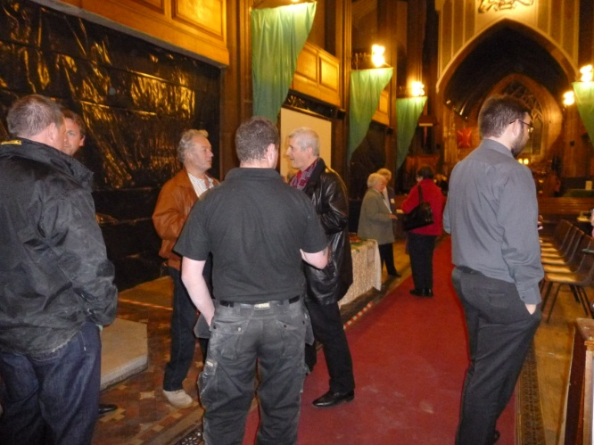
Appeal Launch Evening … A big “thank you” to our Architect (John Prichard) along with representatives from Lambert Walker (John Lambert, Paul McGiffen, & Michael Goulding) and our Structural Engineer (Fred Tandy) for attending the “Appeal Launch Evening” last Wednesday and offering to show visitors the progress being made in the North Aisle and, as far as safe to do so, the areas where work will need to be completed (in due course) in the Rectors Vestry. The evening, presented by the Project Group and representatives of the PCC, incorporated a drinks reception, presentation by the Rector (Roger Scoones) and short speech by Project Director (John Briggs) as well as guided tour of the north aisle and Rector’s Vestry. The evening concluded with a viewing of the Appeal Video with coffee and cakes in
in the hospitality area.
