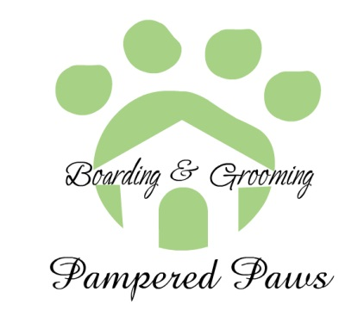

Pet Biography

Name _________________________________ Breed __________________

Birthdate ___________ Gender ______________ Altered -- Yes / No

Last Vet Visit _______________ Why?_____________________

Brand of Food ______________________ How many Cups a day? ________

Medication?_______________________________ How often? _____________

Health Issues—Arthritis, Blindness, Chronic Ear infections ?______________________

Special Treatment because of Health Issues ___________________________

Flea & Tick Meds -– Yes / No --- Brand _______________ Last given______________

Rules they obey? – Come, Sit, Stay, Lay down ______-- Tricks?___________________

Behavior around New dogs—Aggressive to Big/Small, Very Social, Timid of Big/Small

_______________________________________________________________________

Kennel behavior – Digging, Climber, Anxiety, Destroys blankets/ towels, ect.

_________________________________________________________

Consent to Treat Ailments or issues while boarding (worms, Ear infections, Diarrhea, Ect.) Yes/ No

Extra Info:

I Hereby give Pampered Paws permission to use photographs of my pet, on Facebook and other social media applications. I also grant permission for Pampered Paws to publish photographs of my pet for promotion of the organization in printed publications, photographic displays on Pampered Paws website or advertisements.

I approve I decline

I hereby certify that the information above is true and accurate.

Signature:________________________________ Date:_________________