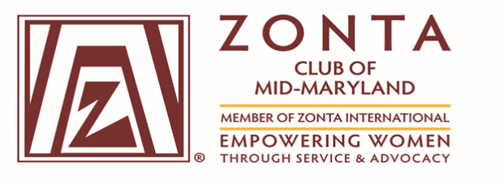
(Chartered May 5, 2016)

General Membership Meeting Minutes
Virtual Zoom Meeting
Thursday, November 12, 2020

Attendance:
President Virginia Moore
1st Vice President Tammie Edwards
Assistant Treasurer Erma Barron
Directors Alice Ross, Cleopatra White and Terrie Wills
Recording Secretary Doris Winston
Members: Phyllis Anderson
Tanya Duckett Brennan
Gloria Smith-Hill
Linda White-Andrews
Tanya Shanklin
Total - 12 Members

Call to Order: President Virginia H. Moore called the meeting to order at 7 pm

Zonta Vision and Code: Recited by President, Virginia M. Moore and members.

Agenda Review/Approval: The agenda was reviewed and approved by members. No comments or changes were noted.

Minutes for the October 15, 2020 General Body Meeting were approved.

President’s Remarks:
Virginia Moore commented on the District 3 Challenge, to make donations to the “Go Fund Me Page, the website was provided. Virginia announced the MLAW Conference on November 14, 2020, from 9am – 1pm.

Correspondence: N/A

1st Vice President Membership Report:

Tammie Edwards introduced prospective members.

Tammie provided a Video on Cheryl West, Mechanical and Aerospace Engineer. Ms. West received the Amelia Earhart Fellowship. She joined Zonta from 1977-1978.

2nd Vice President- Programs Report:
Tammie Edwards introduced Guest Speaker, Shuntrice Holloman, Program Specialist for NIH Fitness and Wellbeing Program. Ms. Holloman provided a presentation on “Healthy and Empowered.”
Committee Reports:

Fundraising Committee Report: Gloria Hill Smith provided information on the Virtual Shopping Event, scheduled for November 29. Audrey Farley provided information and answered questions concerning the event and purchases. Zonta Club of Mid-Atlantic will receive 20% of the total proceeds. Gloria informed club members, if donations are being made by check, write in the memo section, “what the donation is for.” Donations of $50 or more for service projects will be accepted until February 2021. The Zonta Club of Mid-Maryland is in partnership with the NeFe Foundation. The Club will receive from the NeFe Foundation 10% of the total proceeds for fundraiser projects.

Service Committee Report: No written report was provided. Alice provided information on the Family Justice Center’s “Holiday Hope Thanksgiving Baskets Distribution Program.” The flyer was distributed to club members. The flyer provided information on the dates and times, when and where to drop off donations. Cleo is collecting donated items by Sunday, November 15, 2020.

Advocacy Committee Report: Virginia Moore gave a brief report for the advocacy committee. Virginia reported that the Club logo will be displayed during the MLAW conference and placed in the booklet.

16 Days of Activism: November 25-December 10, 2020. Domestic Violence Campaign Kickoff by Zonta Club of Mid-Maryland. On November 22, 2020, sponsorship letters were distributed.
Chairs: Amanda and Nicole

Public Relations and Social Media Committee: Presented by Tanya Shanklin
The Zonta Club of Mid-Maryland Website and Facebook Page remain the same. The format has changed, links to scholarships provided, and coordinates with international websites. New website: www.ZontaMidMaryland.org. Website provides photos.

Treasurer’s Report:
Tanya Duckett-Brennan provided an overview for each financial report, Operations Account – 11/3/20 and Service Account – 11/3/20. Tanya explained methods of payment for donations by PayPal or check.

New Business: None
Unfinished Business: None
Meeting was adjourned: 8:48 pm
Minutes submitted by Doris Winston, Recording Secretary

2

