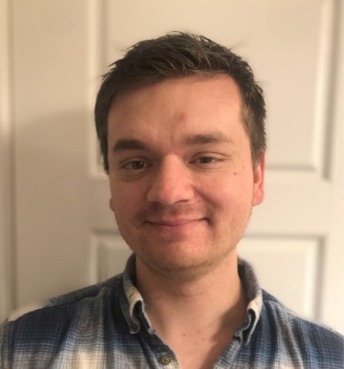
Michael H. Hastilow
Michael Hastilow M.S. is a graduate student at Southern Adventist University studying Clinical Mental Health Counseling. He is an intern with Bernard & Associates to gain a deeper understanding of crisis counseling and crisis response. He has a passion for helping others and is driven to learn what it takes to work in high stress environments. While this is his first formal foray into the world of crisis management, he has informal experience in working with those in critical need and those who have experienced traumatic events. Michael brings a fresh perspective to Bernard & Associates and a willingness to dive into the world of crisis counseling in hopes of bringing about effective change during times of crisis.

Academic:
- MS: Southern Adventist University: Clinical Mental Health Counseling focusing on crisis counseling and suicide prevention. Internship at Bernard & Associates, P.C. (8 months)
- BS: Southern Adventist University: Clinical Psychology; Internship at Southern Adventist University as a student teacher, Collegedale, TN (8 months)

Licensure/Certification:
- Trained, Critical Incident Stress Management; Southern Adventist University – Hamilton County
- Trained, FEMA National Incident Management System (NIMS)
- Certified, Collaborative Institutional Training Initiative (CITI)

Volunteer Service:
- F.L.A.G. Camp: Chattanooga, Tennessee inner-city community outreach
- Mount Vernon Hill Church Community Outreach: Mount Vernon, Ohio
- ACTS Center Community Pantry: Mount Vernon, Ohio

Special Projects:
- Southern Adventist University Crisis Response Simulation (2019): Incident Commander – Led teams through simulation and organized logistics and staffing of the incident response.
- Southern Adventist University Administrative Crisis Response Demonstration (2020): Incident Commander – Demonstrated the various steps taken in a crisis response for heads of the University.
- FEMA Region II COVID-19 Recovery Table-Top Experience (2020): Participant
- EndCoronaVirus.org (2020): Assistant Presenter
- Southern Adventist University Crisis Response Virtual Tabletop (2020): Group Facilitator- Worked with students taking crisis response classes to help promote discuss and quick problem-solving strategies.

Personal: Born in Sunbury, OH; Youngest of five; Moved to Chattanooga, TN for school in 2014. Senior Class President 2013 at Mount Vernon Academy. Teaching Assistant for upper-division classes at Southern Adventist University since Fall of 2018. Avid snowboarder and basic open-water certified scuba diver with NAUI. Has worked with several Doctoral Candidates and master’s students as a research assistant and editor.

Contact Information:
mhastilow@southern.edu

