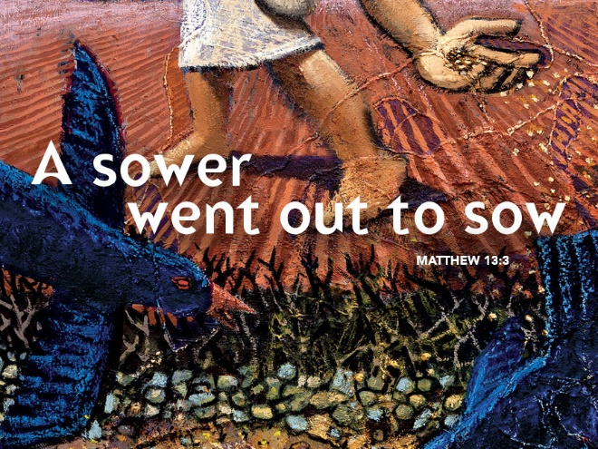

Let My Heart Be Good Soil
July 16, 2017
Matthew 13:1-9, 18-23

Grace and peace to you from God our Father and from Jesus Christ our Savior, amen.
We all have our little quirks. Some people say ‘um’ or ‘ya know’ a lot when the talk. I tend to sway back and forth and jump around a lot. I’ve seen myself on video and I’ve gotten feedback from people, but I just seem to fall back into the swaying back and forth when I preach. I remember the first time my sister Alice saw me preach. She offered me only one criticism. She said all the swaying back and forth made her a little seasick. I try to stop, but the very thing I don’t want to do, that’s what I do as Saint Paul might say. I couldn’t help but notice in our Gospel text for today Jesus got into as boat and put out a little way on the sea of Galilee. I’ve been on the Sea of Galilee when it was a bit choppy and I can just imagine Jesus swaying gently back and forth as he preached and told his stories and parables. The next time I start the swaying and you get a little seasick from watching me go back and forth, just imagine you’re on the shore of Galilee and I’m a little way out in a small fishing boat…
That’s the physical context of where this Gospel story takes place. The sea shore is often the place where Jesus does his teaching. For Matthew, the sea shore is a spiritual place. In order to better understand this parable, we need to take a look at the context of what else is going on in Matthew’s Gospel. Even though this is the Year of Matthew, the readings this year completely skipped over chapter 12. Last week we were in chapter 11 and this week chapter 13. When I sat down to write this sermon I wondered what we might have left out when we skipped over chapter 12. This is a critical omission because the material in today’s Gospel, the Parable of the Sower, along with its explanations, is Jesus' response to the events that have taken place in chapter 12. In chapter 12, opposition to Jesus intensifies. Pharisees now debate Jesus directly (12:1-8). They plot his death (12:14). The Jewish leaders want him dead, but at the same time, he is the hope for the Gentiles. Jesus' mission to the house of Israel has at least partially failed. The Pharisees believe Jesus is in league with Beelzebul (12:24). Jesus knows the Pharisees are against him (12:30). They’re not bearing good fruit because they’re bad trees -- a "brood of vipers" (12:34a). They are "an evil and adulterous generation" who ask for a sign (12:38-39). I suggest you read chapter 12 once again for yourself. If you do, keep the parable of the sower in mind as you read and I think you’ll discover new insights as to the meaning of the parable.
Jesus used a parable, an earthly story with a heavenly meaning to answer some basic questions the disciples and we still have today. Questions like: Why do people not believe? Is there any explanation for the fate Jesus meets when he finally is betrayed and rejected? The answer is: Yes and the explanation begins with simple words: "A sower went out to sow."
If we’re able to read the parable as an answer to such questions raised by the events that happened in chapter 12, we can see how the parable illustrates why some people did not and do not believe. That’s a message and probably the purpose of the parable and its interpretation in Matthew. However, as we will see, one can also glean other meanings from the parable.
The living Word of God speaks to us on many levels and parables are notorious for offering so many different levels of meaning. Just when I think I’ve got it nailed, God smiles and my house of cards collapses. This parable is no different. It’s almost universally accepted that Matthew wrote his Gospel some 80-90 years after the first Easter. Today, we want to know how this parable might speak to us 200 decades after the fact. I find three possible voices speaking through this story. Are you the sower, the seed, or the soil? And what is the message in the parable for you?
I suppose there are people who have felt like the sower. What strikes me about the sower is the indiscriminate way in which he sows the seed. No farmer would intentionally sow seed on a road or among thorns. The sower in the parable is more like Johnny Appleseed who sows seeds where ever he goes. People who see themselves as the sower, are people who freely and carelessly give whatever it is they have to give. They share the good news of God’s love and are sometimes rejected. Jesus probably felt like the sower at times. This is probably how Jesus intended the parable to be understood. The Disciples probably felt like the sower at times. I know I feel like the sower at times and you probably do too. Every time I give money away to people I don’t know how they’re going to use it or if they’re trying to scam me, but I keep on sowing the seeds… Sometimes we don’t see any crops come out of our sown seeds. All we see are weeds, or the birds take away the seeds and there is nothing left. Sometimes we see the crops grow with varying amounts of effectiveness. It can be disheartening if you are the sower in the story, but the sower in the parable reminds us of the need to be liberal with the seed rather than conservative. God’s grace is meant for everyone everywhere, not just those likely to make a positive response to it.
On the other hand, some of us feel like the seed in the parable. Sometimes we feel like God has put us someplace — and left us there — either to grow or to die. Sometimes we blame the sower for putting us where we are, we blame the sower for not being very careful when planting us. Other people decide to make the best of where we are and bring glory to the sower of all life. When I was in the Air Force as a personnel officer I often counseled other officers and enlisted members who thought their current job was beneath their abilities. I told them the most important job they will ever have is the one they have right now. My advice to them was, bloom where you’re planted.
Most of us have been sown in fairly good soil. Life has been pretty good to us. We find enough nutrients and water to grow. And still some of us seem to produce more than others. When I think of the churches that have survived for years in the Soviet Union or Communist China, I am reminded of how good the soil has been for us and how little we have to show for it. At best, their soil has been rocky, perhaps even filled with weeds. Yet they have continued to grow. They have continued to thrive. Here at home, in a land that allows freedom of expression, we find fewer and fewer people responding to God’s call to ministry, a call that includes everyone here, not just the pastor. In a land where the soil has been rich, we are complacent. If you are the seed in the parable, what kind of soil have you been thrown upon and how are you responding to it?
Finally, there is the soil. This is the most common way to read the parable today, as if we were the soil, as if the seed were the word of God come into our hearts. This understanding of the parable is probably how Matthew intended his original audience to understand the parable as well. In this reading of it, the parable becomes a question of how well we hear, how well we understand the gift of God’s Word and then how we respond to that Good News. Our mission statement is, “In Christ’s love, we seek, welcome, and serve all.” I will tell you all the grandiose Mission Statements in the world won’t help us to hear and understand the Word of God if we’re not involved in weekly worship, daily Bible devotions, and regular, intentional Bible study with other people. One of my favorite songs is Let My Heart Be Good Soil. The words go something like this…
Lord, let my heart be good soil,
open to the seed of your word.
Lord, let my heart be good soil,
where love can grow and peace is understood.
When my heart is hard,
break the stone away.
When my heart is cold,
warm it with the day.
When my heart is lost,
lead me on your way.
Lord, let my heart, Lord, let my heart, Lord, let my heart be good soil.

For a heart, any heart to become good soil that heart must be surrounded by God’s Word and God’s people.
May God work the miracle of faith in all of us to give us generous hearts to liberally sow the seeds of God’s Word, the faith to bloom where we’re planted and the strength to stay connected to God’s Word and God’s people so that our hearts and minds will be transformed into the likeness of Christ, to whom be the glory, now and forever, amen.

