Between 13 May to 13 October 1917, 'a lady more brilliant than the sun' appeared six times to three Portuguese shepherd children, Lúcia dos Santos and her cousins Francisco and Jacinta Marto.
The lady asked them to devote themselves to the Holy Trinity and to pray the Rosary every day; prayer would end the Great War then still raging. She also showed them a vision of hell and entrusted them with three secrets.
The children's visions drew thousands of visitors and upset the political balance in the country, with a young, anticlerical republic fighting off a strong conservative reaction. The children were even briefly jailed, and variously ordered to reveal the secrets or admit that they had lied. The local administrator even threatened that he would boil them one by one in a pot of oil.
At the Virgin's last appearance, many of the up to 100,000 visitors reported a 'Miracle of the Sun': multicolored light and erratic movement from the sun. Others saw nothing out of the ordinary.
As predicted by the Virgin, Francisco and Jacinta died soon afterward, in the Spanish Flu pandemic that started in 1918. Lucia became a nun, and sporadically saw the Virgin again later in life, as well as Jesus. She died in 2005, aged 97.
Already in the first few years after the events, Fátima attracted millions of visitors. Our Lady of Fátima was popular among anticommunist and traditionalist Catholics. Pope John Paul II credited Our Lady of Fátima with saving his life in the attempt on his life of 13 May 1981 – the Feast of Our Lady of Fátima. The Pope donated the bullet that wounded him to the Sanctuary at Fátima. Fátima currently is one of the world's most popular centers of pilgrimage.

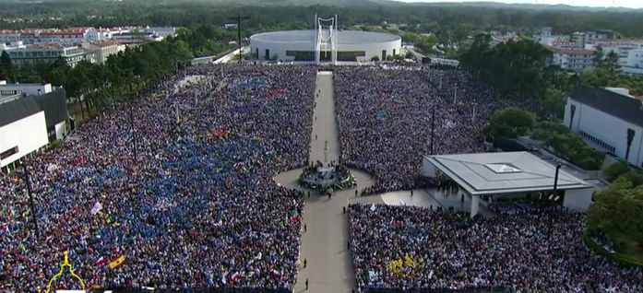

Crowds at the Sanctuary of Our Lady of Fátima on 12 May 2017 for the centennial of the first apparition. Image: Centro Televisivo Vaticano, CC BY 3.0

